Beah Whitefang
Female Human
Alignment: Neutral – Deity: Ehlonna



Class Features
Level Table
Animal Companions
Beah’s Feats

Druid Spells
0 Level Spells || 1st Level Spells
2nd Level Spells || 3rd Level Spells
4th Level Spells || 5th Level Spells
6th Level Spells || 7th Level Spells
8th Level Spells || 9th Level Spells

TSR D&D Players Handbook
TSR D&D Monster Manual
Masters of the Wild
EDITING PAGE 20

DRUID
The fury of a storm, the gentle strength of the morning sun, the cunning of the fox, the power of the bear—all these and more are at the druid’s command. The druid however, claims no mastery over nature. That claim, she says, is the empty boast of a city dweller. The druid gains her power not by ruling nature but by being at one with it. To trespassers in a druid’s sacred grove, and to those who feel her wrath, the distinction is overly fine.
Adventures: Druids adventure to gain knowledge (especially about animals and plants unfamiliar to them) and power. Sometimes, their superiors call on their services. Druids may also bring their power to bear against those who threaten what they love, which more often includes ancient stands of trees or trackless mountains than people. While druids accept that which is horrific or cruel in nature, they hate that which is unnatural, including aberrations (such as beholders and carrion crawlers) and undead (such as zombies and vampires). Druids sometimes lead raids against such creatures, especially when they encroach on the druids’ territory.
Characteristics: Druids cast divine spells much the same way clerics do, though most get their spells from the power of nature rather than from deities. Their spells are oriented toward nature and animals. In addition to spells, druids gain an increasing array of magical powers, including the ability to take the shapes of animals, as they advance in level.
The armor of a druid are restricted by traditional oaths to the items noted in Weapon and Armor proficiency (below),All other armor is prohibited. Though a druid could learn to wear full plate, putting it on would violate her oath and suppress her druidic powers.
Druids avoid carrying much worked metal with them because it interferes with the pure and primal nature that they attempt to embody.
Alignment: Druids, in keeping with nature’s ultimate indifference, must maintain at least some measure of dispassion. As such, they must be neutral on at least one alignment axis (chaotic–lawful or good–evil), if not both. Just as nature encompasses such dichotomies as life and death, beauty and horror, and peace and violence, so two druids can manifest different or even opposite alignments (neutral good and neutral evil, for instance) and still be part of the druidic tradition.
Religion: A druid reveres nature above all. She gains her magical power either from the force of nature itself or from a nature deity. The typical druid pursues a mystic spirituality of transcendent union with nature rather than devoting herself to a divine entity. Still, some druids revere or at least respect either Obad-Hai (god of nature) or Ehlonna (goddess of the woodlands).
Background: Though their organization is invisible to most outsiders, who consider druids to be loners, druids are actually part of a society that spans the land, ignoring political borders. A prospective druid is inducted into this society through secret rituals, including tests that not all survive. Only after achieving some level of competence is the druid allowed to strike out on her own.
All druids are nominally members of this druidic society, though some individuals are so isolated that they have never seen any high-ranking members of the society or participated in druidic gatherings. All druids recognize each other as brothers and sisters. Like true creatures of the wilderness, however, druids sometimes compete with or even prey on each other.
A druid may be expected to perform services for higher-ranking druids, though proper payment is tendered for such assignments. Likewise, a lower-ranking druid may appeal for aid from her higher-ranking comrades in exchange for a fair price in coin or service.
Druids may live in small towns, but they always spend a good portion of their time in wild areas. Even large cities surrounded by cultivated land as far as the eye can see often have druid groves nearby—small, wild refuges where druids live and which they protect fiercely. Near coastal cities, such refuges may be nearby islands, where the druids can find the isolation they need.
Races: Elves and gnomes have an affinity for natural lands and often become druids. Humans and halfelves also frequently adopt this path, and druids are particularly common among savage humans. Dwarves, halflings, and half-orcs are rarely druids.
Few from among the brutal humanoids are inducted into druidic society, though gnolls have a fair contingent of evil druids among them. Gnoll druids are accepted, though perhaps not welcomed, by druids of other races.
Other Classes: The druid shares with rangers and many barbarians a reverence for nature and a familiarity with natural lands. She doesn’t much understand the urban mannerism typical of a rogue, and she finds arcane magic disruptive and slightly distasteful. The typical druid also dislikes the paladin’s devotion to abstract ideals instead of “the real world.” Druids, however, are nothing if not accepting of diversity, and they take little offense at other characters, even those very different from them.
Role: The druid enjoys extraordinary versatility. Though she lacks the sheer healing power of the cleric, she makes up for it with additional offensive power, thanks to her spell selection and wild shape ability. A druid back up by another secondary healer (such as a paladin) can prove extremely valuable to a group of adventurers. Her animal companion also provides valuable melee combat support.

GAME RULE INFORMATION
Druids have the following game statistics.
Abilities: Wisdom determines how powerful a spell a druid can cast, how many spells she can cast per day, and how hard those spells are to resist. To cast a spell, a druid must have a Wisdom score of 10 + the spell’s level. A druid gets bonus spells based on Wisdom. The Difficulty Class of a saving throw against a druid’s spell is 10 + the spell’s level + the druid’s Wisdom modifier.
Since a druid wears light or medium armor, a high Dexterity score greatly improves her defensive ability.
Alignment: Neutral good, lawful neutral, neutral, chaotic
neutral, or neutral evil.
Hit Die: d8.

Class Skills
The druid’s class skills (and the key ability for each skill) are Concentration (Con), Craft (Int), Diplomacy (Cha), Handle Animal (Cha), Heal (Wis), Knowledge (nature) (Int), Listen (Wis), Profession (Wis), Ride (Dex), Spellcraft (Int), Spot (Wis), Survival (Wis), and Swim (Str). See Chapter 4: Skills for skill
descriptions.
Skill Points at 1st Level: (4 + Int modifier) × 4.
Skill Points at Each Additional Level: 4 + Int modifier.

Class Features
All of the following are class features of the druid.
Weapon and Armor Proficiency:
Druids are proficient with the following weapons: club, dagger, dart, quarterstaff, scimitar, sickle, shortspear, sling, and spear. They are also proficient with all natural attacks (claw, bite, and so forth) of any form they assume with wild shape (see below).
Druids are proficient with light and medium armor but are prohibited from wearing metal armor; thus, they may wear only padded, leather, or hide armor. (A druid may also wear wooden armor that has been altered by the ironwood spell so that it functions as though it were steel. See the ironwood spell description, page 246) Druids are proficient with shields (except tower shields) but must use only wooden ones.
A druid who wears prohibited armor or carries a prohibited shield is unable to cast druid spells or use any of her supernatural or spelllike class abilities while doing so and for 24 hours thereafter.
Spells: A druid casts divine spells (the same type of spells available to the cleric, paladin, and ranger), which are drawn from the druid spell list (page 189). Her alignment may restrict her from casting certain spells opposed to her moral or ethical beliefs; see Chaotic, Evil, Good, and Lawful Spells, below. A druid must choose and prepare her spells in advance (see below).
To prepare or cast a spell, the druid must have a Wisdom score equal to at least 10 + the spell level (Wis 10 for 0-level spells, Wis 11 for 1st-level spells, and so forth). The Difficulty Class for a saving throw against a druid’s spell is 10 + the spell level + the druid’s Wisdom modifier.
Like other spellcasters, a druid can cast only a certain number of spells of each spell level per day. Her base daily spell allotment is given on Table 3–8: The Druid. In addition, she receives bonus spells per day if she has a high Wisdom score (see Table 1–1: Ability Modifiers and Bonus Spells, page8). She does not have access to any domain spells or granted powers, as a cleric does.
A druid prepares and casts spells the way a cleric does, though she cannot lose a prepared spell to cast a cure spell in its place (but see Spontaneous Casting, below). A druid may prepare and cast any spell on the druid spell list (page 189), provided that she can cast spells of that level, but she must choose which spells to prepare during her daily meditation.
Spontaneous Casting: A druid can channel stored spell energy into summoning spells that she hasn’t prepared ahead of time. She can “lose” a prepared spell in order to cast any summon nature’s ally spell of the same level or lower. For example, a druid who has prepared repel vermin (a 4th-level spell) may lose repel vermin in order to cast summon nature’s ally IV (also a 4th-level spell).
Chaotic, Evil, Good, and Lawful Spells: A druid can’t cast spells of an alignment opposed to her own or her deity’s (if she has one). For example, a neutral good druid cannot cast evil spells. Spells associated with particular alignments are indicated by the chaos, evil, good, and law descriptors in their spell descriptions (see Chapter 11: Spells).

Title Page
Class Features
Level Table
Animal Companions
Beah’s Feats

Druid Spells
0 Level Spells || 1st Level Spells
2nd Level Spells || 3rd Level Spells
4th Level Spells || 5th Level Spells
6th Level Spells || 7th Level Spells
8th Level Spells || 9th Level Spells
Bonus Languages: A druid’s bonus language options include Sylvan, the language of woodland creatures. This choice is in addition to the bonus languages available to the character because of her race (see Race and Languages, page 12, and the Speak Language skill, page 82).
A druid also knows Druidic, a secret language known only to druids, which she learns upon becoming a 1st-level druid. Druidic is a free language for a druid; that is, she knows it in addition to her regular allotment of languages and it doesn’t take up a language slot. Druids are forbidden to teach this language to nondruids. Druidic has its own alphabet.
Animal Companion (Ex): A druid may begin play with an
animal companion selected from the following list: badger, camel, dire rat, dog, riding dog, eagle, hawk, horse (light or heavy), owl, pony, snake (Small or Medium viper), or wolf. If the DM’s campaign takes place wholly or partly in an aquatic environment, the DM may add the following creatures to the druid’s list of options: crocodile, porpoise, Medium shark, and squid. This animal is a loyal companion that accompanies the druid on her adventures as appropriate for its kind.
A 1st-level druid’s companion is completely typical for its kind except as noted in the sidebar on page 36. As a druid advances in level, the animal’s power increases as shown on the table in the sidebar.
If a druid releases her companion from service, she may gain a new one by performing a ceremony requiring 24 uninterrupted hours of prayer. This ceremony can also replace an animal companion that has perished.
A druid of 4th level or higher may select from alternative lists of animals (see the sidebar). Should she select an animal companion from one of these alternative lists, the creature gains abilities as if the character’s druid level were lower than it actually is. Subtract the value indicated in the appropriate list header from the character’s druid level and compare the result with the druid level entry on the table in the sidebar to determine the animal companion’s powers. (If this adjustment would reduce the druid’s effective level to 0 or lower, she can’t have that animal as a companion.) For example, a 6th-level druid could select a leopard as an animal companion. The leopard would have characteristics and special abilities as if the druid were 3rd level (taking into account the –3 adjustment) instead of 6th level.
Nature Sense (Ex): A druid gains a +2 bonus on Knowledge (nature) and Survival checks.
Wild Empathy (Ex): A druid can use body language, vocalizations, and demeanor to improve the attitude of an animal (such as a bear or a monitor lizard). This ability functions just like a Diplomacy check made to improve the attitude of a person (see Chapter 4: Skills). The druid rolls 1d20 and adds her druid level and her Charisma modifier to determine the wild empathy check result. The typical domestic animal has a starting attitude of indifferent, while wild animals are usually unfriendly.
To use wild empathy, the druid and the animal must be able to study each other, which means that they must be within 30 feet of one another under normal conditions. Generally, influencing an animal in this way takes 1 minute but, as with influencing people, it might take more or less time.
A druid can also use this ability to influence a magical beast with an Intelligence score of 1 or 2 (such as a basilisk or a girallon), but she takes a –4 penalty on the check.
Woodland Stride (Ex): Starting at 2nd level, a druid may move through any sort of undergrowth (such as natural thorns, briars, overgrown areas, and similar terrain) at her normal speed and without taking damage or suffering any other impairment. However, thorns, briars, and overgrown areas that have been magically manipulated to impede motion still affect her.
Trackless Step (Ex): Starting at 3rd level, a druid leaves no trail in natural surroundings and cannot be tracked. She may choose to leave a trail if so desired.
Resist Nature’s Lure (Ex): Starting at 4th level, a druid gains a +4 bonus on saving throws against the spell-like abilities of fey (such as dryads, pixies, and sprites).
Wild Shape (Su): At 5th level, a druid gains the ability to turn herself into any Small or Medium animal and back again once per day. Her options for new forms include all creatures with the animal type (see the Monster Manual). This ability functions like the polymorph spell, except as noted here. The effect lasts for 1 hour per druid level, or until she changes back. Changing form (to animal or back) is a standard action and doesn’t provoke an attack of opportunity.
The form chosen must be that of an animal the druid is familiar with. For example, a druid who has never been outside a temperate forest could not become a polar bear.
A druid loses her ability to speak while in animal form because she is limited to the sounds that a normal, untrained animal can make, but she can communicate normally with other animals of the same general grouping as her new form. (The normal sound a wild parrot makes is a squawk, so changing to this form does not permit speech.)
A druid can use this ability more times per day at 6th, 7th, 10th, 14th, and 18th level, as noted on Table 3–8: The Druid. In addition, she gains the ability to take the shape of a Large animal at 8th level, a Tiny animal at 11th level, and a Huge animal at 15th level. The new form’s Hit Dice can’t exceed the character’s druid level. For instance, a druid can’t take the form of a dire bear (a Large creature that always has at least 12 HD) until 12th level, even though she can begin taking Large forms at 8th level.
At 12th level, a druid becomes able to use wild shape to change into a plant creature, such as a shambling mound, with the same size restrictions as for animal forms. (A druid can’t use this ability to take the form of a plant that isn’t a creature, such as a tree or a rose bush.)
At 16th level, a druid becomes able to use wild shape to change into a Small, Medium, or Large elemental (air, earth, fire, or water) once per day. These elemental forms are in addition to her normal wild shape usage. In addition to the normal effects of wild shape, the druid gains all the elemental’s extraordinary, supernatural, and spell-like abilities. She also gains the elemental’s feats for as long as she maintains the wild shape, but she retains her own creature type (humanoid, in most cases).
At 18th level, a druid becomes able to assume elemental form twice per day, and at 20th level she can do so three times per day. At 20th level, a druid may use this wild shape ability to change into a Huge elemental.

Title Page
Class Features
Level Table
Animal Companions
Beah’s Feats

Druid Spells
0 Level Spells || 1st Level Spells
2nd Level Spells || 3rd Level Spells
4th Level Spells || 5th Level Spells
6th Level Spells || 7th Level Spells
8th Level Spells || 9th Level Spells

Venom Immunity (Ex): At 9th level, a druid gains immunity to all poisons.
A Thousand Faces (Su): At 13th level, a druid gains the ability to change her appearance at will, as if using the alter self spell (page 197), but only while in her normal form.
Timeless Body (Ex): After attaining 15th level, a druid no
longer takes ability score penalties for aging (see Table 6–5: Aging Effects, page 109) and cannot be magically aged. Any penalties she may have already incurred, however, remain in place. Bonuses still accrue, and the druid still dies of old age when her time is up.
Ex-Druids
A druid who ceases to revere nature, changes to a prohibited alignment, or teaches the Druidic language to a nondruid loses all spells and druid abilities (including her animal companion, but not including weapon, armor, and shield proficiencies). She cannot thereafter gain levels as a druid until she atones (see the atonement spell description, page 201).

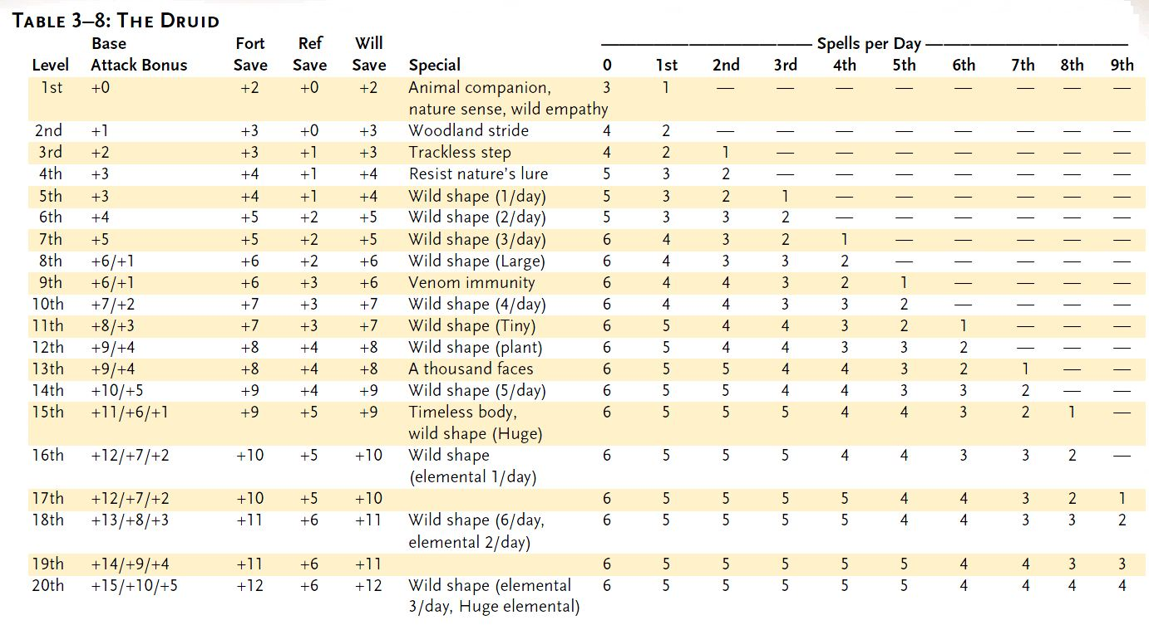

THE DRUID’S ANIMAL COMPANION
A druid’s animal companion is different from a normal animal of its kind in many ways. The companion is treated as a magical beast, not an animal, for the purpose of all effects that depend on its type (though it retains an animal’s HD, base attack bonus, saves, skill points, and feats). It is superior to a normal animal of its kind and has special powers, as described below.

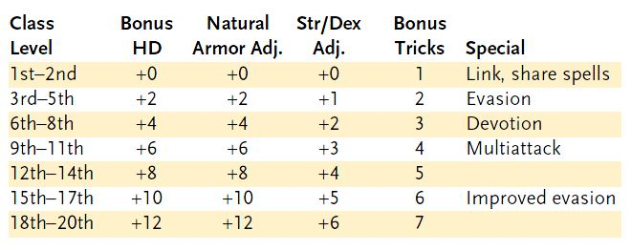

Animal Companion Basics: Use the base statistics for a creature of the companion’s kind, as given in the Monster Manual, but make the following changes.
Class Level: The character’s druid level. The druid’s class levels stack with levels of any other classes that are entitled to an animal companion (such as the ranger) such for the purpose of determining the companion’s abilities and the alternative lists available to the character.

Title Page
Class Features
Level Table
Animal Companions
Beah’s Feats

Druid Spells
0 Level Spells || 1st Level Spells
2nd Level Spells || 3rd Level Spells
4th Level Spells || 5th Level Spells
6th Level Spells || 7th Level Spells
8th Level Spells || 9th Level Spells

Bonus HD: Extra eight-sided (d8) Hit Dice, each of which gains a Constitution modifier, as normal. Remember that extra Hit Dice improve the animal companion’s base attack and base save bonuses. An animal companion’s base attack bonus is the same as that of a druid of a level equal to the animal’s HD.
An animal companion has good Fortitude and Reflex saves (treat it as a character whose level equals the animal’s HD). An animal companion gains additional skill points and feats for bonus HD as normal for advancing a monster’s Hit Dice (see the Monster Manual).
Natural Armor Adj.: The number noted here is an improvement to the animal companion’s existing natural armor bonus.
Str/Dex Adj.: Add this value to the animal companion’s Strength and Dexterity scores.
Bonus Tricks: The value given in this column is the total number of “bonus” tricks that the animal knows in addition to any that the druid might choose to teach it (see the Handle Animal skill, page 74). These bonus tricks don’t require any training time or Handle Animal checks, and they don’t count against the normal limit of tricks known by the animal. The druid selects these bonus tricks, and once selected, they can’t be changed.
Link (Ex): A druid can handle her animal companion as a free action, or push it as a move action, even if she doesn’t have any ranks in the Handle Animal skill. The druid gains a +4 circumstance bonus on all wild empathy checks and Handle Animal checks made regarding an animal companion.
Share Spells (Ex): At the druid’s option, she may have any spell (but not any spell-like ability) she casts upon herself also affect her animal companion. The animal companion must be within 5 feet of her at the time of casting to receive the benefit. If the spell or effect has a duration other than instantaneous, it stops affecting the animal companion if the companion moves farther than 5 feet away and will not affect the animal again, even if it returns to the druid before the duration expires. Additionally, the druid may cast a spell with a target of “You” on her animal companion (as a touch range spell) instead of on herself. A druid and her animal companion can share spells even if the spells normally do not affect creatures of the companion’s type (animal).
Evasion (Ex): If an animal companion is subjected to an attack that normally allows a Reflex saving throw for half damage, it takes no
damage if it makes a successful saving throw.
Devotion (Ex): An animal companion’s devotion to its master is so complete that it gains a +4 morale bonus on Will saves against enchantment spells and effects.
Multiattack: An animal companion gains Multiattack as a bonus feat if it has three or more natural attacks (see the Monster Manual for details on this feat) and does not already have that feat. If it does not have the requisite three or more natural attacks, the animal companion instead gains a second attack with its primary natural weapon, albeit at a –5 penalty.
Improved Evasion (Ex): When subjected to an attack that normally allows a Reflex saving throw for half damage, an animal companion takes no damage if it makes a successful saving throw and only half damage if the saving throw fails.

ALTERNATIVE ANIMAL COMPANIONS
As explained in the text on page 35, a druid of sufficiently high level can select her animal companion from one of the following lists, applying the indicated adjustment to the druid’s level (in parentheses) for purposes of determining the companion’s characteristics and special abilities.

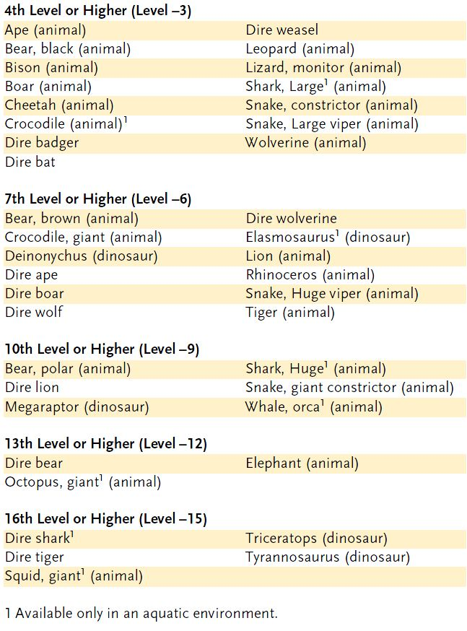

Title Page
Class Features
Level Table
Animal Companions
Beah’s Feats

Druid Spells
0 Level Spells || 1st Level Spells
2nd Level Spells || 3rd Level Spells
4th Level Spells || 5th Level Spells
6th Level Spells || 7th Level Spells
8th Level Spells || 9th Level Spells

Beah’s Feats
Feats Table 1 (Acrobatic – Point Blank Shot)
Feats Table 2 (Power Attack – Weapon Focus, Item Creation and Metamagic)
Title Page

ANIMAL AFFINITY [GENERAL] X 2
You are good with animals.
Benefit: You get a +2 (x2 = +4) bonus on all Handle Animal checks and
Ride checks.
SKILL FOCUS [GENERAL]
Choose a skill, such as Move Silently. You have a special knack with that skill.
Benefit: You get a +3 bonus on all checks involving that skill.
Special: You can gain this feat multiple times. Its effects do not stack. Each time you take the feat, it applies to a new skill.

TRACK [GENERAL]
You can follow the trails of creatures and characters across most types of terrain.
Benefit: To find tracks or to follow them for 1 mile requires a successful Survival check. You must make another Survival check every time the tracks become difficult to follow, such as when other tracks cross them or when the tracks backtrack and diverge. You move at half your normal speed (or at your normal speed with a –5 penalty on the check, or at up to twice your normal speed with a –20 penalty on the check). The DC depends on the surface and the prevailing conditions, as given on the table below:


Very Soft Ground: Any surface (fresh snow, thick dust, wet mud) that holds deep, clear impressions of footprints.
Soft Ground: Any surface soft enough to yield to pressure, but firmer than wet mud or fresh snow, in which a creature leaves frequent but shallow footprints.
Firm Ground: Most normal outdoor surfaces (such as lawns, fields, woods, and the like) or exceptionally soft or dirty indoor surfaces (thick rugs and very dirty or dusty floors). The creature might leave some traces (broken branches or tufts of hair), but it leaves only occasional or partial footprints.
Hard Ground: Any surface that doesn’t hold footprints at all, such as bare rock or an indoor floor. Most streambeds fall into this category, since any footprints left behind are obscured or washed away. The creature leaves only traces (scuff marks or displaced pebbles).
Several modifiers may apply to the Survival check, as given on the
table below.
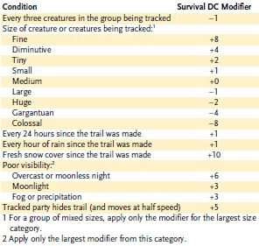

If you fail a Survival check, you can retry after 1 hour (outdoors) or 10 minutes (indoors) of searching.
Normal: Without this feat, you can use the Survival skill to find tracks, but you can follow them only if the DC for the task is 10 or lower. Alternatively, you can use the Search skill to find a footprint or similar sign of a creature’s passage using the DCs given above, but you can’t use Search to follow tracks, even if someone else has already found them.
Special: A ranger automatically has Track as a bonus feat. He need not select it.
This feat does not allow you to find or follow the tracks made by a subject of a pass without trace spell.

Feats Table 1 (Acrobatic – Point Blank Shot) – Beah’s Feats - Title Page
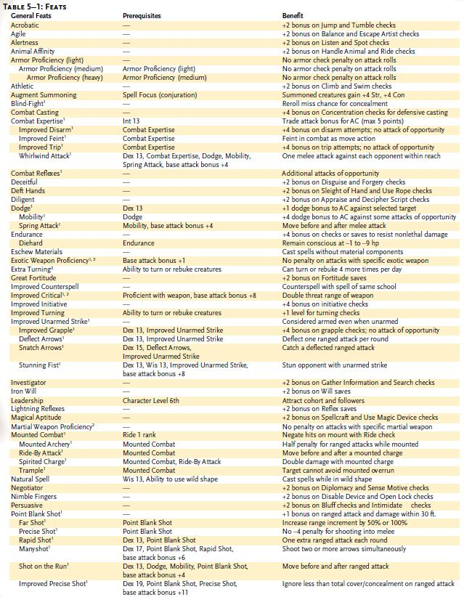
Feats Table 2 (Power Attack – Weapon Focus, Item Creation and Metamagic) – Beah’s Feats - Title Page
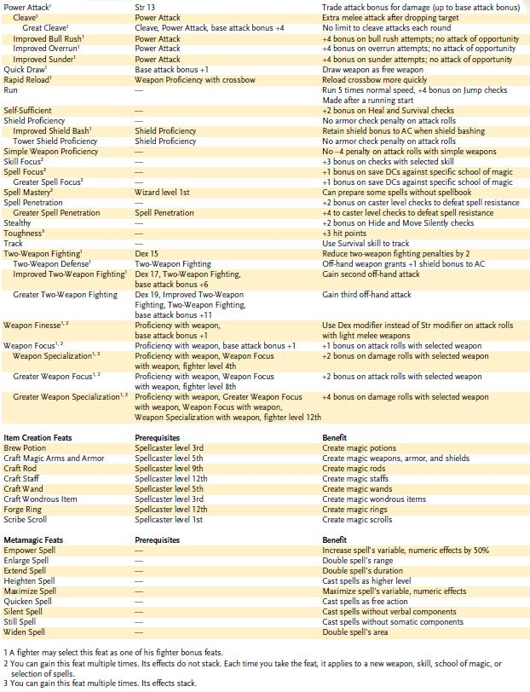

Title Page
Class Features
Level Table
Animal Companions
Beah’s Feats

0 Level Druid Spells
0 Level Spells || 1st Level Spells
2nd Level Spells || 3rd Level Spells
4th Level Spells || 5th Level Spells
6th Level Spells || 7th Level Spells
8th Level Spells || 9th Level Spells

0-LEVEL DRUID SPELLS (ORISONS)
Create Water: Creates 2 gallons/level of pure water.
Cure Minor Wounds: Cures 1 point of damage.
Detect Magic: Detects spells and magic items within 60 ft.
Detect Poison: Detects poison in one creature or object.
Flare: Dazzles one creature (-1 penalty on attack rolls).
Guidance: +1 on one attack roll, saving throw, or skill check.
Know Direction: You discern north.
Mending: Makes minor repairs on an object.
Purify Food and Drink: Purifies 1 cu. Ft./level of food or water.
Read Magic^{F}: Read scrolls and spellbooks.
Resistance: Subject gains +1 bonus on saving throws.
Virtue: Subject gains 1 temporary hp.

Create Water
Conjuration (Creation) [Water]
Level: Clr 0, Drd 0, Pal 1
Components: V, S
Casting Time: 1 standard action
Range: Close (25 ft. + 5 ft./2 levels)
Effect: Up to 2 gallons of water/level
Duration: Instantaneous
Saving Throw: None
Spell Resistance: No

This spell generates wholesome, drinkable water, just like clean rain water. Water can be created in an area as small as will actually contain the liquid, or in an area three times as large—possibly creating a downpour or filling many small receptacles.
Note: Conjuration spells can’t create substances or objects within a creature. Water weighs about 8 pounds per gallon. One cubic foot of water contains roughly 8 gallons and weighs about 60 pounds.



Cure Minor Wounds
Conjuration (Healing)
Level: Clr 0, Drd 0

This spell functions like *cure light wounds, except that it cures only 1 point of damage.

*Cure Light Wounds
Conjuration (Healing)
Level: Brd 1, Clr 1, Drd 1, Healing 1, Pal 1, Rgr 2
Components: V, S
Casting Time: 1 standard action
Range: Touch
Target: Creature touched
Duration: Instantaneous
Saving Throw: Will half (harmless); see text
Spell Resistance: Yes (harmless); see text

When laying your hand upon a living creature, you channel positive energy that cures 1d8 points of damage +1 point per caster level (maximum +5).
Since undead are powered by negative energy, this spell deals damage to them instead of curing their wounds. An undead creature can apply spell resistance, and can attempt a Will save to take half damage.

Detect Magic
Divination
Level: Brd 0, Clr 0, Drd 0, Sor/Wiz 0
Components: V, S
Casting Time: 1 standard action
Range: 60 ft.
Area: Cone-shaped emanation
Duration: Concentration, up to 1
min./level (D)
Saving Throw: None
Spell Resistance: No

You detect magical auras. The amount of information revealed depends on how long you study a particular area or subject.
1st Round: Presence or absence of magical auras.
2nd Round: Number of different magical auras and the power of the most potent aura.
3rd Round: The strength and location of each aura. If the items or creatures bearing the auras are in line of sight, you can make Spellcraft skill checks to determine the school of magic involved in each. (Make one check per aura; DC 15 + spell level, or 15 + half caster level for a nonspell effect.)
Magical areas, multiple types of magic, or strong local magical emanations may distort or conceal weaker auras.
Aura Strength: An aura’s power depends on a spell’s functioning spell level or an item’s caster level. If an aura falls into more than one category, detect magic indicates the stronger of the two.
Lingering Aura: A magical aura lingers after its original source dissipates (in the case of a spell) or is destroyed (in the case of a magic item). If detect magic is cast and directed at such a location, the spell indicates an aura strength of dim (even weaker than a faint aura). How long the aura lingers at this dim level depends on its original power:



(Detect Magic cont.)
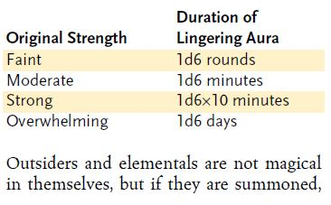
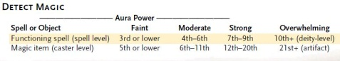
Detect Poison
Divination
Level: Clr 0, Drd 0, Pal 1, Rgr 1, Sor/Wiz 0
Components: V, S
Casting Time: 1 standard action
Range: Close (25 ft. + 5 ft./2 levels)
Target or Area: One creature, one object, or a 5-ft. cube
Duration: Instantaneous
Saving Throw: None
Spell Resistance: No



You determine whether a creature, object, or area has been poisoned or is poisonous. You can determine the exact type of poison with a DC 20 Wisdom check. A character with the Craft (alchemy) skill may try a DC 20 Craft (alchemy) check if the Wisdom check fails, or may try the Craft (alchemy) check prior to the Wisdom check.
The spell can penetrate barriers, but 1 foot of stone, 1 inch of common metal, a thin sheet of lead, or 3 feet of wood or dirt blocks it.

Flare
Evocation [Light]
Level: Brd 0, Drd 0, Sor/Wiz 0
Components: V
Casting Time: 1 standard action
Range: Close (25 ft. + 5 ft./2 levels)
Effect: Burst of light
Duration: Instantaneous
Saving Throw: Fortitude negates
Spell Resistance: Yes



This cantrip creates a burst of light. If you cause the light to burst directly in front of a single creature, that creature is dazzled for 1 minute unless it makes a successful Fortitude save. Sightless creatures, as well as creatures already dazzled, are not affected by flare.

Guidance
Divination
Level: Clr 0, Drd 0
Components: V, S
Casting Time: 1 standard action
Range: Touch
Target: Creature touched
Duration: 1 minute or until discharged
Saving Throw: Will negates (harmless)
Spell Resistance: Yes

This spell imbues the subject with a touch of divine guidance. The creature gets a +1 competence bonus on a single attack roll, saving throw, or skill check. It must choose to use the bonus before making the roll to which it applies.

Know Direction
Divination
Level: Brd 0, Drd 0
Components: V, S
Casting Time: 1 standard action
Range: Personal
Target: You
Duration: Instantaneous

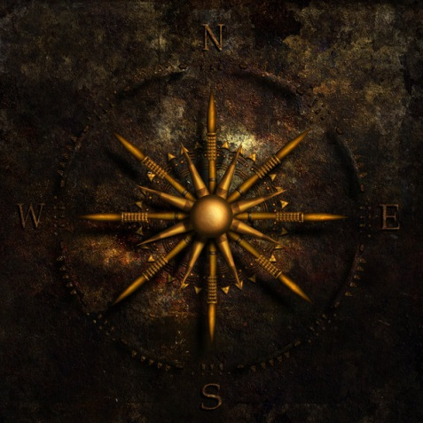

You instantly know the direction of north from your current position. The spell is effective in any environment in which “north” exists, but it may not work in extraplanar settings. Your knowledge of north is correct at the moment of casting, but you can get lost again within moments if you don’t find some external reference point to help you keep track of direction.

Mending
Transmutation
Level: Brd 0, Clr 0, Drd 0, Sor/Wiz 0
Components: V, S
Casting Time: 1 standard action
Range: 10 ft.
Target: One object of up to 1 lb.
Duration: Instantaneous
Saving Throw: Will negates (harmless, object)
Spell Resistance: Yes (harmless, object)

Mending repairs small breaks or tears in objects (but not warps, such as might be caused by a warp wood spell). It will weld broken metallic objects such as a ring, a chain link, a medallion, or a slender dagger, providing but one break exists. Ceramic or wooden objects with multiple breaks can be invisibly rejoined to be as strong as new. A hole in a leather sack or a wineskin is completely healed over by mending. The spell can repair a magic item, but the item’s magical abilities are not restored. (For restoring a broken magic item’s abilities, see the item creation feats in Chapter 5: Feats.) The spell cannot mend broken magic rods, staffs, or wands, nor does it affect creatures (including constructs).

Title Page
Class Features
Level Table
Animal Companions
Beah’s Feats

0 Level Druid Spells
0 Level Spells || 1st Level Spells
2nd Level Spells || 3rd Level Spells
4th Level Spells || 5th Level Spells
6th Level Spells || 7th Level Spells
8th Level Spells || 9th Level Spells

Purify Food and Drink
Transmutation
Level: Clr 0, Drd 0
Components: V, S
Casting Time: 1 standard action
Range: 10 ft.
Target: 1 cu. ft./level of contaminated food and water
Duration: Instantaneous
Saving Throw: Will negates (object)
Spell Resistance: Yes (object)

This spell makes spoiled, rotten, poisonous, or otherwise contaminated food and water pure and suitable for eating and drinking. This spell does not prevent subsequent natural decay or spoilage. Unholy water and similar food and drink of significance is spoiled by purify food and drink, but the spell has no effect on creatures of any type nor upon magic potions.
Note: Water weighs about 8 pounds per gallon. One cubic foot of water contains roughly 8 gallons and weighs about 60 pounds.


Read Magic
Divination
Level: Brd 0, Clr 0, Drd 0, Pal 1, Rgr 1, Sor/Wiz 0
Components: V, S, F
Focus: A clear crystal or mineral prism.
Casting Time: 1 standard action
Range: Personal
Target: You
Duration: 10 min./level

By means of read magic, you can decipher magical inscriptions on objects—books, scrolls, weapons, and the like—that would otherwise be unintelligible. This deciphering does not normally invoke the magic contained in the writing, although it may do so in the case of a cursed scroll. Furthermore, once the spell is cast and you have read the magical inscription, you are thereafter able to read that particular writing without recourse to the use of read magic. You can read at the rate of one page (250 words) per minute. The spell allows you to identify a glyph of warding with a DC 13 Spellcraft check, a greater glyph of warding with a DC 16 Spellcraft check, or any symbol spell with a Spellcraft check (DC 10 + spell level).
Read magic can be made permanent with a permanency spell.



Resistance
Abjuration
Level: Brd 0, Clr 0, Drd 0, Pal 1,
Sor/Wiz 0
Components: V, S, M/DF
Casting Time: 1 standard action
Range: Touch
Target: Creature touched
Duration: 1 minute
Saving Throw: Will negates (harmless)
Spell Resistance: Yes (harmless)

You imbue the subject with magical energy that protects it from harm, granting it a +1 resistance bonus on saves.
Resistance can be made permanent with a permanency spell.
Arcane Material Component: A miniature cloak.

Virtue
Transmutation
Level: Clr 0, Drd 0, Pal 1
Components: V, S, DF
Casting Time: 1 standard action
Range: Touch
Target: Creature touched
Duration: 1 min.
Saving Throw: Fortitude negates (harmless)
Spell Resistance: Yes (harmless)

The subject gains 1 temporary hit point.

Title Page
Class Features
Level Table
Animal Companions
Beah’s Feats

1st Level Druid Spells
0 Level Spells || 1st Level Spells
2nd Level Spells || 3rd Level Spells
4th Level Spells || 5th Level Spells
6th Level Spells || 7th Level Spells
8th Level Spells || 9th Level Spells

1st-LEVEL DRUID SPELLS

Calm Animals: Calms (2d4 + level) HD of animals.
Charm Animal: Makes one animal your friend.
Cure Light Wounds: Cures 1d8 damage +1/level (max +5).
Detect Animals or Plants: Detects kinds of animals or plants.
Detect Snares and Pits: Reveals natural or primitive traps.
Endure Elements: Exist comfortably in hot or cold environments.
Faerie Fire: Outlines subjects with light, canceling blur, concealment, and the like.
Goodberry: 2d4 berries each cure 1 hp (max 8 hp/24 hours).
Hide from Animals: Animals cannot perceive one subject/level.
Jump: Subject gets bonus on Jump checks.
Longstrider: Your speed increases by 10ft.
Magic Fang: One natural weapon of subject creature gets +1 on attack and damage rolls.
Magic Stone: Three stones gain +1 on attack rolls, deal 1d6+1 damage.
Obscuring Mist: Fog surrounds you.
Pass without Trace: One subject/level leaves no tracks.
Produce Flame: 1d6 damage +1/level, touch or thrown.
Shillelagh: Cudgel or quarterstaff becomes +1 weapon (1d10 damage) for 1 min/level.
Speak with Animals: You can communicate with animals.
Summon Nature’s Ally I: Calls creature to fight.

Calm Animals
Enchantment (Compulsion) [Mind-
Affecting]
Level: Animal 1, Drd 1, Rgr 1
Components: V, S
Casting Time: 1 standard action
Range: Close (25 ft. + 5 ft./2 levels)
Targets: Animals within 30 ft. of each other
Duration: 1 min./level
Saving Throw: Will negates; see text
Spell Resistance: Yes

This spell soothes and quiets animals, rendering them docile and harmless. Only ordinary animals (those with Intelligence scores of 1 or 2) can be affected by this spell. All the subjects must be of the same kind, and no two may be more than 30 feet apart. The maximum number of Hit Dice of animals you can affect is equal to 2d4 + caster level. A dire animal or an animal trained to attack or guard is allowed a saving throw; other animals are not. (A druid could calm a normal bear or wolf with little trouble, but it’s more difficult to affect a trained guard dog.)
The affected creatures remain where they are and do not attack or flee. They are not helpless and defend themselves normally if attacked. Any threat (such as fire, a hungry predator, or an imminent attack) breaks the spell on the threatened creatures.

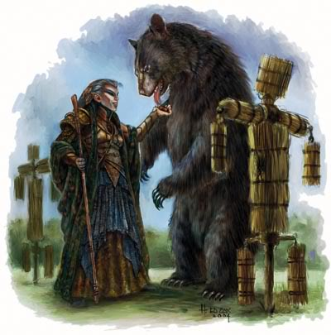

Charm Animal
Enchantment (Charm) [Mind-Affecting]
Level: Drd 1, Rgr 1
Target: One animal

This spell functions like *charm person, except that it affects a creature of the animal type. See the Monster Manual for more information on creature types.

*Charm Person
Enchantment (Charm) [Mind-Affecting]
Level: Brd 1, Sor/Wiz 1
Components: V, S
Casting Time: 1 standard action
Range: Close (25 ft. + 5 ft./2 levels)
Target: One humanoid creature
Duration: 1 hour/level
Saving Throw: Will negates
Spell Resistance: Yes

This charm makes a humanoid creature regard you as its trusted friend and ally (treat the target’s attitude as friendly; see Influencing NPC Attitudes, page 72). If the creature is currently being threatened or attacked by you or your allies, however, it receives a +5 bonus on its saving throw.
The spell does not enable you to control the charmed person as if it were an automaton, but it perceives your words and actions in the most favorable way. You can try to give the subject orders, but you must win an opposed Charisma check to convince it to do anything it wouldn’t ordinarily do. (Retries are not allowed.) An affected creature never obeys suicidal or obviously harmful orders, but a charmed fighter, for example, might believe you if you assured him that the only chance to save your life is for him to hold back an onrushing red dragon for “just a few seconds.” Any act by you or your apparent allies that threatens the charmed person breaks the spell. You must speak the person’s language to communicate your commands, or else be good at pantomiming.

Cure Light Wounds
Conjuration (Healing)
Level: Brd 1, Clr 1, Drd 1, Healing 1, Pal 1, Rgr 2
Components: V, S
Casting Time: 1 standard action
Range: Touch
Target: Creature touched
Duration: Instantaneous
Saving Throw: Will half (harmless); see text
Spell Resistance: Yes (harmless); see text

When laying your hand upon a living creature, you channel positive energy that cures 1d8 points of damage +1 point per caster level (maximum +5).
Since undead are powered by negative energy, this spell deals damage to them instead of curing their wounds. An undead creature can apply spell resistance, and can attempt a Will save to take half damage.

Detect Animals or Plants
Divination
Level: Drd 1, Rgr 1
Components: V, S
Casting Time: 1 standard action
Range: Long (400 ft. + 40 ft./level)
Area: Cone-shaped emanation
Duration: Concentration, up to 10
min./level (D)
Saving Throw: None
Spell Resistance: No

You can detect a particular kind of animal or plant in a cone emanating out from you in whatever direction you face. You must think of a kind of animal or plant when using the spell, but you can change the animal or plant kind each round. The amount of information revealed depends on how long you search a particular area or focus on a specific kind of animal or plant.
1st Round: Presence or absence of that kind of animal or plant in the area.
2nd Round: Number of individuals of the specified kind in the area, and the condition of the healthiest specimen.
3rd Round: The condition (see below) and location of each individual present. If an animal or plant is outside your line of sight, then you discern its direction but not its exact location.
Conditions: For purposes of this spell, the categories of condition are as follows:
- Normal: Has at least 90% of full normal hit points, free of disease.
- Fair: 30% to 90% of full normal hit points remaining.
- Poor: Less than 30% of full normal hit points remaining, afflicted with a disease, or suffering from a debilitating injury.
- Weak: 0 or fewer hit points remaining, afflicted with a disease in the terminal stage, or crippled.
If a creature falls into more than one category, the spell indicates the weaker of the two.
Each round you can turn to detect a kind of animal or plant in a new area. The spell can penetrate barriers, but 1 foot of stone, 1 inch of common metal, a thin sheet of lead, or 3 feet of wood or dirt blocks it.
The DM decides if a specific kind of animal or plant is present.

Detect Snares and Pits
Divination
Level: Drd 1, Rgr 1
Components: V, S
Casting Time: 1 standard action
Range: 60 ft.
Area: Cone-shaped emanation
Duration: Concentration, up to 10
min./level (D)
Saving Throw: None
Spell Resistance: No



You can detect simple pits, deadfalls, and snares as well as mechanical traps constructed of natural materials. The spell does not detect complex traps, including trapdoor traps.
Detect snares and pits does detect certain natural hazards—quicksand (a snare), a sinkhole (a pit), or unsafe walls of natural rock (a deadfall). However, it does not reveal other potentially dangerous conditions, such as a cavern that floods during rain, an unsafe construction, or a naturally poisonous plant. The spell does not detect magic traps (except those that operate by pit, deadfall, or snaring; see the spell snare), nor mechanically complex ones, nor those that have been rendered safe or inactive.
The amount of information revealed depends on how long you study a particular area.
1st Round: Presence or absence of hazards.
2nd Round: Number of hazards and the location of each. If a hazard is outside your line of sight, then you discern its direction but not its exact location.
Each Additional Round: The general type and trigger for one particular hazard closely examined by you.
Each round, you can turn to detect snares and pits in a new area. The spell can penetrate barriers, but 1 foot of stone, 1 inch of common metal, a thin sheet of lead, or 3 feet of wood or dirt blocks it.

Endure Elements
Abjuration
Level: Clr 1, Drd 1, Pal 1, Rgr 1, Sor/Wiz 1, Sun 1
Components: V, S
Casting Time: 1 standard action
Range: Touch
Target: Creature touched
Duration: 24 hours
Saving Throw: Will negates (harmless)
Spell Resistance: Yes (harmless)

A creature protected by endure elements suffers no harm from being in a hot or cold environment. It can exist comfortably in conditions between –50 and 140 degrees Fahrenheit without having to make Fortitude saves (as described in the Dungeon Master’s Guide). The creature’s equipment is likewise protected.
Endure elements doesn’t provide any protection from fire or cold damage, nor does it protect against other environmental hazards such as smoke, lack of air, and so forth.

Title Page
Class Features
Level Table
Animal Companions
Beah’s Feats

1st Level Druid Spells
0 Level Spells || 1st Level Spells
2nd Level Spells || 3rd Level Spells
4th Level Spells || 5th Level Spells
6th Level Spells || 7th Level Spells
8th Level Spells || 9th Level Spells

Faerie Fire
Evocation [Light]
Level: Drd 1
Components: V, S, DF
Casting Time: 1 standard action
Range: Long (400 ft. + 40 ft./level)
Area: Creatures and objects within a 5-ft.-radius burst
Duration: 1 min./level (D)
Saving Throw: None
Spell Resistance: Yes



(Faerie Fire cont.) A pale glow surrounds and outlines the subjects. Outlined subjects shed light as candles. Outlined creatures do not benefit from the concealment normally provided by darkness (though a 2nd-level or higher magical darkness effect functions normally), blur, displacement, invisibility, or similar effects. The light is too dim to have any special effect on undead or darkdwelling creatures vulnerable to light. The faerie fire can be blue, green, or violet, according to your choice at the time of casting. The faerie fire does not cause any harm to the objects or creatures thus outlined.

Goodberry
Transmutation
Level: Drd 1
Components: V, S, DF
Casting Time: 1 standard action
Range: Touch
Targets: 2d4 fresh berries touched
Duration: One day/level
Saving Throw: None
Spell Resistance: Yes

Casting goodberry upon a handful of freshly picked berries makes 2d4 of them magical. You (as well as any other druid of 3rd or higher level) can immediately discern which berries are affected. Each transmuted berry provides nourishment as if it were a normal meal for a Medium creature. The berry also cures 1 point of damage when eaten, subject to a maximum of 8 points of such curing in any 24-hour period.

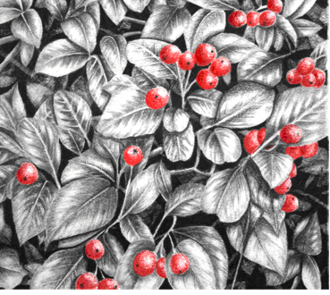

Hide from Animals
Abjuration
Level: Drd 1, Rgr 1
Components: S, DF
Casting Time: 1 standard action
Range: Touch
Targets: One creature touched/level
Duration: 10 min./level (D)
Saving Throw: Will negates (harmless)
Spell Resistance: Yes

Animals cannot see, hear, or smell the warded creatures. Even extraordinary or supernatural sensory capabilities, such as blindsense, blindsight, scent, and tremorsense, cannot detect or locate warded creatures. Animals simply act as though the warded creatures are not there. Warded creatures could stand before the hungriest of lions and not be molested or even noticed. If a warded character touches an animal or attacks any creature, even with a spell, the spell ends for all recipients.

Jump
Transmutation
Level: Drd 1, Rgr 1, Sor/Wiz 1
Components: V, S, M
Casting Time: 1 standard action
Range: Touch
Target: Creature touched
Duration: 1 min./level (D)
Saving Throw: Will negates (harmless)
Spell Resistance: Yes

The subject gets a +10 enhancement bonus on Jump checks. The enhancement bonus increases to +20 at caster level 5th, and to +30 (the maximum) at caster level 9th.
Material Component: A grasshopper’s hind leg, which you break when the spell is cast.

Longstrider
Transmutation
Level: Drd 1, Rgr 1, Travel 1
Components: V, S, M
Casting Time: 1 standard action
Range: Personal
Target: You
Duration: 1 hour/level (D)

This spell increases your base land speed by 10 feet. (This adjustment counts as an enhancement bonus.) It has no effect on other modes of movement, such as burrow, climb, fly, or swim.
Material Component: A pinch of dirt.

Magic Fang
Transmutation
Level: Drd 1, Rgr 1
Components: V, S, DF
Casting Time: 1 standard action
Range: Touch
Target: Living creature touched
Duration: 1 min./level
Saving Throw: Will negates (harmless)
Spell Resistance: Yes (harmless)

Magic fang gives one natural weapon of the subject a +1 enhancement bonus on attack and damage rolls. The spell can affect a slam attack, fist, bite, or other natural weapon. (The spell does not change an unarmed strike’s damage from nonlethal damage to lethal damage.)
Magic fang can be made permanent with a permanency spell.

Title Page
Class Features
Level Table
Animal Companions
Beah’s Feats

1st Level Druid Spells
0 Level Spells || 1st Level Spells
2nd Level Spells || 3rd Level Spells
4th Level Spells || 5th Level Spells
6th Level Spells || 7th Level Spells
8th Level Spells || 9th Level Spells

Magic Stone
Transmutation
Level: Clr 1, Drd 1, Earth 1
Components: V, S, DF
Casting Time: 1 standard action
Range: Touch
Targets: Up to three pebbles touched
Duration: 30 minutes or until discharged
Saving Throw: Will negates (harmless,
object)
Spell Resistance: Yes (harmless, object)



You transmute as many as three pebbles, which can be no larger than sling bullets, so that they strike with great force when thrown or slung. If hurled, they have a range increment of 20 feet. If slung, treat them as sling bullets (range increment 50 feet). The spell gives them a +1 enhancement bonus on attack and damage rolls. The user of the stones makes a normal ranged attack. Each stone that hits deals 1d6+1 points of damage (including the spell’s enhancement bonus), or 2d6+2 points against undead.

Obscuring Mist
Conjuration (Creation)
Level: Air 1, Clr 1, Drd 1, Sor/Wiz 1,
Water 1
Components: V, S
Casting Time: 1 standard action
Range: 20 ft.
Effect: Cloud spreads in 20-ft. radius from you, 20 ft. high
Duration: 1 min./level
Saving Throw: None
Spell Resistance: No

A misty vapor arises around you. It is stationary once created. The vapor obscures all sight, including darkvision, beyond 5 feet. A creature 5 feet away has concealment (attacks have a 20% miss chance). Creatures farther away have total concealment (50% miss chance, and the attacker cannot use sight to locate the target).
A moderate wind (11+ mph), such as from a gust of wind spell, disperses the fog in 4 rounds. A strong wind (21+ mph) disperses the fog in 1 round. A fireball, flame strike, or similar spell burns away the fog in the explosive or fiery spell’s area. A wall of fire burns away the fog in the area into which it deals damage.
This spell does not function underwater.

Pass without Trace
Transmutation
Level: Drd 1, Rgr 1
Components: V, S, DF
Casting Time: 1 standard action
Range: Touch
Targets: One creature/level touched
Duration: 1 hour/level (D)
Saving Throw: Will negates (harmless)
Spell Resistance: Yes (harmless)

The subject or subjects can move through any type of terrain—mud, snow, dust, or the like—and leave neither footprints nor scent. Tracking the subjects is impossible by nonmagical means.

Produce Flame
Evocation [Fire]
Level: Drd 1, Fire 2
Components: V, S
Casting Time: 1 standard action
Range: 0 ft.
Effect: Flame in your palm
Duration: 1 min./level (D)
Saving Throw: None
Spell Resistance: Yes

Flames as bright as a torch appear in your open hand. The flames harm neither you nor your equipment.
In addition to providing illumination, the flames can be hurled or used to touch enemies. You can strike an opponent with a melee touch attack, dealing fire damage equal to 1d6 +1 point per caster level (maximum +5). Alternatively, you can hurl the flames up to 120 feet as a thrown weapon. When doing so, you attack with a ranged touch attack (with no range penalty) and deal the same damage as with the melee attack. No sooner do you hurl the flames than a new set appears in your hand. Each attack you make reduces the remaining duration by 1 minute. If an attack reduces the remaining duration to 0 minutes or less, the spell ends after the attack resolves.
This spell does not function underwater.



Shillelagh
Transmutation
Level: Drd 1
Components: V, S, DF
Casting Time: 1 standard action
Range: Touch
Target: One touched nonmagical oak club or quarterstaff
Duration: 1 min./level
Saving Throw: Will negates (object)
Spell Resistance: Yes (object)

Your own nonmagical club or quarterstaff becomes a weapon with a +1 enhancement bonus on attack and damage rolls. (A quarterstaff gains this enhancement for both ends of the weapon.) It deals damage as if it were two size categories larger (a Small club or quarterstaff so transmuted deals 1d8 points of damage, a Medium 2d6, and a Large 3d6), +1 for its enhancement bonus. These effects only occur when the weapon is wielded by you. If you do not wield it, the weapon behaves as if unaffected by this spell.

Speak with Animals
Divination
Level: Brd 3, Drd 1, Rgr 1
Components: V, S
Casting Time: 1 standard action
Range: Personal
Target: You
Duration: 1 min./level

You can comprehend and communicate with animals. You are able to ask questions of and receive answers from animals, although the spell doesn’t make them any more friendly or cooperative than normal. Furthermore, wary and cunning animals are likely to be terse and evasive, while the more stupid ones make inane comments. If an animal is friendly toward you, it may do some favor or service for you (as determined by the DM).

Summon Nature’s Ally I
Conjuration (Summoning)
Level: Drd 1, Rgr 1
Components: V, S, DF
Casting Time: 1 round
Range: Close (25 ft. + 5 ft./2 levels)
Effect: One summoned creature
Duration: 1 round/level (D)
Saving Throw: None
Spell Resistance: No

This spell summons a natural creature. It appears where you designate and acts immediately, on your turn. It attacks your opponents to the best of its ability. If you can communicate with the creature, you can direct it not to attack, to attack particular enemies, or to perform other actions.
A summoned monster cannot summon or otherwise conjure another creature, nor can it use any teleportation or planar travel abilities. Creatures cannot be summoned into an environment that cannot support them. For instance, a porpoise may only be summoned in an aquatic environment.
The spell conjures one of the creatures from the 1st-level list on the accompanying Summon Nature’s Ally table. You choose which kind of creature to summon, and you can change that choice each time you cast the spell. All the creatures on the table are neutral unless otherwise noted.

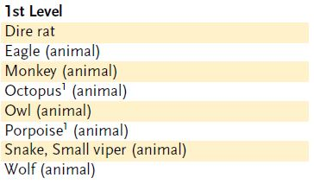
Title Page
Class Features
Level Table
Animal Companions
Beah’s Feats

1st Level Druid Spells
0 Level Spells || 1st Level Spells
2nd Level Spells || 3rd Level Spells
4th Level Spells || 5th Level Spells
6th Level Spells || 7th Level Spells
8th Level Spells || 9th Level Spells

Title Page
Class Features
Level Table
Animal Companions
Beah’s Feats

2nd Level Druid Spells
0 Level Spells || 1st Level Spells
2nd Level Spells || 3rd Level Spells
4th Level Spells || 5th Level Spells
6th Level Spells || 7th Level Spells
8th Level Spells || 9th Level Spells

2nd-LEVEL DRUID SPELLS

Animal Messenger: Sends a Tiny animal to a specific place.
Animal Trance: Fascinates 2d6 HD of animals.
Barkskin: Grants +2 (or higher) enhancement to natural armor.
Bear’s Endurance: Subject gains +4 to Con for 1 min./level.
Bull’s Strength: Subject gains +4 to Str for 1 min./level.
Cat’s Grace: Subject gains +4 to Dex for 1 min./level.
Chill Metal: Cold metal damages those who touch it.
Delay Poison: Stops poison from harming subject for 1 hour/level.
Fire Trap^{M}: Opened object deals 1d4 +1/level damage.
Flame Blade: Touch attack deals 1d8 +1/two levels damage.
Flaming Sphere: Creates rolling ball of fire, 2d6 damage, lasts 1 round/level.
Fog Cloud: Fog obscures vision.
Gust of Wind: Blows away or knocks down smaller creatures.
Heat Metal: Make metal so hot it damages those who touch it.
Hold Animal: Paralyzes one animal for 1 round/level.
Owl’s Wisdom: Subject gains +4 to Wis for 1 min./level.
Reduce Animal: Shrinks one willing animal.
Resist Energy: Ignores 10 (or more) points of damage/attack from specified energy type.
Restoration, Lesser: Dispels magical ability penalty or repairs 1d4 ability damage.
Soften Earth and Stone: Turns stone to clay or dirt to sand or mud.
Spider Climb: Grants ability to walk on walls and ceilings.
Summon Nature’s Ally II: Calls creature to fight.
Summon Swarm: Summons swarm of bats, rats, or spiders.
Tree Shape: You look exactly like a tree for 1 hour/level.
Warp Wood: Bends wood (shaft, handle, door, plank).
Wood Shape: Rearranges wooden objects to suit you.



Animal Messenger
Enchantment (Compulsion) [Mind-
Affecting]
Level: Brd 2, Drd 2, Rgr 1
Components: V, S, M
Casting Time: 1 standard action
Range: Close (25 ft. + 5 ft./2 levels)
Target: One Tiny animal
Duration: One day/level
Saving Throw: None; see text
Spell Resistance: Yes

You compel a Tiny animal to go to a spot you designate. The most common use for this spell is to get an animal to carry a message to your allies. The animal cannot be one tamed or trained by someone else, including such creatures as familiars and animal companions.
Using some type of food desirable to the animal as a lure, you call the animal to you. It advances and awaits your bidding. You can mentally impress on the animal a certain place well known to you or an obvious landmark (such as the peak of a distant mountain). The directions must be simple, because the animal depends on your knowledge and can’t find a destination on its own. You can attach some small item or note to the messenger. The animal then goes to the designated location and waits there until the duration of the spell expires, whereupon it resumes its normal activities.
During this period of waiting, the messenger allows others to approach it and remove any scroll or token it carries. Unless the intended recipient of a message is expecting a messenger in the form of a bird or other small animal, the carrier may be ignored. The intended recipient gains no special ability to communicate with the animal or read any attached message (if it’s written in a language he or she doesn’t know, for example).
Material Component: A morsel of food the animal likes.

Animal Trance
Enchantment (Compulsion) [Mind-
Affecting, Sonic]
Level: Brd 2, Drd 2
Components: V, S
Casting Time: 1 standard action
Range: Close (25 ft. + 5 ft./2 levels)
Targets: Animals or magical beasts with Intelligence 1 or 2
Duration: Concentration
Saving Throw: Will negates; see text
Spell Resistance: Yes



Your swaying motions and music (or singing, or chanting) compel animals and magical beasts to do nothing but watch you. Only a creature with an Intelligence score of 1 or 2 can be fascinated by this spell. Roll 2d6 to determine the total number of HD worth of creatures that you fascinate. The closest targets are selected first until no more targets within range can be affected. For example, if Vadania affects 7 HD worth of animals and there are several 2 HD wolves within close range, only the three closest wolves are affected.
A magical beast, a dire animal, or an animal trained to attack or guard is allowed a saving throw; an animal not trained to attack or guard is not.

Barkskin
Transmutation
Level: Drd 2, Rgr 2, Plant 2
Components: V, S, DF
Casting Time: 1 standard action
Range: Touch
Target: Living creature touched
Duration: 10 min./level
Saving Throw: None
Spell Resistance: Yes (harmless)

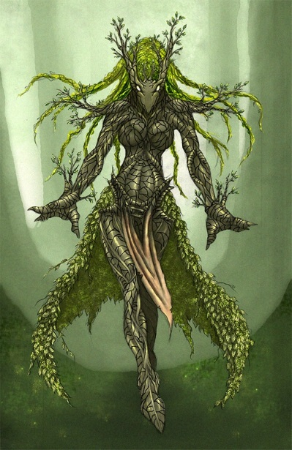

Barkskin toughens a creature’s skin. The effect grants a +2 enhancement bonus to the creature’s existing natural armor bonus. This enhancement bonus increases by 1 for every three caster levels above 3rd, to a maximum of +5 at caster level 12th.
The enhancement bonus provided by barkskin stacks with the target’s natural armor bonus, but not with other enhancement bonuses to natural armor. A creature without natural armor has an effective natural armor bonus of +0, much as a character wearing only normal clothing has an armor bonus of +0.

Bear’s Endurance
Transmutation
Level: Clr 2, Drd 2, Rgr 2, Sor/Wiz 2
Components: V, S, DF
Casting Time: 1 standard action
Range: Touch
Target: Creature touched
Duration: 1 min./level
Saving Throw: Will negates (harmless)
Spell Resistance: Yes

The affected creature gains greater vitality and stamina. The spell grants the subject a +4 enhancement bonus to Constitution, which adds the usual benefits to hit points, Fortitude saves, Constitution checks, and so forth.
Hit points gained by a temporary increase in Constitution score are not temporary hit points. They go away when the subject’s Constitution drops back to normal. They are not lost first as temporary hit points are (see page 146).

Bull’s Strength
Transmutation
Level: Clr 2, Drd 2, Pal 2, Sor/Wiz 2,
Strength 2
Components: V, S, M/DF
Casting Time: 1 standard action
Range: Touch
Target: Creature touched
Duration: 1 min./level
Saving Throw: Will negates (harmless)
Spell Resistance: Yes (harmless)

The subject becomes stronger. The spell grants a +4 enhancement bonus to Strength, adding the usual benefits to melee attack rolls, melee damage rolls, and other uses of the Strength modifier.
Arcane Material Component: A few hairs, or a pinch of dung, from a bull.

Title Page
Class Features
Level Table
Animal Companions
Beah’s Feats

2nd Level Druid Spells
0 Level Spells || 1st Level Spells
2nd Level Spells || 3rd Level Spells
4th Level Spells || 5th Level Spells
6th Level Spells || 7th Level Spells
8th Level Spells || 9th Level Spells



Cat’s Grace
Transmutation
Level: Brd 2, Drd 2, Rgr 2, Sor/Wiz 2
Components: V, S, M
Casting Time: 1 standard action
Range: Touch
Target: Creature touched
Duration: 1 min./level
Saving Throw: Will negates (harmless)
Spell Resistance: Yes

The transmuted creature becomes more graceful, agile, and coordinated. The spell grants a +4 enhancement bonus to Dexterity, adding the usual benefits to AC, Reflex saves, and (Cat’s Grace cont.) other uses of the Dexterity modifier.
Material Component: A pinch of cat fur.

Chill Metal
Transmutation [Cold]
Level: Drd 2
Components: V, S, DF
Casting Time: 1 standard action
Range: Close (25 ft. + 5 ft./2 levels)
Target: Metal equipment of one creature per two levels, no two of which can be more than 30 ft. apart; or 25 lb. of metal/level, none of which can be more than 30 ft. away from any of the rest
Duration: 7 rounds
Saving Throw: Will negates (object)
Spell Resistance: Yes (object)

Chill metal makes metal extremely cold. Unattended, nonmagical metal gets no saving throw. Magical metal is allowed a saving throw against the spell (Magic item’s saving throws are covered in the Dungeon Master’s Guide.) An item in a creature’s possession uses the creature’s saving throw bonus unless its own is higher.
A creature takes cold damage if its equipment is chilled. It takes full damage if its armor is affected or if it is holding, touching, wearing, or carrying metal weighing one-fifth of its weight. The creature takes minimum damage (1 point or 2 points; see the table) if it’s not wearing metal armor and the metal that it’s carrying weighs less than one-fifth of its weight.
On the first round of the spell, the metal becomes chilly and uncomfortable to touch but deals no damage. The same effect also occurs on the last round of the spell’s duration. During the second (and also the next-to-last) round, icy coldness causes pain and damage. In the third, fourth, and fifth rounds, the metal is freezing cold, causing more damage, as shown on the table below.

(Chill Metal cont.)

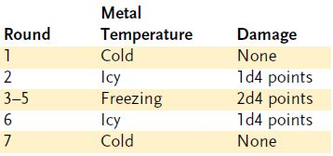

Any heat intense enough to damage the creature negates cold damage from the spell (and vice versa) on a point-for-point basis. For example, if the damage roll from a chill metal spell indicates 5 points of cold damage and the subject plunges through a wall of fire in the same round and takes 8 points of fire damage, it winds up taking no cold damage and only 3 points of fire damage. Underwater, chill metal deals no damage, but ice immediately forms around the affected metal, making it more buoyant.
Chill metal counters and dispels heat metal.

Delay Poison
Conjuration (Healing)
Level: Brd 2, Clr 2, Drd 2, Pal 2, Rgr 1
Components: V, S, DF
Casting Time: 1 standard action
Range: Touch
Target: Creature touched
Duration: 1 hour/level
Saving Throw: Fortitude negates
(harmless)
Spell Resistance: Yes (harmless)

The subject becomes temporarily immune to poison. Any poison in its system or any poison to which it is exposed during the spell’s duration does not affect the subject until the spell’s duration has expired. Delay poison does not cure any damage that poison may have already done.

Fire Trap
Abjuration [Fire]
Level: Drd 2, Sor/Wiz 4
Components: V, S, M
Casting Time: 10 minutes
Range: Touch
Target: Object touched
Duration: Permanent until discharged (D)
Saving Throw: Reflex half; see text
Spell Resistance: Yes

Fire trap creates a fiery explosion when an intruder opens the item that the trap protects. A fire trap can ward any object that can be opened and closed (book, box, bottle, chest, coffer, coffin, door, drawer, and so forth).
When casting fire trap, you select a point on the object as the spell’s center. When someone other than you opens the object, a fiery explosion fills the area within a 5-foot radius around the spell’s center. The flames deal 1d4 points of fire damage +1 point per caster level (maximum +20). The item protected by the trap is not harmed by this explosion.
A fire trapped item cannot have a second closure or warding spell placed on it.
A knock spell does not bypass a fire trap. An unsuccessful dispel magic spell does not detonate the spell.
Underwater, this ward deals half damage and creates a large cloud of steam. You can use the fire trapped object without discharging it, as can any individual to whom the object was specifically attuned when cast. Attuning a fire trapped object to an individual usually involves setting a password that you can share with friends.
Note: Magic traps such as fire trap are hard to detect and disable. A rogue (only) can use the Search skill to find a fire trap and Disable Device to thwart it. The DC in each case is 25 + spell level (DC 27 for a druid’s fire trap or DC 29 for the arcane version).
Material Component: A half-pound of gold dust (cost 25 gp) sprinkled on the warded object.



Title Page
Class Features
Level Table
Animal Companions
Beah’s Feats

2nd Level Druid Spells
0 Level Spells || 1st Level Spells
2nd Level Spells || 3rd Level Spells
4th Level Spells || 5th Level Spells
6th Level Spells || 7th Level Spells
8th Level Spells || 9th Level Spells

Flame Blade
Evocation [Fire]
Level: Drd 2
Components: V, S, DF
Casting Time: 1 standard action
Range: 0 ft.
Effect: Sword-like beam
Duration: 1 min./level (D)
Saving Throw: None
Spell Resistance: Yes

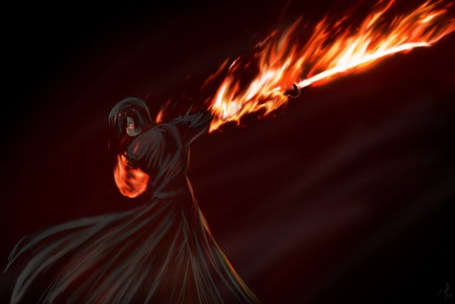

A 3-foot-long, blazing beam of red-hot fire springs forth from your hand. You wield this bladelike beam as if it were a scimitar. Attacks with the flame blade are melee touch attacks. The blade deals 1d8 points of fire (Flame Blade cont.) damage +1 point per two caster levels (maximum +10). Since the blade is immaterial, your Strength modifier does not apply to the damage. A flame blade can ignite combustible materials such as parchment, straw, dry sticks, and cloth.
The spell does not function underwater.

Flaming Sphere
Evocation [Fire]
Level: Drd 2, Sor/Wiz 2
Components: V, S, M/DF
Casting Time: 1 standard action
Range: Medium (100 ft. + 10 ft./level)
Effect: 5-ft.-diameter sphere
Duration: 1 round/level
Saving Throw: Reflex negates
Spell Resistance: Yes

A burning globe of fire rolls in whichever direction you point and burns those it strikes. It moves 30 feet per round. As part of this movement, it can ascend or jump up to 30 feet to strike a target. If it enters a space with a creature, it stops moving for the round and deals 2d6 points of fire damage to that creature, though a successful Reflex save negates that damage. A flaming sphere rolls over barriers less than 4 feet tall, such as furniture and low walls. It ignites flammable substances it touches and illuminates the same area as a torch would.
The sphere moves as long as you actively direct it (a move action for

(Flaming Sphere cont.)
you); otherwise, it merely stays at rest and burns. It can be extinguished by any means that would put out a normal fire of its size. The surface of the sphere has a spongy, yielding consistency and so does not cause damage except by its flame. It cannot push aside unwilling creatures or batter down large obstacles. A flaming sphere winks out if it exceeds the spell’s range.
Arcane Material Component: A bit of tallow, a pinch of brimstone, and a dusting of powdered iron.



Fog Cloud
Conjuration (Creation)
Level: Drd 2, Sor/Wiz 2, Water 2
Components: V, S
Casting Time: 1 standard action
Range: Medium (100 ft. + 10 ft. level)
Effect: Fog spreads in 20-ft. radius, 20 ft. high
Duration: 10 min./level
Saving Throw: None
Spell Resistance: No

A bank of fog billows out from the point you designate. The fog obscures all sight, including darkvision, beyond 5 feet. A creature within 5 feet has concealment (attacks have a 20% miss chance). Creatures farther away have total concealment (50% miss chance, and the attacker can’t use sight to locate the target).
A moderate wind (11+ mph) disperses the fog in 4 rounds; a strong wind (21+ mph) disperses the fog in 1 round.
The spell does not function underwater.

Gust of Wind
Evocation [Air]
Level: Drd 2, Sor/Wiz 2
Components: V, S
Casting Time: 1 standard action
Range: 60 ft.
Effect: Line-shaped gust of severe wind emanating out from you to the extreme of the range
Duration: 1 round
Saving Throw: Fortitude negates
Spell Resistance: Yes

This spell creates a severe blast of air (approximately 50 mph) that originates from you, affecting all creatures in its path.
A Tiny or smaller creature on the ground is knocked down and rolled 1d4×10 feet, taking 1d4 points of nonlethal damage per 10 feet. If flying, a Tiny or smaller creature is blown back 2d6×10 feet and takes 2d6 points of nonlethal damage due to battering and buffeting.
Small creatures are knocked prone by the force of the wind, or if flying are blown back 1d6×10 feet.
Medium creatures are unable to move forward against the force of the wind, or if flying are blown back 1d6×5 feet.
Large or larger creatures may move normally within a gust of wind effect.
A gust of wind can’t move a creature beyond the limit of its range.
Any creature, regardless of size, takes a – 4 penalty on ranged attacks and Listen checks in the area of a gust of wind. The force of the gust automatically extinguishes candles, torches, and similar unprotected flames. It causes protected flames, such as those of lanterns, to dance wildly and has a 50% chance to extinguish those lights.
In addition to the effects noted, a gust of wind can do anything that a sudden blast of wind would be expected to do. It can create a stinging spray of sand or dust, fan a large fire, overturn delicate awnings or hangings, heel over a small boat, and blow gases or vapors to the edge of its range.
Gust of wind can be made permanent with a permanency spell.

Title Page
Class Features
Level Table
Animal Companions
Beah’s Feats

2nd Level Druid Spells
0 Level Spells || 1st Level Spells
2nd Level Spells || 3rd Level Spells
4th Level Spells || 5th Level Spells
6th Level Spells || 7th Level Spells
8th Level Spells || 9th Level Spells

Heat Metal
Transmutation [Fire]
Level: Drd 2, Sun 2
Components: V, S, DF
Casting Time: 1 standard action
Range: Close (25 ft. + 5 ft./2 levels)
Target: Metal equipment of one creature per two levels, no two of which can be more than 30 ft. apart; or 25 lb. of metal/level, all of which must be within a 30-ft. circle
Duration: 7 rounds
Saving Throw: Will negates (object)
Spell Resistance: Yes (object)

Heat metal makes metal extremely warm. Unattended, nonmagical metal gets no saving throw. Magical metal is allowed a saving throw against the spell. (Magic item’s saving throws are covered in the Dungeon Master’s Guide.) An item in a creature’s possession uses the creature’s saving throw bonus unless its own is higher.
A creature takes fire damage if its equipment is heated. It takes full damage if its armor is affected or if it is holding, touching, wearing, or carrying metal weighing one-fifth of its weight. The creature takes minimum damage (1 point or 2 points; see the table) if it’s not wearing metal armor and the metal that it’s carrying weighs less than one-fifth of its weight.



On the first round of the spell, the metal becomes warm and uncomfortable to touch but deals no damage. The same effect also occurs on the last round of the spell’s duration. During the second (and also the next-to-last) round, intense heat causes pain and damage. In the third, fourth, and fifth rounds, the metal is searing hot, causing more damage, as shown on the table below.

(Heat Metal cont.)

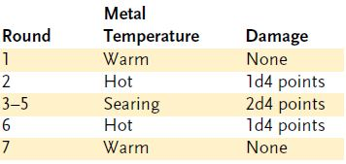

Any cold intense enough to damage the creature negates fire damage from the spell (and vice versa) on a point-for-point basis. For example, if the damage roll from a heat metal spell indicates 2 points of fire (Heat Metal cont.) damage and the subject is hit by a ray of frost in the same round and takes 3 points of cold damage, it winds up taking no fire damage and only 1 point of cold damage. If cast underwater, heat metal deals half damage and boils the surrounding water.
Heat metal counters and dispels chill metal.

Hold Animal
Enchantment (Compulsion) [Mind-
Affecting]
Level: Animal 2, Drd 2, Rgr 2
Components: V, S
Target: One animal

This spell functions like *hold person, except that it affects an animal instead of a humanoid.

*Hold Person
Enchantment (Compulsion) [Mind-
Affecting]
Level: Brd 2, Clr 2, Sor/Wiz 3
Components: V, S, F/DF
Casting Time: 1 standard action
Range: Medium (100 ft. + 10 ft./level)
Target: One humanoid creature
Duration: 1 round/level (D); see text
Saving Throw: Will negates; see text
Spell Resistance: Yes

The subject becomes paralyzed and freezes in place. It is aware and breathes normally but cannot take any actions, even speech. Each round on its turn, the subject may attempt a new saving throw to end the effect. (This is a full-round action that does not provoke attacks of opportunity.)
A winged creature who is paralyzed cannot flap its wings and falls. A swimmer can’t swim and may drown.
Arcane Focus: A small, straight piece of iron.

Owl’s Wisdom
Transmutation
Level: Clr 2, Drd 2, Pal 2, Rgr 2, Sor/Wiz 2
Components: V, S, M/DF
Casting Time: 1 standard action
Range: Touch
Target: Creature touched
Duration: 1 min./level
Saving Throw: Will negates (harmless)
Spell Resistance: Yes

The transmuted creature becomes wiser. The spell grants a +4 enhancement bonus to Wisdom, adding the usual benefit to Wisdom-related skills. Clerics, druids, paladins, and rangers (and other Wisdombased spellcasters) who receive owl’s wisdom do not gain any additional bonus spells for the increased Wisdom, but the save DCs for their spells increase.
Arcane Material Component: A few feathers, or a pinch of droppings, from an owl.

Reduce Animal
Transmutation
Level: Drd 2, Rgr 3
Components: V, S
Casting Time: 1 standard action
Range: Touch
Target: One willing animal of Small,
Medium, Large, or Huge size
Duration: 1 hour/level (D)
Saving Throw: None
Spell Resistance: No

This spell functions like reduce person, except that it affects a single willing animal (not one with which you are engaged in combat, for instance). This decrease in size allows the animal to fit better into tight spaces, such as the typical dungeon room or subterranean passage. Reduce the damage dealt by the animal’s natural attacks as shown on Table 2–3 in the Dungeon Master’s Guide.

Resist Energy
Abjuration
Level: Clr 2, Drd 2, Fire 3, Pal 2, Rgr 1, Sor/Wiz 2
Components: V, S, DF
Casting Time: 1 standard action
Range: Touch
Target: Creature touched
Duration: 10 min./level
Saving Throw: Fortitude negates (harmless)
Spell Resistance: Yes (harmless)

This abjuration grants a creature limited protection from damage of whichever one of five energy types you select: acid, cold, electricity, fire, or sonic. The subject gains energy resistance 10 against the energy type chosen, meaning that each time the creature is subjected to such damage (whether from a natural or magical source), that damage is reduced by 10 points before being applied to the creature’s hit points. The value of the energy resistance granted increases to 20 points at 7th level and to a maximum of 30 points at 11th level. The spell protects the recipient’s equipment as well.
Resist energy absorbs only damage. The subject could still suffer unfortunate side effects, such as drowning in acid (since drowning damage comes from lack of oxygen) or becoming encased in ice.
Note: Resist energy overlaps (and does not stack with) protection from energy. If a character is warded by protection from energy and resist energy, the protection spell absorbs damage until its power is exhausted.

Restoration, Lesser
Conjuration (Healing)
Level: Clr 2, Drd 2, Pal 1
Components: V, S
Casting Time: 3 rounds
Range: Touch
Target: Creature touched
Duration: Instantaneous
Saving Throw: Will negates (harmless)
Spell Resistance: Yes (harmless)

Lesser restoration dispels any magical effects reducing one of the subject’s ability scores (such as ray of enfeeblement) or cures 1d4 points of temporary ability damage to one of the subject’s ability scores (such as from a shadow’s touch or from poison). It also eliminates any fatigue suffered by the character, and improves an exhausted condition to fatigued. It does not restore permanent ability drain.

Title Page
Class Features
Level Table
Animal Companions
Beah’s Feats

2nd Level Druid Spells
0 Level Spells || 1st Level Spells
2nd Level Spells || 3rd Level Spells
4th Level Spells || 5th Level Spells
6th Level Spells || 7th Level Spells
8th Level Spells || 9th Level Spells

Soften Earth and Stone
Transmutation [Earth]
Level: Drd 2, Earth 2
Components: V, S, DF
Casting Time: 1 standard action
Range: Close (25 ft. + 5 ft./2 levels)
Area: 10-ft. square/level; see text
Duration: Instantaneous
Saving Throw: None
Spell Resistance: No

When this spell is cast, all natural, undressed earth or stone in the spell’s area is softened. Wet earth becomes thick mud, dry earth becomes loose sand or dirt, and stone becomes soft clay that is easily molded or chopped. You affect a 10-footsquare area to a depth of 1 to 4 feet, depending on the (Soften Earth and Stone cont.) toughness or resilience of the ground at that spot (DM’s option). Magical, enchanted, dressed, or worked stone cannot be affected. Earth or stone creatures are not affected.
A creature in mud must succeed on a Reflex save or be caught for 1d2 rounds and unable to move, attack, or cast spells. A creature that succeeds on its save can move through the mud at half speed, and it can’t run or charge.
Loose dirt is not as troublesome as mud, but all creatures in the area can move at only half their normal speed and can’t run or charge over the surface.
Stone softened into clay does not hinder movement, but it does allow characters to cut, shape, or excavate areas they may not have been able to affect before. For example, a party of adventurers trying to break out of a cavern might use this spell to soften a wall. While soften earth and stone does not affect dressed or worked stone, cavern ceilings or vertical surfaces such as cliff faces can be affected. Usually, this causes a moderate collapse or landslide as the loosened material peels away from the face of the wall or roof and falls.
A moderate amount of structural damage can be dealt to a manufactured structure (such as a wall or a tower) by softening the ground beneath it, causing it to settle. However, most well-built structures will only be damaged by this spell, not destroyed.

Spider Climb
Transmutation
Level: Drd 2, Sor/Wiz 2
Components: V, S, M
Casting Time: 1 standard action
Range: Touch
Target: Creature touched
Duration: 10 min./level
Saving Throw: Will negates (harmless)
Spell Resistance: Yes (harmless)

The subject can climb and travel on vertical surfaces or even traverse ceilings as well as a spider does. The affected creature must have its hands free to climb in this manner. The subject gains a climb speed of 20 feet; furthermore, it need not make Climb checks to traverse a vertical or horizontal surface (even upside down). A spider climbing creature retains its Dexterity bonus to Armor Class (if any) while climbing, and opponents get no special bonus to their attacks against it. It cannot, however, use the run action while climbing.
Material Component: A drop of bitumen and a live spider, both of which must be eaten by the subject.

Summon Nature’s Ally II
Conjuration (Summoning)
Level: Drd 2, Rgr 2
Effect: One or more creatures, no two of which can be more than 30 ft. apart

This spell functions like *summon nature’s ally I, except that you can summon one 2nd-level creature or 1d3 1st-level creatures of the same kind.

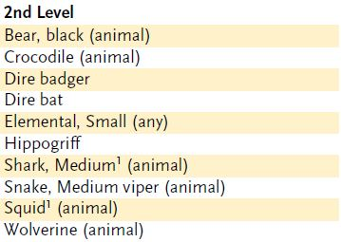

*Summon Nature’s Ally I
Conjuration (Summoning)
Level: Drd 1, Rgr 1
Components: V, S, DF
Casting Time: 1 round
Range: Close (25 ft. + 5 ft./2 levels)
Effect: One summoned creature
Duration: 1 round/level (D)
Saving Throw: None
Spell Resistance: No

This spell summons a natural creature. It appears where you designate and acts immediately, on your turn. It attacks your opponents to the best of its ability. If you can communicate with the creature, you can direct it not to attack, to attack particular enemies, or to perform other actions.
A summoned monster cannot summon or otherwise conjure another creature, nor can it use any teleportation or planar travel abilities. Creatures cannot be summoned into an environment that cannot support them. For instance, a porpoise may only be summoned in an aquatic environment.
The spell conjures one of the creatures from the 1st-level list on the accompanying Summon Nature’s Ally table. You choose which kind of creature to summon, and you can change that choice each time you cast the spell. All the creatures on the table are neutral unless otherwise noted.

Summon Swarm
Conjuration (Summoning)
Level: Brd 2, Drd 2, Sor/Wiz 2
Components: V, S, M/DF
Casting Time: 1 round
Range: Close (25 ft. + 5 ft./2 levels)
Effect: One swarm of bats, rats, or
spiders
Duration: Concentration + 2 rounds
Saving Throw: None
Spell Resistance: No

You summon a swarm of bats, rats, or spiders (your choice), which attacks all other creatures within its area. (You may summon the swarm so that it shares the area of other creatures.) If no living creatures are within its area, the swarm attacks or pursues the nearest creature as best it can. The caster has no control over its target or direction of travel.
See the Monster Manual for details of bat, rat, and spider swarms.
Arcane Material Component: A square of red cloth.

Title Page
Class Features
Level Table
Animal Companions
Beah’s Feats

2nd Level Druid Spells
0 Level Spells || 1st Level Spells
2nd Level Spells || 3rd Level Spells
4th Level Spells || 5th Level Spells
6th Level Spells || 7th Level Spells
8th Level Spells || 9th Level Spells

Tree Shape
Transmutation
Level: Drd 2, Rgr 3
Components: V, S, DF
Casting Time: 1 standard action
Range: Personal
Target: You
Duration: 1 hour/level (D)

(Tree Shape cont.)

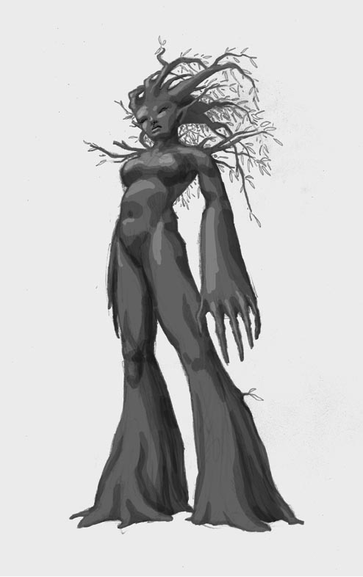

By means of this spell, you are able to assume the form of a Large living tree or shrub or a Large dead tree trunk with a small number of limbs. The closest inspection cannot reveal that the tree in question is actually a magically concealed creature. To all normal tests you are, in fact, a tree or shrub, although a detect magic spell reveals a faint transmutation on the tree. While in tree form, you can observe all that transpires around you just as if you were in your normal form, and your hit points and save bonuses remain (Tree Shape cont.) unaffected. You gain a +10 natural armor bonus to AC but have an effective Dexterity score of 0 and a speed of 0 feet. You are immune to critical hits while in tree form. All clothing and gear carried or worn changes with you.
You can dismiss tree shape as a free action (instead of as a standard action).

Warp Wood
Transmutation
Level: Drd 2
Components: V, S
Casting Time: 1 standard action
Range: Close (25 ft. + 5 ft./2 levels)
Target: 1 Small wooden object/level, all within a 20-ft. radius
Duration: Instantaneous
Saving Throw: Will negates (object)
Spell Resistance: Yes (object)

You cause wood to bend and warp, permanently destroying its straightness, form, and strength. A warped door springs open (or becomes stuck, requiring a Strength check to open, at your option). A boat or ship springs a leak. Warped ranged weapons are useless. A warped melee weapon causes a –4 penalty on attack rolls.
You may warp one Small or smaller object (such as a wagon wheel or a human’s crossbow) or its equivalent per caster level. A Medium object (such as an oar or a human’s spear) counts as two Small objects, a Large object (such as a rowboat or a hill giant’s greatclub) as four, a Huge object (such as a wagon or a cloud giant’s morningstar) as eight, a Gargantuan object (such as a keelboat) as sixteen, and a Colossal object (such as a sailing ship) as thirty-two.
Alternatively, you can unwarp wood (effectively warping it back to normal) with this spell, straightening wood that has been warped by this spell or by other means. Make whole, on the other hand, does no good in repairing a warped item.
You can combine multiple consecutive warp wood spells to warp (or unwarp) an object that is too large for you to warp with a single spell.
Until the object is completely warped, it suffers no ill effects.

Wood Shape
Transmutation
Level: Drd 2
Components: V, S, DF
Casting Time: 1 standard action
Range: Touch
Target: One touched piece of wood no larger than 10 cu. ft. + 1 cu. ft./level
Duration: Instantaneous
Saving Throw: Will negates (object)
Spell Resistance: Yes (object)

Wood shape enables you to form one existing piece of wood into any shape that suits your purpose. For example, you can make a wooden weapon, fashion a special trapdoor, or sculpt a crude idol. This spell also permits you to reshape a wood door to make an exit where one didn’t exist or to seal a door shut. While it is possible to make crude coffers, doors, and so forth, fine detail isn’t possible. There is a 30% chance that any shape that includes moving parts simply doesn’t work.

Title Page
Class Features
Level Table
Animal Companions
Beah’s Feats

3rd Level Druid Spells
0 Level Spells || 1st Level Spells
2nd Level Spells || 3rd Level Spells
4th Level Spells || 5th Level Spells
6th Level Spells || 7th Level Spells
8th Level Spells || 9th Level Spells

3rd-LEVEL DRUID SPELLS

Call Lightning: Calls down lightning bolts (3d6 per bolt) from sky.
Contagion: Infects subject with chosen disease.
Cure Moderate Wounds: Cures 2d8 damage +1/level (max +10).
Daylight: 60-ft. radius of bright light.
Diminish Plants: Reduces size or blights growth of normal plants.
Dominate Animal: Subject animal obeys silent mental commands.
Magic Fang. Greater: One natural weapon of subject creature gets +1/three levels on attack and damage rolls (max +5).
Meld into Stone: You and your gear merge with stone.
Neutralize Poison: Immunizes subject against poison, detoxifies venom in or on subject.
Plant Growth: Grows vegetation, improves crops.
Poison: Touch deals 1d10 Con damage, repeats in 1 min.
Protection from Energy: Absorbs 12 points/level of damage from one kind of energy.
Quench: Extinguishes nonmagical fires or one magic item.
Remove Disease: Cures all diseases affecting subject.
Sleet Storm: Hampers vision and movement.
Snare: Creates a magic booby trap.
Speak with Plants: You can talk to normal plants and plant creatures.
Spike Growth: Creatures in area take 1d4 damage, may be slowed.
Stone Shape: Sculpts stone into any shape.
Summon Nature’s Ally III: Calls creature to fight.
Water Breathing: Subjects can breathe underwater.
Wind Wall: Deflects arrows, smaller creatures, and gases.

Call Lightning
Evocation [Electricity]
Level: Drd 3
Components: V, S
Casting Time: 1 round
Range: Medium (100 ft. + 10 ft./level)
Effect: One or more 30-ft.-long vertical lines of lightning
Duration: 1 min./level
Saving Throw: Reflex half
Spell Resistance: Yes

Immediately upon completion of the spell, and once per round thereafter, you may call down a 5-foot-wide, 30-foot-long, vertical bolt of lightning that deals 3d6 points of electricity damage. The bolt of lightning flashes down in a vertical stroke at whatever target point you choose within the spell’s range (measured from your position at the time). Any creature in the target square or in the path of the bolt is affected.
You need not call a bolt of lightning immediately; other actions, even spellcasting, can be performed. However, each round after the first you may use a standard action (concentrating on the spell) to call a bolt. You may call a total number of bolts equal to your caster level (maximum 10 bolts).
If you are outdoors and in a stormy area—a rain shower, clouds and wind, hot and cloudy conditions, or even a tornado (including a whirlwind formed by a djinni or an air elemental of at least Large size; see the Monster Manual)—each bolt deals 3d10 points of electricity damage instead of 3d6.
This spell functions indoors or underground but not underwater.

Contagion
Necromancy [Evil]
Level: Clr 3, Destruction 3, Drd 3,
Sor/Wiz 4
Components: V, S
Casting Time: 1 standard action
Range: Touch
Target: Living creature touched
Duration: Instantaneous
Saving Throw: Fortitude negates
Spell Resistance: Yes

The subject contracts a disease selected from the table below, which strikes immediately (no incubation period). The DC noted is for the subsequent saves (use contagion’s normal save DC for the initial saving throw).

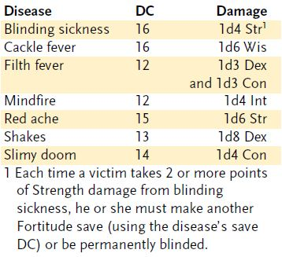

See the Dungeon Master’s Guide for descriptions of each disease, as well as for the general effects of disease.

Cure Moderate Wounds
Conjuration (Healing)
Level: Brd 2, Clr 2, Drd 3, Healing 2, Pal 3, Rgr 3

This spell functions like *cure light wounds, except that it cures 2d8 points of damage +1 point per caster level (maximum +10).

*Cure Light Wounds
Conjuration (Healing)
Level: Brd 1, Clr 1, Drd 1, Healing 1, Pal 1, Rgr 2
Components: V, S
Casting Time: 1 standard action
Range: Touch
Target: Creature touched
Duration: Instantaneous
Saving Throw: Will half (harmless); see text
Spell Resistance: Yes (harmless); see text

When laying your hand upon a living creature, you channel positive energy that cures 1d8 points of damage +1 point per caster level (maximum +5).
Since undead are powered by negative energy, this spell deals damage to them instead of curing their wounds. An undead creature can apply spell resistance, and can attempt a Will save to take half damage.

Daylight
Evocation [Light]
Level: Brd 3, Clr 3, Drd 3, Pal 3, Sor/Wiz 3
Components: V, S
Casting Time: 1 standard action
Range: Touch
Target: Object touched
Duration: 10 min./level (D)
Saving Throw: None
Spell Resistance: No

The object touched sheds light as bright as full daylight in a 60-foot radius, and dim light for an additional 60 feet beyond that. Creatures that take penalties in bright light also take them while within the radius of this magical light. Despite its name, this spell is not the equivalent of daylight for the purposes of creatures that are damaged or destroyed by bright light (such as vampires). If daylight is cast on a small object that is then placed inside or under a light-proof covering, the spell’s effects are blocked until the covering is removed.
Daylight brought into an area of magical darkness (or vice versa) is temporarily negated, so that the otherwise prevailing light conditions exist in the overlapping areas of effect.
Daylight counters or dispels any darkness spell of equal or lower level, such as darkness.

Title Page
Class Features
Level Table
Animal Companions
Beah’s Feats

Druid Spells
0 Level Spells || 1st Level Spells
2nd Level Spells || 3rd Level Spells
4th Level Spells || 5th Level Spells
6th Level Spells || 7th Level Spells
8th Level Spells || 9th Level Spells

Diminish Plants
Transmutation
Level: Drd 3, Rgr 3
Components: V, S, DF
Casting Time: 1 standard action
Range: See text
Target or Area: See text
Duration: Instantaneous
Saving Throw: None
Spell Resistance: No

This spell has two versions.
Prune Growth: This version causes normal vegetation (grasses, briars, bushes, creepers, hedges, thistles, trees, vines, and so forth) within long range (400 feet + 40 feet per level) to shrink to about one-third of their normal size, becoming untangled and less bushy. The affected vegetation appears to have been carefully pruned and trimmed.
(Diminish Plants cont.) At your option, the area can be a 100-foot-radius circle, a 150-foot-radius semicircle, or a 200-foot-radius quarter-circle. You may also designate (Diminish Plants cont.) portions of the area that are not affected.
Stunt Growth: This version targets normal plants within a range of 1/2 mile, reducing their potential productivity over the course of the following year to onethird below normal.
Diminish plants counters plant growth. This spell has no effect on plant creatures.

Dominate Animal
Enchantment (Compulsion) [Mind-
Affecting]
Level: Animal 3, Drd 3
Components: V, S
Casting Time: 1 round
Range: Close (25 ft. + 5 ft./2 levels)
Target: One animal
Duration: 1 round/level
Saving Throw: Will negates
Spell Resistance: Yes

You can enchant an animal and direct it with simple commands such as “Attack,” “Run,” and “Fetch.” Suicidal or self-destructive commands (including an order to attack a creature two or more size categories larger than the dominated animal) are simply ignored.
Dominate animal establishes a mental link between you and the subject creature. The animal can be directed by silent mental command as long as it remains in range. You need not see the creature to control it. You do not receive direct sensory input from the creature, but you know what it is experiencing. Because you are directing the animal with your own intelligence, it may be able to undertake actions normally beyond its own comprehension. You need not concentrate exclusively on controlling the creature unless you are trying to direct it to do something it normally (Dominate Animal cont.) couldn’t do. Changing your instructions or giving a dominated creature a new command is the equivalent of redirecting a spell, so it is a move action.

Magic Fang, Greater
Transmutation
Level: Drd 3, Rgr 3
Range: Close (25 ft. + 5 ft./2 levels)
Target: One living creature
Duration: 1 hour/level

This spell functions like *magic fang, except that the enhancement bonus on attack and damage rolls is +1 per four caster levels (maximum +5).
Alternatively, you may imbue all of the creature’s natural weapons with a +1 enhancement bonus (regardless of your caster level).
Greater magic fang can be made permanent with a permanency spell.

*Magic Fang
Transmutation
Level: Drd 1, Rgr 1
Components: V, S, DF
Casting Time: 1 standard action
Range: Touch
Target: Living creature touched
Duration: 1 min./level
Saving Throw: Will negates (harmless)
Spell Resistance: Yes (harmless)

Magic fang gives one natural weapon of the subject a +1 enhancement bonus on attack and damage rolls. The spell can affect a slam attack, fist, bite, or other natural weapon. (The spell does not change an unarmed strike’s damage from nonlethal damage to lethal damage.)
Magic fang can be made permanent with a permanency spell.

Meld into Stone
Transmutation [Earth]
Level: Clr 3, Drd 3
Components: V, S, DF
Casting Time: 1 standard action
Range: Personal
Target: You
Duration: 10 min./level

Meld into stone enables you to meld your body and possessions into a single block of stone. The stone must be large enough to accommodate your body in all three dimensions. When the casting is complete, you and not more than 100 pounds of nonliving gear merge with the stone. If either condition is violated, the spell fails and is wasted.
While in the stone, you remain in contact, however tenuous, with the face of the stone through which you melded. You remain aware of the passage of time and can cast spells on yourself while hiding in the stone. Nothing that goes on outside the stone can be seen, but you can still hear what happens around you. Minor physical damage to the stone does not harm you, but its partial destruction (to the extent that you no longer fit within it) expels you and deals you 5d6 points of damage. The stone’s complete destruction expels you and slays you instantly unless you make a DC 18 Fortitude save.
Any time before the duration expires, you can step out of the stone through the surface that you entered. If the spell’s duration expires or the effect is dispelled before you voluntarily exit the stone, you are violently expelled and take 5d6 points of damage.
The following spells harm you if cast upon the stone that you are occupying:
- Stone to flesh expels you and deals you 5d6 points of damage.
- Stone shape deals you 3d6 points of damage but does not expel you.
- Transmute rock to mud expels you and then slays you instantly unless you make a DC 18 Fortitude save, in which case you are merely expelled.
- Passwall expels you without damage.

Title Page
Class Features
Level Table
Animal Companions
Beah’s Feats

Druid Spells
0 Level Spells || 1st Level Spells
2nd Level Spells || 3rd Level Spells
4th Level Spells || 5th Level Spells
6th Level Spells || 7th Level Spells
8th Level Spells || 9th Level Spells

Neutralize Poison
Conjuration (Healing)
Level: Brd 4, Clr 4, Drd 3, Pal 4, Rgr 3
Components: V, S, M/DF
Casting Time: 1 standard action
Range: Touch
Target: Creature or object of up to 1 cu. ft./level touched
Duration: 10 min./level
Saving Throw: Will negates (harmless, object)
Spell Resistance: Yes (harmless, object)

You detoxify any sort of venom in the creature or object touched. A poisoned creature suffers no additional effects from the poison, and any temporary effects are ended, but the spell does not reverse instantaneous effects, such as hit point damage, temporary ability damage, or effects that don’t go away on their own. For example, if a poison has dealt 3 points of Constitution damage to a character and threatens to deal more damage later, this spell prevents the future damage but does not repair the damage already done.
(Neutralize Poison cont.) The creature is immune to any poison it is exposed to during the duration of the spell. Unlike with delay poison, such effects aren’t postponed until after the duration —the creature need not make any saves against poison effects (Neutralize Poison cont.) applied to it during the length of the spell.
This spell can instead neutralize the poison in a poisonous creature or object for the duration of the spell, at the caster’s option.
Arcane Material Component: A bit of charcoal.

Plant Growth
Transmutation
Level: Drd 3, Plant 3, Rgr 3
Components: V, S, DF
Casting Time: 1 standard action
Range: See text
Target or Area: See text
Duration: Instantaneous
Saving Throw: None
Spell Resistance: No

Plant growth has different effects depending on the version chosen.
Overgrowth: This effect causes normal vegetation (grasses, briars, bushes, creepers, thistles, trees, vines) within long range (400 feet + 40 feet per caster level) to become thick and overgrown. The plants entwine to form a thicket or jungle that creatures must hack or force a way through. Speed drops to 5 feet, or 10 feet for Large or larger creatures. (The DM may allow faster movement for very small or very large creatures.) The area must have brush and trees in it for this spell to take effect.
At your option, the area can be a 100-foot-radius circle, a 150-foot-radius semicircle, or a 200-foot-radius quarter circle. You may designate places within the area that are not affected.
Enrichment: This effect targets plants within a range of one-half mile, raising their potential productivity over the course of the next year to one-third above normal.
(Plant Growth cont.)

Plant growth counters diminish plants.
This spell has no effect on plant creatures.

Poison
Necromancy
Level: Clr 4, Drd 3
Components: V, S, DF
Casting Time: 1 standard action
Range: Touch
Target: Living creature touched
Duration: Instantaneous; see text
Saving Throw: Fortitude negates; see text
Spell Resistance: Yes

Calling upon the venomous powers of natural predators, you infect the subject with a horrible poison by making a successful melee touch attack. The poison deals 1d10 points of temporary Constitution damage immediately and another 1d10 points of temporary Constitution damage 1 minute later. Each instance of damage can be negated by a Fortitude save (DC 10 + ½ your caster level + your Wis modifier).

Protection from Energy
Abjuration
Level: Clr 3, Drd 3, Luck 3, Protection 3, Rgr 2, Sor/Wiz 3
Components: V, S, DF
Casting Time: 1 standard action
Range: Touch
Target: Creature touched
Duration: 10 min./level or until discharged
Saving Throw: Fortitude negates (harmless)
Spell Resistance: Yes (harmless)

Protection from energy grants temporary immunity to the type of energy you specify when you cast it (acid, cold, electricity, fire, or sonic). When the spell absorbs 12 points per caster level of energy damage (to a maximum of 120 points at 10th level), it is discharged.
Note: Protection from energy overlaps (and does not stack with) resist energy. If a character is warded by protection from energy and resist energy, the protection spell absorbs damage until its power is exhausted.

Quench
Transmutation
Level: Drd 3
Components: V, S, DF
Casting Time: 1 standard action
Range: Medium (100 ft. + 10 ft./level)
Area or Target: One 20-ft. cube/level (S) or one fire-based magic item
Duration: Instantaneous
Saving Throw: None or Will negates (object)
Spell Resistance: No or Yes (object)

Quench is often used to put out forest fires and other conflagrations. It extinguishes all nonmagical fires in its area. The spell also dispels any fire spells in its area, though you must succeed on a dispel check (1d20 +1 per caster level, maximum +15) against each spell to dispel it. The DC to dispel such spells is 11 + the caster level of the fire spell.
Each elemental (fire) creature within the area of a quench spell takes 1d6 points of damage per caster level (maximum 15d6, no save allowed).
Alternatively, you can target the spell on a single magic item that creates or controls flame, such as a wand of fireball or a flaming burst sword. The item loses all its fire-based magical abilities for 1d4 hours unless it succeeds on a Will save. (Artifacts are immune to this effect.)

Remove Disease
Conjuration (Healing)
Level: Clr 3, Drd 3, Rgr 3
Components: V, S
Casting Time: 1 standard action
Range: Touch
Target: Creature touched
Duration: Instantaneous
Saving Throw: Fortitude negates (harmless)
Spell Resistance: Yes (harmless)

Remove disease cures all diseases that the subject is suffering from. The spell also kills parasites, including green slime and others. Certain special diseases may not be countered by this spell or may be countered only by a caster of a certain level or higher.
Note: Since the spell’s duration is instantaneous, it does not prevent reinfection after a new exposure to the same disease at a later date.

Title Page
Class Features
Level Table
Animal Companions
Beah’s Feats

Druid Spells
0 Level Spells || 1st Level Spells
2nd Level Spells || 3rd Level Spells
4th Level Spells || 5th Level Spells
6th Level Spells || 7th Level Spells
8th Level Spells || 9th Level Spells

Sleet Storm
Conjuration (Creation) [Cold]
Level: Drd 3, Sor/Wiz 3
Components: V, S, M/DF
Casting Time: 1 standard action
Range: Long (400 ft. + 40 ft./level)
Area: Cylinder (40-ft. radius, 20 ft. high)
Duration: 1 round/level
Saving Throw: None
Spell Resistance: No

Driving sleet blocks all sight (even darkvision) within it and causes the (Sleet Storm cont.) ground in the area to be icy. A creature can walk within or through the area of sleet at half normal speed with a DC 10 Balance check. (Sleet Storm cont.) Failure means it can’t move in that round, while failure by 5 or more means it falls (see the Balance skill for details).
The sleet extinguishes torches and small fires.
Arcane Material Component: A pinch of dust and a few drops of water.

Snare
Transmutation
Level: Rgr 2, Drd 3
Components: V, S, DF
Casting Time: 3 rounds
Range: Touch
Target: Touched nonmagical circle of vine, rope, or thong with a 2 ft. diameter + 2 ft./level
Duration: Until triggered or broken
Saving Throw: None
Spell Resistance: No

This spell enables you to make a snare that functions as a magic trap. The snare can be made from any supple vine, a thong, or a rope. When you cast snare upon it, the cordlike object blends with its surroundings (Search DC 23 for a character with the trapfinding ability to locate). One end of the snare is tied in a loop that contracts around one or more of the limbs of any creature stepping inside the circle. (The head of a worm or a snake could be thus ensnared, for example.)
If a strong and supple tree is nearby, the snare can be fastened to it. The spell causes the tree to bend and then straighten when the loop is triggered, dealing 1d6 points of damage to the creature trapped and lifting it off the ground by the trapped limb or limbs. If no such tree is available, the cordlike object tightens around the creature, dealing no damage but causing it to be entangled.
(Snare cont.)

The snare is magical. To escape, a trapped creature must make a DC 23 Escape Artist check or a DC 23 Strength check that is a full-round action. The snare has AC 7 and 5 hit points. A successful escape from the snare breaks the loop and ends the spell.

Speak with Plants
Divination
Level: Brd 4, Drd 3, Rgr 2
Components: V, S
Casting Time: 1 standard action
Range: Personal
Target: You
Duration: 1 min./level

You can comprehend and communicate with plants, including both normal plants and plant creatures. You are able to ask questions of and receive answers from plants. A regular plant’s sense of its surroundings is limited, so it won’t be able to give (or recognize) detailed descriptions of creatures or answer questions about events outside its immediate vicinity.
The spell doesn’t make plant creatures any more friendly or cooperative than normal. Furthermore, wary and cunning plant creatures are likely to be terse and evasive, while the more stupid ones may make inane comments. If a plant creature is friendly toward you, it may do some favor or service for you (as determined by the DM).

Spike Growth
Transmutation
Level: Drd 3, Rgr 2
Components: V, S, DF
Casting Time: 1 standard action
Range: Medium (100 ft. + 10 ft./level)
Area: One 20-ft. square/level
Duration: 1 hour/level (D)
Saving Throw: Reflex partial
Spell Resistance: Yes

Any ground-covering vegetation in the spell’s area becomes very hard and sharply pointed without changing its appearance. In areas of bare earth, roots and rootlets act in the same way. Typically, spike growth can be cast in any outdoor setting except open water, ice, heavy snow, sandy desert, or bare stone. Any creature moving on foot into or through the spell’s area takes 1d4 points of piercing damage for each 5 feet of movement through the spiked area.
Any creature that takes damage from this spell must also succeed on a Reflex save or suffer injuries to its feet and legs that slow its land speed by one-half. This speed penalty lasts for 24 hours or until the injured creature receives a cure spell (which also restores lost hit points). Another character can remove the penalty by taking 10 minutes to dress the injuries and succeeding on a Heal check against the spell’s save DC.
Spike growth can’t be disabled with the Disable Device skill.
Note: Magic traps such as spike growth are hard to detect. A rogue (only) can use the Search skill to find a spike growth. The DC is 25 + spell level, or DC 28 for spike growth (or DC 27 for spike growth cast by a ranger).

Stone Shape
Transmutation [Earth]
Level: Clr 3, Drd 3, Earth 3, Sor/Wiz 5
Components: V, S, M/DF
Casting Time: 1 standard action
Range: Touch
Target: Stone or stone object touched, up to 10 cu. ft. + 1 cu. ft./level
Duration: Instantaneous
Saving Throw: None
Spell Resistance: No

You can form an existing piece of stone into any shape that suits your purpose. For example, you can make a stone weapon, a special trapdoor, or a crude idol. Stone shape also permits you to reshape a stone door to make an exit where one didn’t exist or to seal a door shut. While it’s possible to make crude coffers, doors, and so forth with stone shape, fine detail isn’t possible. There is a 30% chance that any shape including moving parts simply doesn’t work.
Arcane Material Component: Soft clay, which must be worked into roughly the desired shape of the stone object and then touched to the stone while the verbal component is uttered.

Title Page
Class Features
Level Table
Animal Companions
Beah’s Feats

Druid Spells
0 Level Spells || 1st Level Spells
2nd Level Spells || 3rd Level Spells
4th Level Spells || 5th Level Spells
6th Level Spells || 7th Level Spells
8th Level Spells || 9th Level Spells

Summon Nature’s Ally III
Conjuration (Summoning) [see text]
Level: Drd 3, Rgr 3
Effect: One or more creatures, no two of which can be more than 30 ft. apart

This spell functions like *summon nature’s ally I, except that you can summon one 3rd-level creature, 1d3 2nd-level creatures of the same kind, or 1d4+1 1st-level creatures of the same kind.
When you use a summoning spell to summon an air, chaotic, earth, evil, fire, good, lawful, or water creature, it is a spell of that type. For example, summon nature’s ally III is an evil and fire spell when you cast it to summon a salamander.

(Summon Nature’s Ally III cont.)

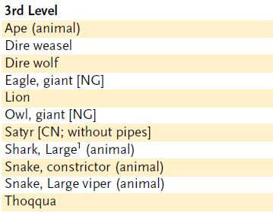

*Summon Nature’s Ally I
Conjuration (Summoning)
Level: Drd 1, Rgr 1
Components: V, S, DF
Casting Time: 1 round
Range: Close (25 ft. + 5 ft./2 levels)
Effect: One summoned creature
Duration: 1 round/level (D)
Saving Throw: None
Spell Resistance: No

This spell summons a natural creature. It appears where you designate and acts immediately, on your turn. It attacks your opponents to the best of its ability. If you can communicate with the creature, you can direct it not to attack, to attack particular enemies, or to perform other actions.
A summoned monster cannot summon or otherwise conjure another creature, nor can it use any teleportation or planar travel abilities. Creatures cannot be summoned into an environment that cannot support them. For instance, a porpoise may only be summoned in an aquatic environment.
The spell conjures one of the creatures from the 1st-level list on the accompanying Summon Nature’s Ally table. You choose which kind of creature to summon, and you can change that choice each time you cast the spell. All the creatures on the table are neutral unless otherwise noted.

Water Breathing
Transmutation
Level: Clr 3, Drd 3, Sor/Wiz 3, Water 3
Components: V, S, M/DF
Casting Time: 1 standard action
Range: Touch
Target: Living creatures touched
Duration: 2 hours/level; see text
Saving Throw: Will negates (harmless)
Spell Resistance: Yes (harmless)

The transmuted creatures can breathe water freely. Divide the duration evenly among all the creatures you touch.
The spell does not make creatures unable to breathe air.
Arcane Material Component: A short reed or piece of straw.

Wind Wall
Evocation [Air]
Level: Air 2, Clr 3, Drd 3, Rgr 2, Sor/
Wiz 3
Components: V, S, M/DF
Casting Time: 1 standard action
Range: Medium (100 ft. + 10 ft./level)
Effect: Wall up to 10 ft./level long and 5 ft./level high (S)
Duration: 1 round/level
Saving Throw: None; see text
Spell Resistance: Yes

An invisible vertical curtain of wind appears. It is 2 feet thick and of considerable strength. It is a roaring blast sufficient to blow away any bird smaller than an eagle, or tear papers and similar materials from unsuspecting hands. (A Reflex save allows a creature to maintain its grasp on an object.) Tiny and Small flying creatures cannot pass through the barrier. Loose materials and cloth garments fly upward when caught in a wind wall. Arrows and bolts are deflected upward and miss, while any other normal ranged weapon passing through the wall has a 30% miss chance. (A giant-thrown boulder, a siege engine projectile, and other massive ranged weapons are not affected.) Gases, most gaseous breath weapons, and creatures in gaseous form cannot pass through the wall (although it is no barrier to incorporeal
creatures).
While the wall must be vertical, you can shape it in any continuous path along the ground that you like. It is possible to create cylindrical or square wind walls to enclose specific points. A 5th-level caster can create a wall up to 50 feet long and up to 25 feet high, sufficient to form a cylinder of wind 15 feet in diameter.
Arcane Material Component: A tiny fan and a feather of exotic origin.

Title Page
Class Features
Level Table
Animal Companions
Beah’s Feats

Druid Spells
0 Level Spells || 1st Level Spells
2nd Level Spells || 3rd Level Spells
4th Level Spells || 5th Level Spells
6th Level Spells || 7th Level Spells
8th Level Spells || 9th Level Spells

4th-LEVEL DRUID SPELLS
Air Walk: Subject treads on air as if solid (climb at 45-degree angle).
Antiplant Shell: Keeps animated plants at bay.
Blight: Withers one plant or deals 1d6/level damage to plant creatures.
Command Plants: Sway the actions of one or more plant creatures.
Control Water: Raises or lowers bodies of water.
Cure Serious Wounds: Cures 3d8 damage +1/level (max +15).
Dispel Magic: Cancels spells and magical effects.
Flame Strike: Smite foes with divine fire (1d6/level damage).
Freedom of Movement: Subject moves normally despite impediments.
Giant Vermin: Turns centipedes, scorpions, or spiders into giant vermin.
Ice Storm: Hail deals 5d6 damage in cylinder 40 ft. across.
Reincarnate: Brings dead subject back in a random body.
Repel Vermin: Insects, spiders, and other vermin stay 10 ft. away.
Rusting Grasp: Your touch corrodes iron and alloys.
Scrying^{F}: Spies on subject from a distance.
Spike Stones: Creatures in area take 1d8 damage and may be slowed.
Summon Nature’s Ally IV: Calls creature to fight.

Air Walk
Transmutation [Air]
Level: Air 4, Clr 4, Drd 4
Components: V, S, DF
Casting Time: 1 standard action
Range: Touch
Target: Creature (Gargantuan or smaller) touched
Duration: 10 min./level
Saving Throw: None
Spell Resistance: Yes (harmless)

The subject can tread on air as if walking on solid ground. Moving upward is similar to walking up a hill. The maximum upward or downward angle possible is 45 degrees, at a rate equal to one-half the air walker’s normal speed.
A strong wind (21+ mph) can push the subject along or hold it back. At the end of its turn each round, the wind blows the air walker 5 feet for each 5 miles per hour of wind speed. The creature can, at the DM’s option, be (Air Walk cont.) subject to additional penalties in exceptionally strong or turbulent winds, such as loss of control over movement or physical damage from being buffeted about.
Should the spell duration expire while the subject is still aloft, the magic fails slowly. The subject floats downward 60 feet per round for 1d6 rounds. If it reaches the ground in that amount of time, it lands safely. If not, it falls the rest of the distance, taking 1d6 points of damage per 10 feet of fall. Since dispelling a spell effectively ends it, the subject also descends in this way if the air walk spell is dispelled, but not if it is negated by an antimagic field.
You can cast air walk on a specially trained mount so it can be ridden through the air. You can train a mount to move with the aid of air walk (counts as a trick; see page 74) with one week of work and a DC 25 Handle Animal check.

Antiplant Shell
Abjuration
Level: Drd 4
Components: V, S, DF
Casting Time: 1 standard action
Range: 10 ft.
Area: 10-ft.-radius emanation, centered on you
Duration: 10 min./level (D)
Saving Throw: None
Spell Resistance: Yes

The antiplant shell spell creates an invisible, mobile barrier that keeps all creatures within the shell protected from attacks by plant creatures or animated plants. As with many abjuration spells, forcing the barrier against creatures that the spell keeps at bay strains and collapses the field (see Abjuration, page 172).

Blight
Necromancy
Level: Drd 4, Sor/Wiz 5
Components: V, S, DF
Casting Time: 1 standard action
Range: Touch
Duration: Instantaneous
Saving Throw: Fortitude half; see text
Spell Resistance: Yes

This spell withers a single plant of any size. An affected plant creature takes 1d6 points of damage per level (maximum 15d6) and may attempt a Fortitude saving throw for half damage. A plant that isn’t a creature (such as a tree or shrub) doesn’t receive a save and immediately withers and dies.
This spell has no effect on the soil or surrounding plant life.
Command Plants
Transmutation
Level: Drd 4, Plant 4, Rgr 3
Components: V
Casting Time: 1 standard action
Range: Close (25 ft. + 5 ft./2 levels)
Targets: Up to 2 HD/level of plant creatures, no two of which can be more than 30 ft. apart
Duration: One day/level
Saving Throw: Will negates
Spell Resistance: Yes

This spell allows you some degree of control over one or more plant creatures. Affected plant creatures can understand you, and they perceive your words and actions in the most favorable way (treat their attitude as friendly). They will not attack you while the spell lasts. You can try to give a subject orders, but you must win an opposed Charisma check to convince it to do anything it wouldn’t ordinarily do. (Retries are not allowed.) A commanded plant never obeys suicidal or obviously harmful orders, but it might be convinced that something very dangerous is worth doing (see charm person).
You can affect a number of plant creatures whose combined level or HD do not exceed twice your level.

Control Water
Transmutation [Water]
Level: Clr 4, Drd 4, Sor/Wiz 6, Water 4
Components: V, S, M/DF
Casting Time: 1 standard action
Range: Long (400 ft. + 40 ft./level)
Area: Water in a volume of 10 ft./level by 10 ft./level by 2 ft./level (S)
Duration: 10 min./level (D)
Saving Throw: None; see text
Spell Resistance: No

Depending on the version you choose, the control water spell raises or lowers water.
Lower Water: This causes water or similar liquid to reduce its depth by as much as 2 feet per caster level (to a minimum depth of 1 inch). The water is lowered within a squarish depression whose sides are up to caster level × 10 feet long. In extremely large and deep bodies of water, such as a deep ocean, the spell creates a whirlpool that sweeps ships and similar craft downward, putting them at risk and rendering them unable to leave by normal movement for the duration of the spell. When cast on water elementals and other water-based creatures, this spell acts as a slow spell (Will negates). The spell has no effect on other creatures.
Raise Water: This causes water or similar liquid to rise in height, just as the lower water version causes it to lower. Boats raised in this way slide down the sides of the hump that the spell creates. If the area affected by the spell includes riverbanks, a beach, or other land nearby, the water can spill over onto dry land. With either version, you may reduce one horizontal dimension by half and double the other horizontal dimension.
Arcane Material Component: A drop of water (for raise water) or a pinch of dust (for lower water).

Cure Serious Wounds
Conjuration (Healing)
Level: Brd 3, Clr 3, Drd 4, Pal 4, Rgr 4, Healing 3

This spell functions like *cure light wounds, except that it cures 3d8 points of damage +1 point per caster level (maximum +15).

*Cure Light Wounds
Conjuration (Healing)
Level: Brd 1, Clr 1, Drd 1, Healing 1, Pal 1, Rgr 2
Components: V, S
Casting Time: 1 standard action
Range: Touch
Target: Creature touched
Duration: Instantaneous
Saving Throw: Will half (harmless); see text
Spell Resistance: Yes (harmless); see text

When laying your hand upon a living creature, you channel positive energy that cures 1d8 points of damage +1 point per caster level (maximum +5).
Since undead are powered by negative energy, this spell deals damage to them instead of curing their wounds. An undead creature can apply spell resistance, and can attempt a Will save to take half damage.

Title Page
Class Features
Level Table
Animal Companions
Beah’s Feats

Druid Spells
0 Level Spells || 1st Level Spells
2nd Level Spells || 3rd Level Spells
4th Level Spells || 5th Level Spells
6th Level Spells || 7th Level Spells
8th Level Spells || 9th Level Spells
Dispel Magic
Abjuration
Level: Brd 3, Clr 3, Drd 4, Magic 3, Pal 3, Sor/Wiz 3
Components: V, S
Casting Time: 1 standard action
Range: Medium (100 ft. + 10 ft./level)
Target or Area: One spellcaster, creature, or object; or 20-ft.-radius burst
Duration: Instantaneous
Saving Throw: None
Spell Resistance: No

Because magic is so powerful, so too is the ability to dispel magic. You can use dispel magic to end ongoing spells that have been cast on a creature or object, to temporarily suppress the magical abilities of a magic item, to end ongoing spells (or at least their effects) within an area, or to counter another spellcaster’s spell. A dispelled spell ends as if its duration had expired. Some spells, as detailed in their descriptions, can’t be defeated by dispel magic. Dispel magic can dispel (but not counter) spelllike effects just as it does spells.
Note: The effect of a spell with an instantaneous duration can’t be dispelled, because the magical effect is already over before the dispel magic can take effect. Thus, you can’t use dispel magic to repair damage caused by a fireball or to turn a petrified character back to flesh. In these cases, the magic has departed, leaving only burned flesh or perfectly normal stone in its wake.
You choose to use dispel magic in one of three ways: a targeted dispel, an area dispel, or a counterspell: Targeted Dispel: One object, creature, or spell is the target of the dispel magic spell. You make a dispel check (1d20 + your caster level, maximum +10) against the spell or against each ongoing spell currently in effect on the object or creature. The DC for this dispel check is 11 + the spell’s caster level.
For example, Mialee, at 5th level, targets dispel magic on a drow who is under the effects of haste, mage armor, and bull’s strength. All three spells were cast on the drow by a 7th-level wizard. Mialee makes a dispel check (1d20 + 5 against DC 18) three times, once each for the haste, mage armor, and bull’s strength effects. If she succeeds on a particular check, that spell is dispelled (the drow’s spell resistance doesn’t help him); if she fails, that spell remains in effect.
If you target an object or creature that is the effect of an ongoing spell (such as a monster summoned by monster summoning), you make a dispel check to end the spell that conjured the object or creature.
If the object that you target is a magic item, you make a dispel check against the item’s caster level. If you succeed, all the item’s magical properties are suppressed for 1d4 rounds, after which the item recovers on its own. A suppressed item becomes nonmagical for the duration of the effect. An interdimensional interface (such as a bag of holding) is temporarily closed. A magic item’s physical properties are unchanged: A suppressed magic sword is still a sword (a masterwork sword, in fact). Artifacts and deities are unaffected by mortal magic such as this.
You automatically succeed on your dispel check against any spell that you cast yourself.
Area Dispel: When dispel magic is used in this way, the spell affects everything within a 30-foot radius.
For each creature within the area that is the subject of one or more spells, you make a dispel check against the spell with the highest caster level. If that check fails, you make dispel checks against progressively weaker spells until you dispel one spell (which discharges the dispel magic spell so far as that target is concerned) or until you fail all your checks. The creature’s magic items are not affected.
For each object within the area that is the target of one or more spells, you make dispel checks as with creatures. Magic items are not affected by an area dispel.
For each ongoing area or effect spell whose point of origin is within the area of the dispel magic spell, you can make a dispel check to dispel the spell.
For each ongoing spell whose area overlaps that of the dispel magic spell, you can make a dispel check to end the effect, but only within the overlapping area.
If an object or creature that is the effect of an ongoing spell (such as a monster summoned by monster summoning) is in the area, you can make a dispel check to end the spell that conjured that object or creature (returning it whence it came) in addition to attempting to dispel spells
targeting the creature or object.
You may choose to automatically succeed on dispel checks against any spell that you have cast.
Counterspell: When dispel magic is used in this way, the spell targets a spellcaster and is cast as a counterspell (page 170). Unlike a true counterspell, however, dispel magic may not work; you must make a dispel check to counter the other spellcaster’s spell.



Flame Strike
Evocation [Fire]
Level: Clr 5, Drd 4, Sun 5, War 5
Components: V, S, DF
Casting Time: 1 standard action
Range: Medium (100 ft. + 10 ft./level)
Area: Cylinder (10-ft. radius, 40 ft. high)
Duration: Instantaneous
Saving Throw: Reflex half
Spell Resistance: Yes

A flame strike produces a vertical column of divine fire roaring downward. The spell deals 1d6 points of damage per caster level (maximum 15d6). Half the damage is fire damage, but the other half results directly from divine power and is therefore not subject to being reduced by resistance to fire-based attacks, such as that granted by protection from energy (fire), fire shield (chill shield), and similar magic.

Title Page
Class Features
Level Table
Animal Companions
Beah’s Feats

Druid Spells
0 Level Spells || 1st Level Spells
2nd Level Spells || 3rd Level Spells
4th Level Spells || 5th Level Spells
6th Level Spells || 7th Level Spells
8th Level Spells || 9th Level Spells

Freedom of Movement
Abjuration
Level: Brd 4, Clr 4, Drd 4, Luck 4, Rgr 4
Components: V, S, M/DF
Casting Time: 1 standard action
Range: Personal or touch
Target: You or creature touched
Duration: 10 min./level
Saving Throw: Will negates (harmless)
Spell Resistance: Yes (harmless)

This spell enables you or a creature you touch to move and attack normally for the duration of the spell, even under the influence of magic that usually impedes movement, such as paralysis, solid fog, slow, and web. The subject automatically succeeds on any grapple check made to resist a grapple attempt, as well as on grapple checks or Escape Artist checks made to escape a grapple or a pin.
The spell also allows the subject to move and attack normally while underwater, even with slashing weapons such as axes and swords or with bludgeoning weapons such as flails, hammers, and maces, provided that the weapon is wielded in the hand rather than hurled. The freedom of movement spell does not, however, allow water breathing.
Material Component: A leather thong, bound around the arm or a similar appendage.

Giant Vermin
Transmutation
Level: Clr 4, Drd 4
Components: V, S, DF
Casting Time: 1 standard action
Range: Close (25 ft. + 5 ft./2 levels)
Targets: Up to three vermin, no two of which can be more than 30 ft. apart
Duration: 1 min./level
Saving Throw: None
Spell Resistance: Yes

You turn three normal-sized centipedes, two normal-sized spiders, or a single normal-sized scorpion into larger forms. Only one type of vermin can be transmuted (so a single casting cannot affect both a centipede and a spider), and all must be grown to the same size. The size to which the vermin can be grown depends on your level; see the table below. The Monster Manual has game statistics for centipedes, spiders, and scorpions, as well as other kinds of vermin.
Any giant vermin created by this spell do not attempt to harm you, but your control of such creatures is limited to simple commands (“Attack,” “Defend,” “Stop,” and so forth). Orders to attack a certain creature when it appears or guard against a particular occurrence are too complex for the vermin to understand. Unless commanded to do otherwise, the giant vermin attack whoever or whatever is near them.
The DM can extend this spell’s effects to other kinds of insects, arachnids, or other vermin, such as ants, bees, beetles, praying mantises, and wasps, if he so chooses.

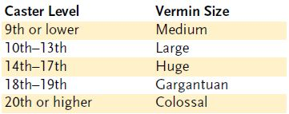

Ice Storm
Evocation [Cold]
Level: Drd 4, Sor/Wiz 4, Water 5
Components: V, S, M/DF
Casting Time: 1 standard action
Range: Long (400 ft. + 40 ft./level)
Area: Cylinder (20-ft. radius, 40 ft. high)
Duration: 1 full round
Saving Throw: None
Spell Resistance: Yes

Great magical hailstones pound down for 1 full round, dealing 3d6 points of bludgeoning damage and 2d6 points of cold damage to every creature in the area. A –4 penalty applies to each Listen check made within the ice storm’s effect, and all land movement within its area is at half speed. At the end of the duration, the hail disappears, leaving no aftereffects (other than the damage dealt).
Arcane Material Component: A pinch of dust and a few drops of water.



Title Page
Class Features
Level Table
Animal Companions
Beah’s Feats

Druid Spells
0 Level Spells || 1st Level Spells
2nd Level Spells || 3rd Level Spells
4th Level Spells || 5th Level Spells
6th Level Spells || 7th Level Spells
8th Level Spells || 9th Level Spells

Reincarnate
Transmutation
Level: Drd 4
Components: V, S, M/DF
Casting Time: 10 minutes
Range: Touch
Target: Dead creature touched
Duration: Instantaneous
Saving Throw: None; see text
Spell Resistance: Yes (harmless)

With this spell, you bring back a dead creature in another body, provided that its death occurred no more than one week before the casting of the spell and the subject’s soul is free and willing to return (see Bringing Back the Dead, page 171). If the subject’s soul is not willing to return, the spell does not work; therefore, a subject that wants to return receives no saving throw.
Since the dead creature is returning in a new body, all physical ills and afflictions are repaired. The condition of the remains is not a factor. So long as some small portion of the creature’s body still exists, it can be reincarnated, but the portion receiving the spell must have been part of the creature’s body at the time of death. The magic of the spell creates an entirely new young adult body for the soul to inhabit from the natural elements at hand. This process takes 1 hour to complete. When he body is ready, the subject is reincarnated.
A reincarnated creature recalls the majority of its former life and form. It retains any class abilities, feats, or skill ranks it formerly possessed. Its class, base attack bonus, base save bonuses, and hit points are unchanged. Strength, Dexterity, and Constitution scores depend partly on the new body. First eliminate the subject’s racial adjustments (since it is no longer of his previous race) and then apply the adjustments found below to its remaining ability scores. The subject’s level (or Hit Dice) is (Reincarnate cont.) reduced by 1. If the subject was 1st level, its new Constitution score is reduced by 2. (If this reduction would put its Con at 0 or lower, it can’t be reincarnated). This level/HD loss or Constitution loss cannot be repaired by any means.
It’s possible for the change in the subject’s ability scores to make it difficult for it to pursue its previous character class. If this is the case, the subject is well advised to become a multiclass character.
For a humanoid creature, the new incarnation is determined using the following table. For nonhumanoid creatures, the DM should create a similar table of creatures of the same type or simply choose the new form.
A creature that has been turned into an undead creature or killed by a death effect can’t be returned to life by this spell. Constructs, elementals, outsiders, and undead creatures can’t be reincarnated. The spell cannot bring back a creature who has died of old age.

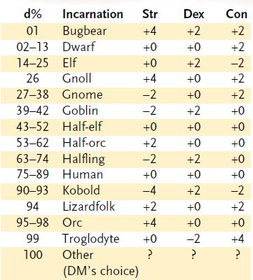

The reincarnated creature gains all abilities associated with its new form, including forms of movement and speeds, natural armor, natural attacks, extraordinary abilities, and the like, but it doesn’t automatically speak the language of the new form. Refer to the Monster Manual for details.
A wish or a miracle spell can restore a reincarnated character to his or her original form.
Material Component: Rare oils and unguents worth a total of least 1,000 gp, spread over the remains.

Repel Vermin
Abjuration
Level: Brd 4, Clr 4, Drd 4, Rgr 3
Components: V, S, DF
Casting Time: 1 standard action
Range: 10 ft.
Area: 10-ft.-radius emanation centered on you
Duration: 10 min./level (D)
Saving Throw: None or Will negates; see text
Spell Resistance: Yes

An invisible barrier holds back vermin. A vermin with Hit Dice of less than onethird your level cannot penetrate the barrier. A vermin with Hit Dice of one-third your level or more can penetrate the barrier if it succeeds on a Will save. Even so, crossing the barrier deals the vermin 2d6 points of damage, and pressing against the barrier causes pain, which deters most vermin.

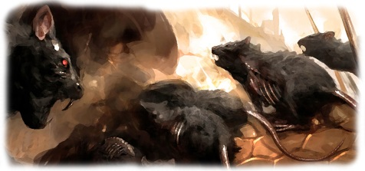

Rusting Grasp
Transmutation
Level: Drd 4
Components: V, S, DF
Casting Time: 1 standard action
Range: Touch
Target: One nonmagical ferrous object (or the volume of the object within 3 ft. of the touched point) or one ferrous creature
Duration: See text
Saving Throw: None
Spell Resistance: No

Any iron or iron alloy item you touch becomes instantaneously rusted, pitted, and worthless, effectively destroyed. If the item is so large that it cannot fit within a 3- foot radius (a large iron door or a wall of iron), a 3-foot-radius volume of the metal is rusted and destroyed. Magic items made of metal are immune to this spell.
You may employ rusting grasp in combat with a successful melee touch attack. Rusting grasp used in this way instantaneously destroys 1d6 points of Armor Class gained from metal armor (to the maximum amount of protection the armor offered) through corrosion. For example, full plate armor (AC +8) could be reduced to +7 or as low as +2 in protection, depending on the die roll.
Weapons in use by an opponent targeted by the spell are more difficult to grasp. You must succeed on a melee touch attack against the weapon. A metal weapon that is hit is destroyed.
Note: Striking at an opponent’s weapon provokes an attack of opportunity. Also, you must touch the weapon and not the other way around.
Against a ferrous creature, rusting grasp instantaneously deals 3d6 points of damage +1 per caster level (maximum +15) per successful attack. The spell lasts for 1 round per level, and you can make one melee touch attack per round.

Scrying
Divination (Scrying)
Level: Brd 3, Clr 5, Drd 4, Sor/Wiz 4
Components: V, S, M/DF, F
Casting Time: 1 hour
Range: See text
Effect: Magical sensor
Duration: 1 min./level
Saving Throw: Will negates
Spell Resistance: Yes

You can see and hear some creature, which may be at any distance. If the subject succeeds on a Will save, the scrying attempt simply fails. The difficulty of the save depends on how well you know the subject and what sort of physical connection (if any) you have to that creature. Furthermore, if the subject is on another plane, it gets a +5 bonus on its Will save.

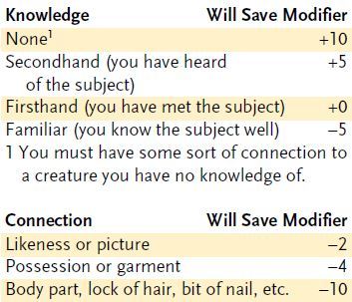

Title Page
Class Features
Level Table
Animal Companions
Beah’s Feats

Druid Spells
0 Level Spells || 1st Level Spells
2nd Level Spells || 3rd Level Spells
4th Level Spells || 5th Level Spells
6th Level Spells || 7th Level Spells
8th Level Spells || 9th Level Spells

(Scrying cont.) If the save fails, you can see (but not hear) the subject and the subject’s immediate surroundings (approx.-imately 10 feet in all directions of the subject). If the subject moves, the sensor follows at a speed of up to 150 feet.
As with all divination (scrying) spells, the sensor has your full visual acuity, including any magical effects. In addition, the following spells have a 5% chance per caster level of operating through the sensor: detect chaos, detect evil, detect good, detect law, detect magic, and message.
If the save succeeds, you can’t attempt to scry on that subject again for at least 24 hours.
Arcane Material Component: The eye of a hawk, an eagle, or a roc, plus nitric acid, copper, and zinc.
Wizard, Sorcerer, or Bard Focus: A mirror of finely wrought and highly polished silver costing not less than 1,000 gp. The mirror must be at least 2 feet by 4 feet.
Cleric Focus: A holy water font costing not less than 100 gp.
Druid Focus: A natural pool of water.

Spike Stones
Transmutation [Earth]
Level: Drd 4, Earth 4
Components: V, S, DF
Casting Time: 1 standard action
Range: Medium (100 ft. + 10 ft./level)
Area: One 20-ft. square/level
Duration: 1 hour/level (D)
Saving Throw: Reflex partial
Spell Resistance: Yes

Rocky ground, stone floors, and similar surfaces shape themselves into long, sharp points that blend into the background. Spike stones impede progress through an area and deal damage. Any creature moving on foot into or through the spell’s area moves at half speed.
In addition, each creature moving through the area takes 1d8 points of piercing damage for each 5 feet of movement through the spiked area.
Any creature that takes damage from this spell must also succeed on a Reflex save to avoid injuries to its feet and legs. A failed save causes the creature’s speed to be reduced to half normal for 24 hours or until the injured creature receives a cure spell (which also restores lost hit points). Another character can remove the penalty by taking 10 minutes to dress the injuries and succeeding on a Heal check against the spell’s save DC.
Spike stones is a magic trap that can’t be disabled with the Disable Device skill.
Note: Magic traps such as spike stones are hard to detect. A rogue (only) can use the Search skill to find spike stones. The DC is 25 + spell level, or DC 29 for spike stones.



Summon Nature’s Ally IV
Conjuration (Summoning) [see text]
Level: Animal 4, Drd 4, Rgr 4
Effect: One or more creatures, no two of which can be more than 30 ft. apart

This spell functions like *summon nature’s ally I, except that you can summon one 4th-level creature, 1d3 3rd-level creatures of the same kind, or 1d4+1 lower-level creatures of the same kind.
When you use a summoning spell to summon an air, chaotic, earth, evil, fire, good, lawful, or water creature, it is a spell of that type.

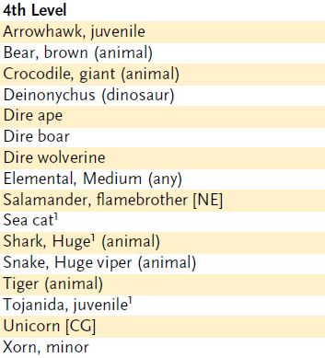
*Summon Nature’s Ally I
Conjuration (Summoning)
Level: Drd 1, Rgr 1
Components: V, S, DF
Casting Time: 1 round
Range: Close (25 ft. + 5 ft./2 levels)
Effect: One summoned creature
Duration: 1 round/level (D)
Saving Throw: None
Spell Resistance: No

This spell summons a natural creature. It appears where you designate and acts immediately, on your turn. It attacks your opponents to the best of its ability. If you can communicate with the creature, you can direct it not to attack, to attack particular enemies, or to perform other actions.
A summoned monster cannot summon or otherwise conjure another creature, nor can it use any teleportation or planar travel abilities. Creatures cannot be summoned into an environment that cannot support them. For instance, a porpoise may only be summoned in an aquatic environment.
The spell conjures one of the creatures from the 1st-level list on the accompanying Summon Nature’s Ally table. You choose which kind of creature to summon, and you can change that choice each time you cast the spell. All the creatures on the table are neutral unless otherwise noted.



Title Page
Class Features
Level Table
Animal Companions
Beah’s Feats

Druid Spells
0 Level Spells || 1st Level Spells
2nd Level Spells || 3rd Level Spells
4th Level Spells || 5th Level Spells
6th Level Spells || 7th Level Spells
8th Level Spells || 9th Level Spells

5th-LEVEL DRUID SPELLS

Animal Growth: One animal/two levels doubles in size.
Atonement: Removes burden of misdeeds from subject.
Awaken^{X}: Animal or tree gains human intellect.
Baleful Polymorph: Transforms subject into harmless animal.
Call Lightning Storm: As call lightning, but 5d6 damage per bolt.
Commune with Nature: Learn about terrain for 1 mile/level.
Control Winds: Change wind direction and speed.
Cure Critical Wounds: Cures 4d8 damage +1/level (max +20).
Death Ward: Grants immunity to all death spells and negative energy effects.
Hallow^{M}: Designates location as holy.
Insect Plague: Locust swarms attack creatures.
Stoneskin^{M}: Ignore 10 points of damage per attack.
Summon Nature’s Ally V: Calls creature to fight.
Transmute Mud to Rock: Transforms two 10-ft. cubes per level.
Transmute Rock to Mud: Transforms two 10-ft. cubes per level.
Tree Stride: Step from one tree to another far away.
Unhallow^{M}: Designates location as unholy.
Wall of Fire: Deals 2d4 fire damage out to 10 ft. and 1d4 out to 20 ft. Passing through wall deals 2d6 damage +1/level.
Wall of Thorns: Thorns damage anyone who tries to pass.

Animal Growth
Transmutation
Level: Drd 5, Rgr 4, Sor/Wiz 5
Components: V, S
Casting Time: 1 standard action
Range: Medium (100 ft. + 10 ft./level)
Targets: Up to one animal (Gargantuan or smaller) per two levels, no two of which can be more than 30 ft. apart
Duration: 1 min./level
Saving Throw: Fortitude negates
Spell Resistance: Yes

A number of animals grow to twice their normal size and eight times their normal weight. This alteration changes each animal’s size category to the next largest (from Large to Huge, for example), grants it a +8 size bonus to Strength and a +4 size bonus to Constitution (and thus an extra 2 hit points per HD), and imposes a –2 size penalty to Dexterity. The creature’s existing natural armor bonus increases by 2. The size change also affects the animal’s modifier to AC and attack rolls and its base damage, as detailed on Table 2–2 in the Dungeon Master’s Guide. The animal’s space and reach change as indicated on Table 8– 4: Creature Size and Scale (page 149), but its speed does not change.
The spell also grants each subject damage reduction 10/magic and a +4 resistance bonus on saving throws.
If insufficient room is available for the desired growth, the creature attains the maximum possible size and may make a Strength check (using its increased Strength) to burst any enclosures in the process. If it fails, it is constrained without harm by the materials enclosing it—the spell cannot be used to crush a creature by increasing its size.
All equipment worn or carried by an animal is similarly enlarged by the spell, though this change has no effect on the magical properties of any such equipment. Any enlarged item that leaves the enlarged creature’s possession instantly returns to its normal size.
The spell gives no means of command or influence over the enlarged animals.
Multiple magical effects that increase size do not stack, which means (among other things) that you can’t use a second casting of this spell to further increase the size of an animal that’s still under the effect of the first casting.

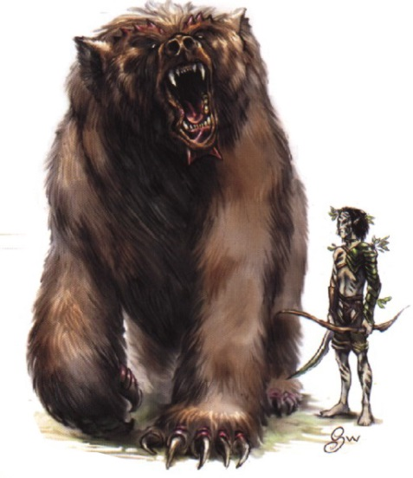

Title Page
Class Features
Level Table
Animal Companions
Beah’s Feats

Druid Spells
0 Level Spells || 1st Level Spells
2nd Level Spells || 3rd Level Spells
4th Level Spells || 5th Level Spells
6th Level Spells || 7th Level Spells
8th Level Spells || 9th Level Spells

Atonement
Abjuration
Level: Clr 5, Drd 5
Components: V, S, M, F, DF, XP
Casting Time: 1 hour
Range: Touch
Target: Living creature touched
Duration: Instantaneous
Saving Throw: None
Spell Resistance: Yes

This spell removes the burden of evil acts or misdeeds from the subject. The creature seeking atonement must be truly repentant and desirous of setting right its misdeeds. If the atoning creature committed the evil act unwittingly or under some form of compulsion, atonement operates normally at no cost to you. However, in the case of a creature atoning for deliberate misdeeds and acts of a knowing and willful nature, you must intercede with your deity (requiring you to expend 500 XP) in order to expunge the subject’s burden. Many casters first assign a subject of this sort a quest (see geas/quest) or similar penance to determine whether the creature is truly contrite before casting the atonement spell on its behalf.
Atonement may be cast for one of several purposes, depending on the version selected.
Reverse Magical Alignment Change: If a creature has had its alignment magically changed, atonement returns its alignment to its original status at no cost in experience points.
Restore Class: A paladin who has lost her class features due to committing an evil act may have her paladinhood restored to her by this spell.
Restore Cleric or Druid Spell Powers: A cleric or druid who has lost the ability to cast spells by incurring the anger of his or her deity may (Atonement cont.) regain that ability by seeking atonement from another cleric of the same deity or another druid. If the transgression was intentional, the casting cleric loses 500 XP for his intercession. If the transgression was unintentional, he does not lose XP.
Redemption or Temptation: You may cast this spell upon a creature of an opposing alignment in order to offer it a chance to change its alignment to match yours. The prospective subject must be present for the entire casting process. Upon completion of the spell, the subject freely chooses whether it retains its original alignment or acquiesces to your offer and changes to your alignment. No duress, compulsion, or magical influence can force the subject to take advantage of the opportunity offered if it is unwilling to abandon its old alignment. This use of the spell does not work on outsiders or any creature incapable of changing its alignment naturally.
Though the spell description refers to evil acts, atonement can also be used on any creature that has performed acts against its alignment, whether those acts are evil, good, chaotic, or lawful.
Note: Normally, changing alignment is up to the player (for PCs) or the DM (for NPCs). This use of atonement simply offers a believable way for a character to change his or her alignment drastically, suddenly, and definitively.
Material Component: Burning incense.
Focus: In addition to your holy symbol or normal divine focus, you need a set of prayer beads (or other prayer device, such as a prayer wheel or prayer book) worth at least 500 gp.
XP Cost: When cast for the benefit of a creature whose guilt was the result of deliberate acts, the cost to you is 500 XP per casting (see above).

Awaken
Transmutation
Level: Drd 5
Components: V, S, DF, XP
Casting Time: 24 hours
Range: Touch
Target: Animal or tree touched
Duration: Instantaneous
Saving Throw: Will negates
Spell Resistance: Yes

You awaken a tree or animal to humanlike sentience. To succeed, you must make a Will save (DC 10 + the animal’s current HD, or the HD the tree will have once awakened).
The awakened animal or tree is friendly toward you. You have no special empathy or connection with a creature you awaken, although it serves you in specific tasks or endeavors if you communicate your desires to it.
An awakened tree has characteristics as if it were an animated object (see the Monster Manual), except that it gains the plant type and its Intelligence, Wisdom, and Charisma scores are each 3d6. An awakened plant gains the ability to move its limbs, roots, vines, creepers, and so forth, and it has senses similar to a human’s.
An awakened animal gets 3d6 Intelligence, +1d3 Charisma, and +2 HD. Its type becomes magical beast (augmented animal). An awakened animal can’t serve as an animal companion, familiar, or special mount.
An awakened tree or animal can speak one language that you know, plus one additional language that you know per point of Intelligence bonus (if any).
XP Cost: 250 XP.

Baleful Polymorph
Transmutation
Level: Drd 5, Sor/Wiz 5
Components: V, S
Casting Time: 1 standard action
Range: Close (25 ft. + 5 ft./2 levels)
Target: One creature
Duration: Permanent
Saving Throw: Fortitude negates, Will partial; see text
Spell Resistance: Yes

As polymorph, except that you change the subject into a Small or smaller animal of no more than 1 HD (such as a dog, lizard, monkey, or toad). If the new form would prove fatal to the creature (for example, if you polymorphed a landbound target into a fish, or a flying target into a toad) the subject gets a +4 bonus on the save.
If the spell succeeds, the subject must also make a Will save. If this second save fails, the creature loses its extraordinary, supernatural, and spell-like abilities, loses its ability to cast spells (if it had the ability), and gains the alignment, special abilities, and Intelligence, Wisdom, and Charisma scores of its new form in place of its own. It still retains its class and level (or HD), as well as all benefits deriving therefrom (such as base attack bonus, base save bonuses, and hit points). It retains any class features (other than spellcasting) that aren’t extraordinary, supernatural, or spelllike abilities.
Incorporeal or gaseous creatures are immune to being polymorphed, and a creature with the shapechanger subtype (such as a lycanthrope or a doppelganger) can revert to its natural form as a standard action.

Call Lightning Storm
Evocation [Electricity]
Level: Drd 5
Range: Long (400 ft. + 40 ft./level)

This spell functions like *call lightning, except that each bolt deals 5d6 points of electricity damage (or 5d10 if created outdoors in a stormy area), and you may call a maximum of 15 bolts.



Title Page
Class Features
Level Table
Animal Companions
Beah’s Feats

Druid Spells
0 Level Spells || 1st Level Spells
2nd Level Spells || 3rd Level Spells
4th Level Spells || 5th Level Spells
6th Level Spells || 7th Level Spells
8th Level Spells || 9th Level Spells

*Call Lightning
Evocation [Electricity]
Level: Drd 3
Components: V, S
Casting Time: 1 round
Range: Medium (100 ft. + 10 ft./level)
Effect: One or more 30-ft.-long vertical lines of lightning
Duration: 1 min./level
Saving Throw: Reflex half
Spell Resistance: Yes

Immediately upon completion of the spell, and once per round thereafter, you may call down a 5-foot-wide, 30-foot-long, vertical bolt of lightning that deals 3d6 points of electricity damage. The bolt of lightning flashes down in a vertical stroke at whatever target point you choose within the spell’s range (measured from your position at the (Call Lightning Storm cont.) time). Any creature in the target square or in the path of the bolt is affected.
You need not call a bolt of lightning immediately; other actions, even spellcasting, can be performed. However, each round after the first you may use a standard action (concentrating on the spell) to call a bolt. You may call a total number of bolts equal to your caster level (maximum 10 bolts).
If you are outdoors and in a stormy area—a rain shower, clouds and wind, hot and cloudy conditions, or even a tornado (including a whirlwind formed by a djinni or an air elemental of at least Large size; see the Monster Manual)—each bolt deals 3d10 points of electricity damage instead of 3d6.
This spell functions indoors or underground but not underwater.

Commune with Nature
Divination
Level: Animal 5, Drd 5, Rgr 4
Components: V, S
Casting Time: 10 minutes
Range: Personal
Target: You
Duration: Instantaneous

You become one with nature, attaining knowledge of the surrounding territory. You instantly gain knowledge of as many as three facts from among the following subjects: the ground or terrain, plants, minerals, bodies of water, people, general animal population, presence of woodland creatures, presence of powerful unnatural creatures, or even the general state of the natural setting. For example, you could determine the location of any powerful undead creatures, the location of all major sources of safe drinking water, and the location of any buildings (which register as blind spots).
In outdoor settings, the spell operates in a radius of 1 mile per caster level. In natural underground settings—caves, caverns, and the like—the radius is limited to 100 feet per caster level. The spell does not function where nature has been replaced by construction or settlement, such as in dungeons and towns.


Control Winds
Transmutation [Air]
Level: Air 5, Drd 5
Components: V, S
Casting Time: 1 standard action
Range: 40 ft./level
Area: 40 ft./level radius cylinder 40 ft.
high
Duration: 10 min./level
Saving Throw: Fortitude negates
Spell Resistance: No

You alter wind force in the area surrounding you. You can make the wind blow in a certain direction or manner, increase its strength, or decrease its strength. The new wind direction and strength persist until the spell ends or until you choose to alter your handiwork, which requires concentration. You may create an “eye” of calm air up to 80 feet in diameter at the center of the area if you so desire, and you may choose to limit the area to any cylindrical area less than your full limit (for example, a 20-foot-diameter tornado centered 100 feet away).
Wind Direction: You may choose one of four basic wind patterns to function over the spell’s area.
- A downdraft blows from the center outward in equal strength in all directions.
- An updraft blows from the outer edges in toward the center in equal strength from all directions, veering upward before impinging on the eye in the center.
- A rotation causes the winds to circle the center in clockwise or counterclockwise fashion.
- A blast simply causes the winds to blow in one direction across the entire area from one side to the other.
Wind Strength: For every three caster levels, you can increase or decrease wind strength by one level. (The categories of wind strength are briefly described below, with more detail to be found in the Dungeon Master’s Guide.) Each round on your turn, a creature in the wind must make a Fortitude save or suffer the effect of being in the windy area.
Strong winds (21+ mph) make sailing difficult.
A severe wind (31+ mph) causes minor ship and building damage.
A windstorm (51+ mph) drives most flying creatures from the skies, uproots small trees, knocks down light wooden structures, tears off roofs, and endangers ships.
Hurricane force winds (75+ mph) destroy wooden buildings, sometimes uproot even large trees, and cause most ships to founder.
A tornado (175+ mph) destroys all nonfortified buildings and often uproots large trees.

Cure Critical Wounds
Conjuration (Healing)
Level: Brd 4, Clr 4, Drd 5, Healing 4

This spell functions like *cure light wounds, except that it cures 4d8 points of damage +1 point per caster level (maximum +20).

*Cure Light Wounds
Conjuration (Healing)
Level: Brd 1, Clr 1, Drd 1, Healing 1, Pal 1, Rgr 2
Components: V, S
Casting Time: 1 standard action
Range: Touch
Target: Creature touched
Duration: Instantaneous
Saving Throw: Will half (harmless); see text
Spell Resistance: Yes (harmless); see text

When laying your hand upon a living creature, you channel positive energy that cures 1d8 points of damage +1 point per caster level (maximum +5).
Since undead are powered by negative energy, this spell deals damage to them instead of curing their wounds. An undead creature can apply spell resistance, and can attempt a Will save to take half damage.

Title Page
Class Features
Level Table
Animal Companions
Beah’s Feats

Druid Spells
0 Level Spells || 1st Level Spells
2nd Level Spells || 3rd Level Spells
4th Level Spells || 5th Level Spells
6th Level Spells || 7th Level Spells
8th Level Spells || 9th Level Spells

Death Ward
Necromancy
Level: Clr 4, Death 4, Drd 5, Pal 4
Components: V, S, DF
Casting Time: 1 standard action
Range: Touch
Target: Living creature touched
Duration: 1 min./level
Saving Throw: Will negates (harmless)
Spell Resistance: Yes (harmless)

The subject is immune to all death spells, magical death effects, energy drain, and any negative energy effects (such as from inflict spells or chill touch).
This spell doesn’t remove negative levels that the subject has already gained, nor does it affect the saving throw necessary 24 hours after gaining a negative level.
Death ward does not protect against other sorts of attacks, such as hit point loss, poison, or petrification, even if those attacks might be lethal.

Hallow
Evocation [Good]
Level: Clr 5, Drd 5
Components: V, S, M/DF
Casting Time: 24 hours
Range: Touch
Area: 40-ft. radius emanating from the touched point
Duration: Instantaneous
Saving Throw: See text
Spell Resistance: See text

Hallow makes a particular site, building, or structure a holy site. This has four major effects.
First, the site or structure is guarded by a magic circle against evil effect.
Second, all Charisma checks made to turn undead gain a +4 sacred bonus, and Charisma checks to command undead take a –4 penalty. Spell resistance does not apply to this effect. (This provision does not apply to the druid version of the spell.)
Third, any dead body interred in a hallowed site cannot be turned into an undead creature.
Finally, you may choose to fix a single spell effect to the hallowed site. The spell effect lasts for one year and functions throughout the entire site, regardless of the normal duration and area or effect. You may designate whether the effect applies to all creatures, creatures who share your faith or alignment, or creatures who adhere to another faith or alignment. For example, you may create a bless effect that aids all creatures of your alignment or faith in the area, or a bane effect that hinders creatures of the opposed alignment or an enemy faith. At the end of the year, the chosen effect lapses, but it can be renewed or replaced simply by casting hallow again.
Spell effects that may be tied to a hallowed site include aid, bane, bless, cause fear, darkness, daylight, death ward, deeper darkness, detect evil, detect magic, dimensional anchor, discern lies, dispel magic, endure elements, freedom of movement, invisibility purge, protection from energy, remove fear, resist energy, silence, tongues, and zone of truth. Saving throws and spell resistance might apply to these spells’ effects. (See the individual spell descriptions for details.)
An area can receive only one hallow spell (and its associated spell effect) at a time.
Hallow counters but does not dispel unhallow.
Material Component: Herbs, oils, and incense worth at least 1,000 gp, plus 1,000 gp per level of the spell to be included in the hallowed area.



Insect Plague
Conjuration (Summoning)
Level: Clr 5, Drd 5
Components: V, S, DF
Casting Time: 1 round
Range: Long (400 ft. + 40 ft./level)
Effect: One swarm of locusts per three levels, each of which must be adjacent to at least one other swarm
Duration: 1 min./level
Saving Throw: None
Spell Resistance: No

You summon a number of swarms of locusts (one per three levels, to a maximum of six swarms at 18th level). The swarms must be summoned so that each one is adjacent to at least one other swarm (that is, the swarms must fill one contiguous area). You may summon the locust swarms so that they share the area of other creatures. Each swarm attacks any creatures occupying its area. The swarms are stationary after being summoned, and won’t pursue creatures that flee.
See the Monster Manual for details on locust swarms.

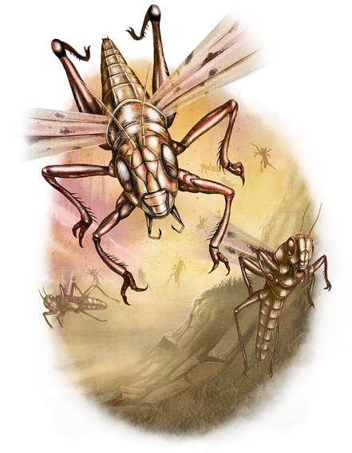

Stoneskin
Abjuration
Level: Drd 5, Earth 6, Sor/Wiz 4, Strength 6
Components: V, S, M
Casting Time: 1 standard action
Range: Touch
Target: Creature touched
Duration: 10 min./level or until Discharged
Saving Throw: Will negates (harmless)
Spell Resistance: Yes (harmless)

The warded creature gains resistance to blows, cuts, stabs, and slashes. The subject gains damage reduction 10/adamantine. (It ignores the first 10 points of damage each time it takes damage from a weapon, though an adamantine weapon bypasses the reduction.) Once the spell has prevented a total of 10 points of damage per caster level (maximum 150 points), it is discharged. Material Component: Granite and 250 gp worth of diamond dust sprinkled on the target’s skin.

Title Page
Class Features
Level Table
Animal Companions
Beah’s Feats

Druid Spells
0 Level Spells || 1st Level Spells
2nd Level Spells || 3rd Level Spells
4th Level Spells || 5th Level Spells
6th Level Spells || 7th Level Spells
8th Level Spells || 9th Level Spells
Summon Nature’s Ally V
Conjuration (Summoning) [see text]
Level: Drd 5
Effect: One or more creatures, no two of which can be more than 30 ft. apart

This spell functions like *summon nature’s ally I, except that you can summon one 5th-level creature, 1d3 4th-level creatures of the same kind, or 1d4+1 lower-level creatures of the same kind.
When you use a summoning spell to summon an air, chaotic, earth, evil, fire, good, lawful, or water creature, it is a spell of that type.

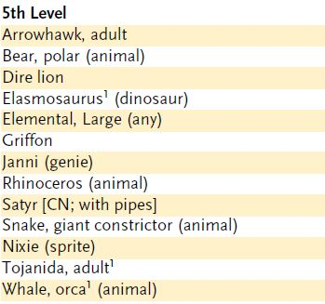

*Summon Nature’s Ally I
Conjuration (Summoning)
Level: Drd 1, Rgr 1
Components: V, S, DF
Casting Time: 1 round
Range: Close (25 ft. + 5 ft./2 levels)
Effect: One summoned creature
Duration: 1 round/level (D)
Saving Throw: None
Spell Resistance: No

This spell summons a natural creature. It appears where you designate and acts immediately, on your turn. It attacks your opponents to the best of its ability. If you can communicate with the creature, you can direct it not to attack, to attack particular enemies, or to perform other actions.
A summoned monster cannot summon or otherwise conjure another creature, nor can it use any teleportation or planar travel abilities. Creatures cannot be summoned into an environment that cannot support them. For instance, a porpoise may only be summoned in an aquatic environment.
The spell conjures one of the creatures from the 1st-level list on the accompanying Summon Nature’s Ally table. You choose which kind of creature to summon, and you can change that choice each time you cast the spell. All the creatures on the table are neutral unless otherwise noted.
Transmute Mud to Rock
Transmutation [Earth]
Level: Drd 5, Sor/Wiz 5
Components: V, S, M/DF
Casting Time: 1 standard action Range: Medium (100 ft. + 10 ft./level)
Area: Up to two 10-ft. cubes/level (S)
Duration: Permanent
Saving Throw: See text
Spell Resistance: No

This spell transforms normal mud or quicksand of any depth into soft stone (sandstone or a similar mineral) permanently. Any creature in the mud is allowed a Reflex save to escape before the area is hardened to stone.
Transmute mud to rock counters and dispels transmute rock to mud.
Arcane Material Component: Sand, lime, and water.

Transmute Rock to Mud
Transmutation [Earth]
Level: Drd 5, Sor/Wiz 5
Components: V, S, M/DF
Casting Time: 1 standard action
Range: Medium (100 ft. + 10 ft./level)
Area: Up to two 10-ft. cubes/level (S)
Duration: Permanent; see text
Saving Throw: See text
Spell Resistance: No

This spell turns natural, uncut or unworked rock of any sort into an equal volume of mud. If the spell is cast upon a boulder, for example, the boulder collapses into mud. Magical stone is not affected by the spell. The depth of the mud created cannot exceed 10 feet. A creature unable to levitate, fly, or otherwise free itself from the mud sinks until hip- or chest-deep, reducing its speed to 5 feet and causing a –2 penalty on attack rolls and AC. Brush thrown atop the mud can support creatures able to climb on top of it. Creatures large enough to walk on the bottom can wade through the area at a speed of 5 feet.
If transmute rock to mud is cast upon the ceiling of a cavern or tunnel, the mud falls to the floor and spreads out in a pool at a depth of 5 feet. For example, a 10th-level caster could convert twenty 10-foot cubes into mud. Pooling on the floor, this mud would cover an area of forty 10-foot squares to a depth of 5 feet. The falling mud and the ensuing cave-in deal 8d6 points of bludgeoning damage to anyone caught directly beneath the area, or half damage to those who succeed on Reflex saves.
Castles and large stone buildings are generally immune to the effect of the spell, since transmute rock to mud can’t affect worked stone and doesn’t reach deep enough to undermine such buildings’ foundations. However, small buildings or structures often rest upon foundations shallow enough to be damaged or even partially toppled by this spell.
The mud remains until a successful dispel magic or transmute mud to rock spell restores its substance—but not necessarily its form. Evaporation turns the mud to normal dirt over a period of days. The exact time depends on exposure to the sun, wind, and normal drainage.
Arcane Material Component: Clay and water.

Title Page
Class Features
Level Table
Animal Companions
Beah’s Feats

Druid Spells
0 Level Spells || 1st Level Spells
2nd Level Spells || 3rd Level Spells
4th Level Spells || 5th Level Spells
6th Level Spells || 7th Level Spells
8th Level Spells || 9th Level Spells

Tree Stride
Conjuration (Teleportation)
Level: Drd 5, Rgr 4
Components: V, S, DF
Casting Time: 1 standard action
Range: Personal
Target: You
Duration: 1 hour/level or until expended; see text

You gain the ability to enter trees and move from inside one tree to inside another tree. The first tree you enter and all others you enter must be of the same kind, must be living, and must have girth at least equal to yours. By moving into an oak tree (for example), you instantly know the location of all other oak trees within transport range (see below) and may choose whether you want to pass into one or simply step back out of the tree you moved into. You may choose to pass to any tree of the appropriate kind within the transport range as shown on the following table.
(Tree Stride cont.)

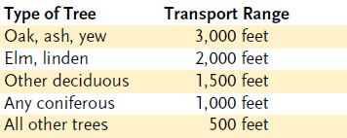

You may move into a tree up to one time per caster level (passing from one tree to another counts only as moving into one tree). The spell lasts until the duration expires or you exit a tree. This means that in a thick oak forest, a 10th-level druid could make ten transports over the course of 10 rounds, traveling as far as 30,000 feet (about 6 miles) in doing so. Each transport is a full-round action.
You can, at your option, remain within a tree without transporting yourself, but you are forced out when the spell ends. If the tree in which you are concealed is chopped down or burned, you are slain if you do not exit before the process is complete.

Unhallow
Evocation [Evil]
Level: Clr 5, Drd 5
Components: V, S, M
Casting Time: 24 hours
Range: Touch
Area: 40-ft. radius emanating from the touched point
Duration: Instantaneous
Saving Throw: See text
Spell Resistance: See text

Unhallow makes a particular site, building, or structure an unholy site. This has three major effects.
First, the site or structure is guarded by a magic circle against good effect.
Second, all turning checks made to turn undead take a –4 penalty, and turning checks to rebuke undead gain a +4 profane bonus. Spell resistance does not apply to this effect. (This provision does not apply to the druid version of the spell.)
Finally, you may choose to fix a single spell effect to the unhallowed site. The spell effect lasts for one year and functions throughout the entire site, regardless of its normal duration and area or effect. You may designate whether the effect applies to all creatures, creatures that share your faith or alignment, or creatures that adhere to another faith or alignment. For example, you may create a bless effect that aids all creatures of like alignment or faith in the area, or a bane effect that hinders creatures of the opposite alignment or an enemy faith. At the end of the year, the chosen effect lapses, but it can be renewed or replaced simply by casting unhallow again.
Spell effects that may be tied to an unhallowed site include aid, bane, bless, cause fear, darkness, daylight, death ward, deeper darkness, detect magic, detect good, dimensional anchor, discern lies, dispel magic, endure elements, freedom of movement, invisibility purge, protection from energy, remove fear, resist energy, silence, tongues, and zone of truth. Saving throws and spell resistance might apply to these spells’ effects. (See the individual spell descriptions for details.)
An area can receive only one unhallow spell (and its associated spell effect) at a time.
Unhallow counters but does not dispel hallow.
Material Component: Herbs, oils, and incense worth at least 1,000 gp, plus 1,000 gp per level of the spell to be tied to the unhallowed area.

Wall of Fire
Evocation [Fire]
Level: Drd 5, Fire 4, Sor/Wiz 4
Components: V, S, M/DF
Casting Time: 1 standard action
Range: Medium (100 ft. + 10 ft./level)
Effect: Opaque sheet of flame up to 20 ft. long/level or a ring of fire with a radius of up to 5 ft. per two levels; either form 20 ft. high
Duration: Concentration + 1 round/level
Saving Throw: None
Spell Resistance: Yes

An immobile, blazing curtain of shimmering violet fire springs into existence. One side of the wall, selected by you, sends forth waves of heat, dealing 2d4 points of fire damage to creatures within 10 feet and 1d4 points of fire damage to those past 10 feet but within 20 feet. The wall deals this damage when it appears and on your turn each round to all creatures in the area. In addition, the wall deals 2d6 points of fire damage +1 point of fire damage per caster level (maximum +20) to any creature passing through it. The wall deals double damage to undead creatures.
If you evoke the wall so that it appears where creatures are, each creature takes damage as if passing through the wall.
If any 5-foot length of wall takes 20 points of cold damage or more in 1 round, that length goes out. (Do not divide cold damage by 4, as normal for objects.)
Wall of fire can be made permanent with a permanency spell. A permanent wall of fire that is extinguished by cold damage becomes inactive for 10 minutes, then reforms at normal strength.
Arcane Material Component: A small piece of phosphorus.

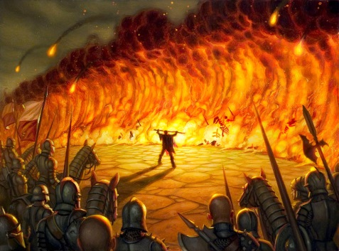

Title Page
Class Features
Level Table
Animal Companions
Beah’s Feats

Druid Spells
0 Level Spells || 1st Level Spells
2nd Level Spells || 3rd Level Spells
4th Level Spells || 5th Level Spells
6th Level Spells || 7th Level Spells
8th Level Spells || 9th Level Spells

Wall of Thorns
Conjuration (Creation)
Level: Drd 5, Plant 5
Components: V, S
Casting Time: 1 standard action
Range: Medium (100 ft. + 10 ft./level)
Effect: Wall of thorny brush, up to one
10-ft. cube/level (S)
Duration: 10 min./level (D)
Saving Throw: None
Spell Resistance: No

A wall of thorns spell creates a barrier of very tough, pliable, tangled brush bearing needle-sharp thorns as long as a human’s finger. Any creature forced into or attempting to move through a wall of thorns takes slashing damage per round of movement equal to 25 minus the creature’s AC. Dexterity and dodge bonuses to AC do not count for this calculation. (Creatures with an Armor Class of 25 or higher, without considering Dexterity and dodge bonuses, take no damage from contact with the wall.)
You can make the wall as thin as 5 feet thick, which allows you to shape the wall as a number of 10-by-10-by-5-foot blocks equal to twice your caster level. This has no effect on the damage dealt by the thorns, but any creature attempting to break through takes that much less time to force its way through the barrier.
Creatures can force their way slowly through the wall by making a Strength check as a full-round action. For every 5 points by which the check exceeds 20, a creature moves 5 feet (up to a maximum distance equal to its normal land speed). For example, a creature that rolled 25 on its Strength check could move 5 feet in a round. Of course, moving or attempting to move through the thorns incurs damage as described above. A creature trapped in the thorns can choose to remain motionless in order to avoid taking any more damage.
Any creature within the area of the spell when it is cast takes damage as if it had moved into the wall and is caught inside. In order to escape, it must attempt to push its way free, or it can wait until the spell ends. Creatures with the ability to pass through overgrown areas unhindered can pass through a wall of thorns at normal speed without taking damage.
A wall of thorns can be breached by slow work with edged weapons. Chopping away at the wall creates a safe passage 1 foot deep for every 10 minutes of work. Normal fire cannot harm the barrier, but magical fire burns it away in 10 minutes.
Despite its appearance, a wall of thorns is not actually a living plant, and thus is unaffected by spells that affect plants.

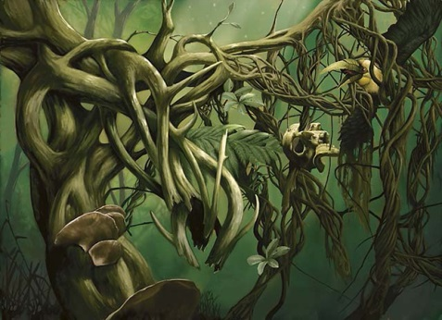

Title Page
Class Features
Level Table
Animal Companions
Beah’s Feats

Druid Spells
0 Level Spells || 1st Level Spells
2nd Level Spells || 3rd Level Spells
4th Level Spells || 5th Level Spells
6th Level Spells || 7th Level Spells
8th Level Spells || 9th Level Spells

6th-LEVEL DRUID SPELLS

Antilife Shell: 10-ft. radius field hedges out living creatures.
Bear’s Endurance, Mass: As bear’s endurance, affects one subject/level.
Bull’s Strength, Mass: As bull’s strength, affects one subject/level.
Cat’s Grace, Mass: As cat’s grace, affects one subject/level.
Cure Light Wounds, Mass: Cures 1d8 damage +1/level for many creatures.
Dispel Magic, Greater: As dispel magic, but +20 on check.
Find the Path: Shows most direct way to a location.
Fire Seeds: Acorns and berries become grenades and bombs.
Ironwood: Magic wood is strong as steel.
Liveoak: Oak becomes treant guardian.
Move Earth: Digs trenches and builds hills.
Owl’s Widsom, Mass: As owl’s wisdom, affects one subject/level.
Repel Wood: Pushes away wooden objects.
Spellstaff: Stores one spell in wooden quarterstaff.
Stone Tell: Talk to natural or worked stone.
Summon Nature’s Ally VI: Calls creature to fight.
Transport via Plants: Move instantly from one plant to another of the same kind.
Wall of Stone: Creates a stone wall that can be shaped.

Antilife Shell
Abjuration
Level: Animal 6, Clr 6, Drd 6
Components: V, S, DF
Casting Time: 1 round
Range: 10 ft.
Area: 10-ft.-radius emanation, centered on you
Duration: 10 min./level (D)
Saving Throw: None
Spell Resistance: Yes

You bring into being a mobile, hemispherical energy field that prevents the entrance of most types of living creatures. The effect hedges out animals, aberrations, dragons, fey, giants, humanoids, magical beasts, monstrous humanoids, oozes, plants, and vermin, but not constructs, elementals, outsiders, or undead. See the Monster Manual for more about creature types.
This spell may be used only defensively, not aggressively. Forcing an abjuration barrier against creatures that the spell keeps at bay collapses the barrier (see Abjuration, page 172).

Bear’s Endurance, Mass
Transmutation
Level: Clr 6, Drd 6, Sor/Wiz 6
Range: Close (25 ft. + 5 ft./2 levels)
Targets: One creature/level, no two of which can be more than 30 ft. apart

Mass bear’s endurance works like *bear’s endurance, except that it affects multiple creatures.

*Bear’s Endurance
Transmutation
Level: Clr 2, Drd 2, Rgr 2, Sor/Wiz 2
Components: V, S, DF
Casting Time: 1 standard action
Range: Touch
Target: Creature touched
Duration: 1 min./level
Saving Throw: Will negates (harmless)
Spell Resistance: Yes

The affected creature gains greater vitality and stamina. The spell grants the subject a +4 enhancement bonus to Constitution, which adds the usual benefits to hit points, Fortitude saves, Constitution checks, and so forth.
Hit points gained by a temporary increase in Constitution score are not temporary hit points. They go away when the subject’s Constitution drops back to normal. They are not lost first as temporary hit points are (see page 146).

Bull’s Strength, Mass
Transmutation
Level: Clr 6, Drd 6, Sor/Wiz 6
Range: Close (25 ft. + 5 ft./2 levels)
Targets: One creature/level, no two of which can be more than 30 ft. apart

This spell functions like *bull’s strength, except that it affects multiple creatures.

*Bull’s Strength
Transmutation
Level: Clr 2, Drd 2, Pal 2, Sor/Wiz 2,
Strength 2
Components: V, S, M/DF
Casting Time: 1 standard action
Range: Touch
Target: Creature touched
Duration: 1 min./level
Saving Throw: Will negates (harmless)
Spell Resistance: Yes (harmless)

The subject becomes stronger. The spell grants a +4 enhancement bonus to Strength, adding the usual benefits to melee attack rolls, melee damage rolls, and other uses of the Strength modifier.
Arcane Material Component: A few hairs, or a pinch of dung, from a bull.

Cat’s Grace, Mass
Transmutation
Level: Brd 6, Drd 6, Sor/Wiz 6
Range: Close (25 ft. + 5 ft./2 levels)
Targets: One creature/level, no two of which can be more than 30 ft. apart

This spell functions like *cat’s grace, except that it affects multiple creatures.

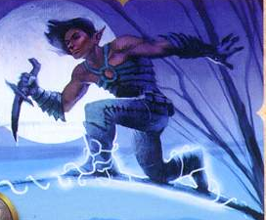

Title Page
Class Features
Level Table
Animal Companions
Beah’s Feats

Druid Spells
0 Level Spells || 1st Level Spells
2nd Level Spells || 3rd Level Spells
4th Level Spells || 5th Level Spells
6th Level Spells || 7th Level Spells
8th Level Spells || 9th Level Spells

*Cat’s Grace
Transmutation
Level: Brd 2, Drd 2, Rgr 2, Sor/Wiz 2
Components: V, S, M
Casting Time: 1 standard action
Range: Touch
Target: Creature touched
Duration: 1 min./level
Saving Throw: Will negates (harmless)
Spell Resistance: Yes

The transmuted creature becomes more graceful, agile, and coordinated. The spell grants a +4 enhancement bonus to Dexterity, adding the usual benefits to AC, Reflex saves, and other uses of the Dexterity modifier.
Material Component: A pinch of cat fur.

Cure Light Wounds, Mass
Conjuration (Healing)
Level: Brd 5, Clr 5, Drd 6, Healing 5
Components: V, S
Casting Time: 1 standard action
Range: Close (25 ft. + 5 ft./2 levels)
Target: One creature/level, no two of which can be more than 30 ft. apart
Duration: Instantaneous
Saving Throw: Will half (harmless) or Will half; see text
Spell Resistance: Yes (harmless) or Yes; see text

You channel positive energy to cure 1d8 points of damage +1 point per caster level (maximum +25) in each selected creature.
Like other cure spells, mass cure light wounds deals damage to undead in its area rather than curing them. Each affected undead may attempt a Will save for half damage.

Title Page
Class Features
Level Table
Animal Companions
Beah’s Feats

Druid Spells
0 Level Spells || 1st Level Spells
2nd Level Spells || 3rd Level Spells
4th Level Spells || 5th Level Spells
6th Level Spells || 7th Level Spells
8th Level Spells || 9th Level Spells

Dispel Magic, Greater
Abjuration
Level: Brd 5, Clr 6, Drd 6, Sor/Wiz 6

This spell functions like *dispel magic, except that the maximum caster level on your dispel check is +20 instead of +10. Additionally, greater dispel magic has a chance to dispel any effect that remove curse can remove, even if dispel magic can’t dispel that effect.

Dispel Magic
Abjuration
Level: Brd 3, Clr 3, Drd 4, Magic 3, Pal 3, Sor/Wiz 3
Components: V, S
Casting Time: 1 standard action
Range: Medium (100 ft. + 10 ft./level)
Target or Area: One spellcaster, creature, or object; or 20-ft.-radius burst
Duration: Instantaneous
Saving Throw: None
Spell Resistance: No

Because magic is so powerful, so too is the ability to dispel magic. You can use dispel magic to end ongoing spells that have been cast on a creature or object, to temporarily suppress the magical abilities of a magic item, to end ongoing spells (or at least their effects) within an area, or to counter another spellcaster’s spell. A dispelled spell ends as if its duration had expired. Some spells, as detailed in their descriptions, can’t be defeated by dispel magic. Dispel magic can dispel (but not counter) spelllike effects just as it does spells.
Note: The effect of a spell with an instantaneous duration can’t be dispelled, because the magical effect is already over before the dispel magic can take effect. Thus, you can’t use dispel magic to repair damage caused by a fireball or to turn a petrified character back to flesh. In these cases, the magic has departed, leaving only burned flesh or perfectly normal stone in its wake.
You choose to use dispel magic in one of three ways: a targeted dispel, an area dispel, or a counterspell: Targeted Dispel: One object, creature, or spell is the target of the dispel magic spell. You make a dispel check (1d20 + your caster level, maximum +10) against the spell or against each ongoing spell currently in effect on the object or creature. The DC for this dispel check is 11 + the spell’s caster level.
For example, Mialee, at 5th level, targets dispel magic on a drow who is under the effects of haste, mage armor, and bull’s strength. All three spells were cast on the drow by a 7th-level wizard. Mialee makes a dispel check (1d20 + 5 against DC 18) three times, once each for the haste, mage armor, and bull’s strength effects. If she succeeds on a particular check, that spell is dispelled (the drow’s spell resistance doesn’t help him); if she fails, that spell remains in effect.
If you target an object or creature that is the effect of an ongoing spell (such as a monster summoned by monster summoning), you make a dispel check to end the spell that conjured the object or creature.
If the object that you target is a magic item, you make a dispel check against the item’s caster level. If you succeed, all the item’s magical properties are suppressed for 1d4 rounds, after which the item recovers on its own. A suppressed item becomes nonmagical for the duration of the effect. An interdimensional interface (such as a bag of holding) is temporarily closed. A magic item’s physical properties are unchanged: A suppressed magic sword is still a sword (a masterwork sword, in fact). Artifacts and deities are unaffected by mortal magic such as this.
You automatically succeed on your dispel check against any spell that you cast yourself.
Area Dispel: When dispel magic is used in this way, the spell affects everything within a 30-foot radius.
For each creature within the area that is the subject of one or more spells, you make a dispel check against the spell with the highest caster level. If that check fails, you make dispel checks against progressively weaker spells until you dispel one spell (which discharges the dispel magic spell so far as that target is concerned) or until you fail all your checks. The creature’s magic items are not affected.
For each object within the area that is the target of one or more spells, you make dispel checks as with creatures. Magic items are not affected by an area dispel.
For each ongoing area or effect spell whose point of origin is within the area of the dispel magic spell, you can make a dispel check to dispel the spell.
For each ongoing spell whose area overlaps that of the dispel magic spell, you can make a dispel check to end the effect, but only within the overlapping area.
If an object or creature that is the effect of an ongoing spell (such as a monster summoned by monster summoning) is in the area, you can make a dispel check to end the spell that conjured that object or creature (Dispel Magic, Greater cont.) (returning it whence it came) in addition to attempting to dispel spells
targeting the creature or object.
You may choose to automatically succeed on dispel checks against any spell that you have cast.
Counterspell: When dispel magic is used in this way, the spell targets a spellcaster and is cast as a counterspell (page 170). Unlike a true counterspell, however, dispel magic may not work; you must make a dispel check to counter the other spellcaster’s spell.

Find the Path
Divination
Level: Brd 6, Clr 6, Drd 6, Knowledge 6, Travel 6
Components: V, S, F
Casting Time: 3 rounds
Range: Personal or touch
Target: You or creature touched
Duration: 10 min./level
Saving Throw: None or Will negates (harmless)
Spell Resistance: No or Yes (harmless)



The recipient of this spell can find the shortest, most direct physical route to a specified destination, be it the way into or out of a locale. The locale can be outdoors, underground, or even inside a maze spell. Find the path works with respect to locations, not objects or creatures at a locale. Thus, the subject could not find the way to “a forest where a green dragon lives” or “a hoard of platinum pieces,” but it could find the exit to a labyrinth. The location must be on the same plane as you are at the time of casting.
The spell enables the subject to sense the correct direction that will eventually lead it to its destination, indicating at appropriate times the exact path to follow or physical actions to take. For example, the spell enables the subject to sense trip wires or the proper word to bypass a glyph of warding. The spell ends when the destination is reached or the duration expires, whichever comes first. Find the path can be used to remove the subject and its companions from the effect of a maze spell in a single round.
This divination is keyed to the recipient, not its companions, and its effect does not predict or allow for the actions of creatures (including guardians).
Focus: A set of divination counters of the sort you favor—bones, ivory counters, sticks, carved runes, or the like.

Fire Seeds
Conjuration (Creation) [Fire]
Level: Drd 6, Fire 6, Sun 6
Components: V, S, M
Casting Time: 1 standard action
Range: Touch
Targets: Up to four touched acorns or up to eight touched holly berries
Duration: 10 min./level or until used
Saving Throw: None or Reflex half; see text
Spell Resistance: No

Depending on the version of fire seeds you choose, you turn acorns into splash weapons that you or another character can throw, or you turn holly berries into bombs that you can detonate on command.
Acorn Grenades: As many as four acorns turn into special splash weapons that can be hurled as far as 100 feet. A ranged touch attack roll is required to strike the intended target. Together, the acorns are capable of dealing 1d6 points of fire damage per caster level (maximum 20d6), divided up among the acorns as you wish. For example, a 20th-level druid could create one 20d6 missile, two 10d6 missiles, one 11d6 and three 3d6 missiles, or any other combination totalling up to four acorns and 20d6 points of damage.
Each acorn explodes upon striking any hard surface. In addition to its regular fire damage, it deals 1 point of splash damage per die, and it ignites any combustible materials within 10 feet. A creature within this area that makes a successful Reflex saving throw takes only half damage; a creature struck directly is not allowed a saving throw.
Holly Berry Bombs: You turn as many as eight holly berries into special bombs. The holly berries are usually placed by hand, since they are too light to make effective thrown weapons (they can be tossed only 5 feet). If you are within 200 feet and speak a word of command, each berry instantly bursts into flame, causing 1d8 points of fire damage +1 point per caster level to every creature in a 5-foot-radius burst and igniting any combustible materials within 5 feet. A creature in the area that makes a successful Reflex saving throw takes only half damage.
Material Component: The acorns or holly berries.

Ironwood
Transmutation
Level: Drd 6
Components: V, S, M
Casting Time: 1 minute/lb. created
Range: 0 ft.
Effect: An ironwood object weighing up to 5 lb./level
Duration: One day/level (D)
Saving Throw: None
Spell Resistance: No

Ironwood is a magical substance created by druids from normal wood. While remaining natural wood in almost every way, ironwood is as strong, heavy, and resistant to fire as steel. Spells that affect metal or iron (such as heat metal) do not function on ironwood. Spells that affect wood (such as wood shape) do affect ironwood, although ironwood does not burn. Using this spell with wood shape or a wood-related Craft check, you can fashion wooden items that function as steel items. Thus, wooden plate armor and wooden swords can be created that are as durable as their normal steel counterparts. These items are freely usable by druids.
Further, if you make only half as much ironwood as the spell would normally allow, any weapon, shield, or suit of armor so created is treated as a magic item with a +1 enhancement bonus.
Material Component: Wood shaped into the form of the intended ironwood object.

Title Page
Class Features
Level Table
Animal Companions
Beah’s Feats

Druid Spells
0 Level Spells || 1st Level Spells
2nd Level Spells || 3rd Level Spells
4th Level Spells || 5th Level Spells
6th Level Spells || 7th Level Spells
8th Level Spells || 9th Level Spells

Liveoak
Transmutation
Level: Drd 6
Components: V, S
Casting Time: 10 minutes
Range: Touch
Target: Tree touched
Duration: One day/level (D)
Saving Throw: None
Spell Resistance: No

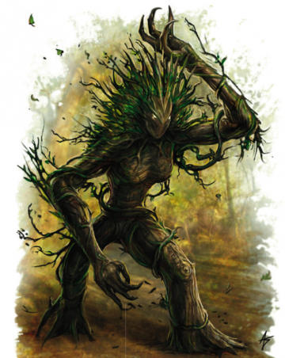

This spell turns an oak tree into a protector or guardian. The spell can be cast on only a single tree at a time; while liveoak is in effect, you can’t cast it again on another tree. The tree on which the spell is cast must be within 10 feet of your dwelling place, within a place sacred to you, or within 300 feet of something that you wish to guard or protect.
Liveoak must be cast on a healthy, Huge oak. A triggering phrase of up to one word per caster level is placed on the targeted oak. For instance, “Attack any persons who come near without first saying ‘sacred mistletoe’ “ is an eleven-word trigger phrase that you could use at 11th level or higher. The liveoak spell triggers the tree into animating as a treant (see the Monster Manual). At the DM’s option, you can extrapolate statistics for a smaller tree from the treant statistics if you cast likeoak on a smaller oak.
If liveoak is dispelled, the tree takes root immediately, wherever it happens to be. If released by you, the tree tries to return to its original location before taking root.

Move Earth
Transmutation [Earth]
Level: Drd 6, Sor/Wiz 6
Components: V, S, M
Casting Time: See text
Range: Long (400 ft. + 40 ft./level)
Area: Dirt in an area up to 750 ft. square and up to 10 ft. deep (S)
Duration: Instantaneous
Saving Throw: None
Spell Resistance: No

Move earth moves dirt (clay, loam, sand), possibly collapsing embank-ments, moving hillocks, shifting dunes, and so forth. However, in no event can rock formations be collapsed or moved. The area to be affected determines the casting time. For every 150-foot square (up to 10 feet deep), casting takes 10 minutes. The maximum area, 750 feet by 750 feet, takes 4 hours and 10 minutes to move.
This spell does not violently break the surface of the ground. Instead, it creates wavelike crests and troughs, with the earth reacting with glacierlike fluidity until the desired result is achieved. Trees, structures, rock formations, and such are mostly unaffected except for changes in elevation and relative topography.
The spell cannot be used for tunneling and is generally too slow to trap or bury creatures. Its primary use is for digging or filling moats or for adjusting terrain contours before a battle.
This spell has no effect on earth creatures.
Material Component: A mixture of soils (clay, loam, and sand) in a small bag, and an iron blade.

Owl’s Wisdom, Mass
Transmutation
Level: Clr 6, Drd 6, Sor/Wiz 6
Range: Close (25 ft. + 5 ft./2 levels)
Target: One creature/level, no two of which can be more than 30 ft. apart



This spell functions like *owl’s wisdom, except
that it affects multiple creatures.
*Owl’s Wisdom
Transmutation
Level: Clr 2, Drd 2, Pal 2, Rgr 2, Sor/Wiz 2
Components: V, S, M/DF
Casting Time: 1 standard action
Range: Touch
Target: Creature touched
Duration: 1 min./level
Saving Throw: Will negates (harmless)
Spell Resistance: Yes

The transmuted creature becomes wiser.
The spell grants a +4 enhancement bonus
to Wisdom, adding the usual benefit to
Wisdom-related skills. Clerics, druids,
paladins, and rangers (and other Wisdombased
spellcasters) who receive owl’s
wisdom do not gain any additional bonus
spells for the increased Wisdom, but the
save DCs for their spells increase.
Arcane Material Component: A few feathers,
or a pinch of droppings, from an owl.

Title Page
Class Features
Level Table
Animal Companions
Beah’s Feats

Druid Spells
0 Level Spells || 1st Level Spells
2nd Level Spells || 3rd Level Spells
4th Level Spells || 5th Level Spells
6th Level Spells || 7th Level Spells
8th Level Spells || 9th Level Spells

Repel Wood
Transmutation
Level: Drd 6, Plant 6
Components: V, S
Casting Time: 1 standard action
Range: 60 ft.
Area: 60-ft. line-shaped emanation from you
Duration: 1 min./level (D)
Saving Throw: None
Spell Resistance: No

Waves of energy roll forth from you, moving in the direction that you determine, causing all wooden objects in the path of the spell to be pushed away from you to the limit of the range. Wooden objects larger than 3 inches in diameter that are fixed firmly are not affected, but loose objects are. Objects (Repel Wood cont.) 3 inches in diameter or smaller that are fixed in place splinter and break, and the pieces move with the wave of energy. Objects affected by the spell are repelled at the rate of 40 feet per round.
Objects such as wooden shields, spears, wooden weapon shafts and hafts, and arrows and bolts are pushed back, dragging those carrying them along. (A creature being dragged by an item it is carrying can let go. A creature being dragged by a shield can loose it as a move action and drop it as a free action.) If a spear is planted (set) to prevent this forced movement, it splinters. Even magic items with wooden sections are repelled, although an antimagic field blocks the effects.
The waves of energy continue to sweep down the set path for the spell’s duration. After you cast the spell, the path is set, and you can then do other things or go elsewhere without affecting the spell’s power.

Spellstaff
Transmutation
Level: Drd 6
Components: V, S, F
Casting Time: 10 minutes
Range: Touch
Target: Wooden quarterstaff touched
Duration: Permanent until discharged (D)
Saving Throw: Will negates (object)
Spell Resistance: Yes (object)

You store one spell that you can normally cast in a wooden quarterstaff. Only one such spell can be stored in a staff at a given time, and you cannot have more than one spellstaff at any given time. You can cast a spell stored within a staff just as though it were among those you had prepared, but it does not count against your normal allotment for a given day. You use up any applicable material components required to cast the spell when you store it in the spellstaff.
Focus: The staff that stores the spell.

Stone Tell
Divination
Level: Drd 6
Components: V, S, DF
Casting Time: 10 minutes
Range: Personal
Target: You
Duration: 1 min./level

You gain the ability to speak with stones, which relate to you who or what has touched them as well as revealing what is covered or concealed behind or under them. The stones relate complete descriptions if asked. A stone’s perspective, perception, and knowledge may prevent the stone from providing the details you are looking for (as determined by the DM). You can speak with natural or worked stone.

Summon Nature’s Ally VI
Conjuration (Summoning) [see text]
Level: Drd 6
Effect: One or more creatures, no two of which can be more than 30 ft. apart

This spell functions like summon nature’s ally I, except that you can summon one 6th-level creature, 1d3 5th-level creatures of the same kind, or 1d4+1 lower-level creatures of the same kind.
When you use a summoning spell to summon an air, chaotic, earth, evil, fire, good, lawful, or water creature, it is a spell of that type.

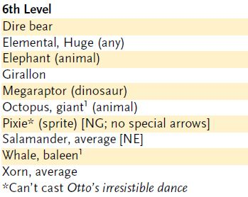

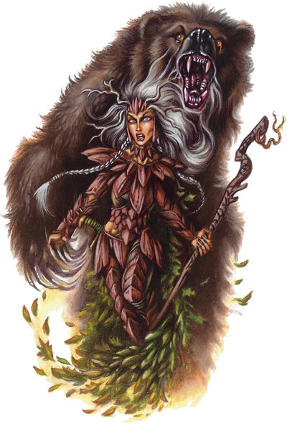

*Summon Nature’s Ally I
Conjuration (Summoning)
Level: Drd 1, Rgr 1
Components: V, S, DF
Casting Time: 1 round
Range: Close (25 ft. + 5 ft./2 levels)
Effect: One summoned creature
Duration: 1 round/level (D)
Saving Throw: None
Spell Resistance: No

This spell summons a natural creature. It appears where you designate and acts immediately, on your turn. It attacks your opponents to the best of its ability. If you can communicate with the creature, you can direct it not to attack, to attack particular enemies, or to perform other actions.
A summoned monster cannot summon or otherwise conjure another creature, nor can it use any teleportation or planar travel abilities. Creatures cannot be summoned into an environment that cannot support them. For instance, a porpoise may only be summoned in an aquatic environment.
The spell conjures one of the creatures from the 1st-level list on the accompanying Summon Nature’s Ally table. You choose which kind of creature to summon, and you can change that choice each time you cast the spell. All the creatures on the table are neutral unless otherwise noted.

Title Page
Class Features
Level Table
Animal Companions
Beah’s Feats

Druid Spells
0 Level Spells || 1st Level Spells
2nd Level Spells || 3rd Level Spells
4th Level Spells || 5th Level Spells
6th Level Spells || 7th Level Spells
8th Level Spells || 9th Level Spells

Transport via Plants
Transmutation
Level: Drd 6
Components: V, S
Casting Time: 1 standard action
Range: Unlimited
Target: You and touched objects or other touched willing creatures
Duration: 1 round
Saving Throw: None
Spell Resistance: No

You can enter any normal plant (Medium or larger) and pass any distance to a plant of the same kind in a single round, regardless of the distance separating the two. The entry plant must be alive. The destination plant need not be familiar to you, but it also must be alive. If you are uncertain (Transport via Plants cont.) of the location of a particular kind of destination plant, you need merely designate direction and distance (“an oak tree one hundred miles due north of here”), and the transport via plants spell moves you as close as possible to the desired location. If a particular destination plant is desired (the oak tree outside your druid grove, for instance), but the plant is not living, the spell fails and you are ejected from the entry plant.
You can bring along objects as long as their weight doesn’t exceed your maximum load. You may also bring one additional willing Medium or smaller creature (carrying gear or objects up to its maximum load) or its equivalent per three caster levels. Use the following equivalents to determine the maximum number of larger creatures you can bring along: A Large creature counts as two Medium creatures, a Huge creature counts as two Large creatures, and so forth. All creatures to be transported must be in contact with one another, and at least one of those creatures must be in contact with you.
You can’t use this spell to travel through plant creatures such as shambling mounds and treants.
The destruction of an occupied plant slays you and any creatures you have brought along, and ejects the bodies and all carried objects from the tree.

Wall of Stone
Conjuration (Creation) [Earth]
Level: Clr 5, Drd 6, Earth 5, Sor/Wiz 5
Components: V, S, M/DF
Casting Time: 1 standard action
Range: Medium (100 ft. + 10 ft./level)
Effect: Stone wall whose area is up to one 5-ft. square/level (S)
Duration: Instantaneous
Saving Throw: See text
Spell Resistance: No

This spell creates a wall of rock that merges into adjoining rock surfaces. It is typically employed to close passages, portals, and breaches against opponents. A wall of stone is 1 inch thick per four caster levels and composed of up to one 5-foot square per level. You can double the wall’s area by halving its thickness. The wall cannot be conjured so that it occupies the same space as a creature or another object.
Unlike a wall of iron, you can create a wall of stone in almost any shape you desire. The wall created need not be vertical, nor rest upon any firm foundation; however, it must merge with and be solidly supported by existing stone. It can be used to bridge a chasm, for instance, or as a ramp. For this use, if the span is more than 20 feet, the wall must be arched and buttressed. This requirement reduces the spell’s area by half. Thus, a 20th-level caster can create span with a surface area of ten 5-foot squares. The wall can be crudely shaped to allow crenellations, battlements, and so forth by likewise reducing the area.
Like any other stone wall, this one can be destroyed by a disintegrate spell or by normal means such as breaking and chipping. Each 5-foot square of the wall has 15 hit points per inch of thickness and hardness 8. A section of wall whose hit points drop to 0 is breached. If a creature tries to break through the wall with a single attack, the DC for the Strength check is 20 + 2 per inch of thickness.
It is possible, but difficult, to trap mobile opponents within or under a wall of stone, provided the wall is shaped so it can hold the creatures. Creatures can avoid entrapment with successful Reflex saves.
Arcane Material Component: A small block of granite.

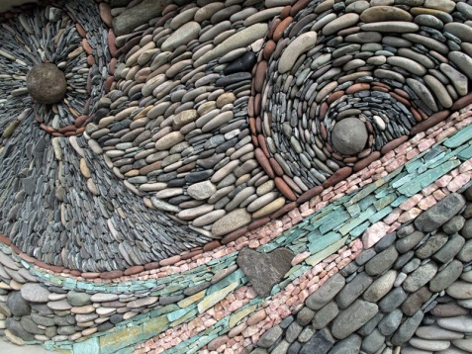

Title Page
Class Features
Level Table
Animal Companions
Beah’s Feats

Druid Spells
0 Level Spells || 1st Level Spells
2nd Level Spells || 3rd Level Spells
4th Level Spells || 5th Level Spells
6th Level Spells || 7th Level Spells
8th Level Spells || 9th Level Spells

7th-LEVEL DRUID SPELLS

Animate Plants: One or more plants animate and fight for you.
Changestaff: Your staff becomes a treant on command.
Control Weather: Changes weather in local area.
Creeping Doom: Swarms of centipedes attack at your command.
Cure Moderate Wounds, Mass: Cures 2d8 damage +1/level for many creatures.
Fire Storm: Deals 1d6/level fire damage.
Heal: Cures 10 points/level of damage, all diseases and mental conditions.
Scrying, Greater: As scrying, but faster and longer.
Summon Nature’s Ally VII: Calls creature to fight.
Sunbeam: Beam blinds and deals 4d6 damage.
Transmute Metal to Wood: Metal within 40 ft. becomes wood.
True Seeing^{M}: Lets you see all things as they really are.
Wind Walk: You and your allies turn vaporous and travel fast.

Animate Plants
Transmutation
Level: Drd 7, Plant 7
Components: V
Casting Time: 1 standard action
Range: Close (25 ft. + 5 ft./2 levels)
Targets: One Large plant per three caster levels or all plants within range; see text
Duration: 1 round/level or 1 hour/level; see text
Saving Throw: None
Spell Resistance: No

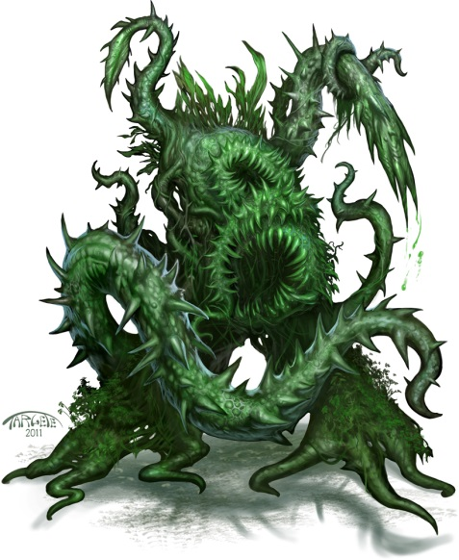

You imbue inanimate plants with mobility and a semblance of life. Each animated plant then immediately attacks whomever or whatever you initially designate as though it were an animated object of the appropriate size category. You may animate one Large or smaller plant (such as a tree), or an equivalent number of larger plants, per three caster levels. A Huge plant counts as two Large or smaller plants, a Gargantuan plant as four, and a Colossal plant as eight. You can change the designated target or targets as a move action, as if directing an active spell.
Use the statistics for animated objects found in the Monster Manual, except that plants smaller than Large don’t have hardness unless the DM rules otherwise for a given case.
Animate plants cannot affect plant creatures (such as treants), nor does it affect nonliving vegetable material (such as a cotton tunic or hempen rope).
Entangle: Alternatively, you may imbue all plants within range with a degree of mobility, which allows them to entwine around creatures in the area. This usage of the spell duplicates the effect of an entangle spell. Spell resistance does not keep creatures from being entangled. This effect lasts 1 hour per caster level.

Changestaff
Transmutation
Level: Drd 7
Components: V, S, F
Casting Time: 1 round
Range: Touch
Target: Your touched staff
Duration: 1 hour/level (D)
Saving Throw: None
Spell Resistance: No

You change a specially prepared quarterstaff into a Huge treantlike creature, about 24 feet tall. When you plant the end of the staff in the ground and speak a special command to conclude the casting of the spell, your staff turns into a creature that looks and fights just like a treant (see the Monster Manual). The staff-treant defends you and obeys any spoken commands. However, it is by no means a true treant; it cannot converse with actual treants or control trees. If the staff-treant is reduced to 0 or fewer hit points, it crumbles to powder and the staff is destroyed. Otherwise, the staff returns to its normal form when the spell duration expires (or when the spell is dismissed), and it can be used as the focus for another casting of the spell. The staff-treant is always at full strength when created, despite any wounds it may have incurred the last time it appeared.
Focus: The quarterstaff, which must be specially prepared. The staff must be a sound limb cut from an ash, oak, or yew, then cured, shaped, carved, and polished (a process requiring twenty-eight days). You cannot adventure or engage in other strenuous activity during the shaping and carving of the staff.

Title Page
Class Features
Level Table
Animal Companions
Beah’s Feats

Druid Spells
0 Level Spells || 1st Level Spells
2nd Level Spells || 3rd Level Spells
4th Level Spells || 5th Level Spells
6th Level Spells || 7th Level Spells
8th Level Spells || 9th Level Spells

Control Weather
Transmutation
Level: Air 7, Clr 7, Drd 7, Sor/Wiz 7
Components: V, S
Casting Time: 10 minutes; see text
Range: 2 miles
Area: 2-mile-radius circle, centered on you; see text
Duration: 4d12 hours; see text
Saving Throw: None
Spell Resistance: No

You change the weather in the local area. It takes 10 minutes to cast the spell and an additional 10 minutes for the effects to manifest. The current, natural weather conditions are determined by the DM. You can call forth weather appropriate to the climate and season of the area you are in.

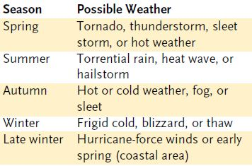

You control the general tendencies of the weather, such as the direction and intensity of the wind. You cannot control specific applications of the weather—where lightning strikes, for example, or the exact path of a (Control Weather cont.) tornado. When you select a certain weather condition to occur, the weather assumes that condition 10 minutes later (changing gradually, not abruptly). The weather continues as you left it for the duration, or until you use a standard action to designate a new kind of weather (which fully manifests itself 10 minutes later). Contradictory conditions are not possible simultaneously—fog and strong wind, for example.
Control weather can do away with atmospheric phenomena (naturally occurring or otherwise) as well as create them.
A druid casting this spell doubles the duration and affects a circle with a 3-mile radius.

Creeping Doom
Conjuration (Summoning)
Level: Drd 7
Components: V, S
Casting Time: 1 round
Range: Close (25 ft. + 5 ft./2 levels)/ 100
ft.; see text
Effect: One swarm of centipedes per two
levels
Duration: 1 min./level
Saving Throw: None
Spell Resistance: No



When you utter the spell of creeping doom, you call forth a mass of centipede swarms (one per two caster levels, to a maximum of ten swarms at 20th level), which need not appear adjacent to one another. (See the Monster Manual for details on centipede swarms.)
You may summon the centipede swarms so that they share the area of other creatures. The swarms remain stationary, attacking any creatures in their area, unless you command the creeping doom to move (a standard action). As a standard action, you can command any number of the swarms to move toward any prey within 100 feet of you. You cannot command any swarm to move more than 100 feet away from you, and if you move more than 100 feet from any swarm, that swarm remains stationary, attacking any creatures in its area (but it can be commanded again if you move within 100 feet).

Cure Moderate Wounds, Mass
Conjuration (Healing)
Level: Brd 6, Clr 6, Drd 7

This spell functions like *cure light wounds mass except that it cures 2d8 points of damage +1 point per caster level (maximum +30).

*Cure Light Wounds, Mass
Conjuration (Healing)
Level: Brd 5, Clr 5, Drd 6, Healing 5
Components: V, S
Casting Time: 1 standard action
Range: Close (25 ft. + 5 ft./2 levels)
Target: One creature/level, no two of which can be more than 30 ft. apart
Duration: Instantaneous
Saving Throw: Will half (harmless) or Will half; see text
Spell Resistance: Yes (harmless) or Yes; see text

You channel positive energy to cure 1d8 points of damage +1 point per caster level (maximum +25) in each selected creature.
Like other cure spells, mass cure light wounds deals damage to undead in its area rather than curing them. Each affected undead may attempt a Will save for half damage.

Fire Storm
Evocation [Fire]
Level: Clr 8, Drd 7, Fire 7
Components: V, S
Casting Time: 1 round
Range: Medium (100 ft. + 10 ft./level)
Area: Two 10-ft. cubes per level (S)
Duration: Instantaneous
Saving Throw: Reflex half
Spell Resistance: Yes

When a fire storm spell is cast, the whole area is shot through with sheets of roaring flame. The raging flames do not harm natural vegetation, ground cover, and any plant creatures in the area that you wish to exclude from damage. Any other creature within the area takes 1d6 points of fire damage per caster level (maximum 20d6).
Heal
Conjuration (Healing)
Level: Clr 6, Drd 7, Healing 6
Components: V, S
Casting Time: 1 standard action
Range: Touch
Target: Creature touched
Duration: Instantaneous
Saving Throw: Will negates (harmless)
Spell Resistance: Yes (harmless)

Heal enables you to channel positive energy into a creature to wipe away injury and afflictions. It immediately ends any and all of the following adverse conditions affecting the Target: ability damage, blinded, confused, dazed, dazzled, deafened, diseased, exhausted, fatigued, feebleminded, insanity, nauseated, sickened, stunned, and poisoned. It also cures 10 hit points of damage per level of the caster, to a maximum of 150 points at 15th level.
Heal does not remove negative levels, restore permanently drained levels, or restore permanently drained ability score points.
If used against an undead creature, heal instead acts like harm.

Title Page
Class Features
Level Table
Animal Companions
Beah’s Feats

Druid Spells
0 Level Spells || 1st Level Spells
2nd Level Spells || 3rd Level Spells
4th Level Spells || 5th Level Spells
6th Level Spells || 7th Level Spells
8th Level Spells || 9th Level Spells

Scrying, Greater
Divination (Scrying)
Level: Brd 6, Clr 7, Drd 7, Sor/Wiz 7
Components: V, S
Casting Time: 1 standard action
Duration: 1 hour/level



This spell functions like *scrying, except as noted above. Additionally, all (Scrying Greater, cont.) of the following spells function reliably through the sensor: detect chaos, detect evil, detect good, detect law, detect magic, message, read magic, and tongues.

*Scrying
Divination (Scrying)
Level: Brd 3, Clr 5, Drd 4, Sor/Wiz 4
Components: V, S, M/DF, F
Casting Time: 1 hour
Range: See text
Effect: Magical sensor
Duration: 1 min./level
Saving Throw: Will negates
Spell Resistance: Yes

You can see and hear some creature, which may be at any distance. If the subject succeeds on a Will save, the scrying attempt simply fails. The difficulty of the save depends on how well you know the subject and what sort of physical connection (if any) you have to that creature. Furthermore, if the subject is on another plane, it gets a +5 bonus on its Will save.

Summon Nature’s Ally VII
Conjuration (Summoning) [see text]
Level: Drd 7
Effect: One or more creatures, no two of which can be more than 30 ft. apart



This spell functions like summon nature’s ally I, except that you can summon one 7th-level creature, 1d3 6th-level creatures of the same kind, or 1d4+1 lower-level creatures of the same kind.
When you use a summoning spell to summon an air, chaotic, earth, evil, fire, good, lawful, or water creature, it is a spell of that type.

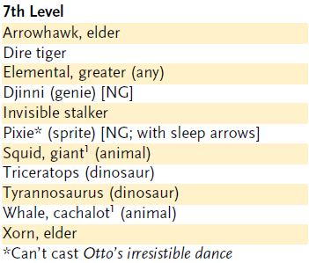

*Summon Nature’s Ally I
Conjuration (Summoning)
Level: Drd 1, Rgr 1
Components: V, S, DF
Casting Time: 1 round
Range: Close (25 ft. + 5 ft./2 levels)
Effect: One summoned creature
Duration: 1 round/level (D)
Saving Throw: None
Spell Resistance: No

This spell summons a natural creature. It appears where you designate and acts immediately, on your turn. It attacks your opponents to the best of its ability. If you can communicate with the creature, you can direct it not to attack, to attack particular enemies, or to perform other actions.
A summoned monster cannot summon or otherwise conjure another creature, nor can it use any teleportation or planar travel abilities. Creatures cannot be summoned into an environment that cannot support them. For instance, a porpoise may only be summoned in an aquatic environment.
The spell conjures one of the creatures from the 1st-level list on the accompanying Summon Nature’s Ally table. You choose which kind of creature to summon, and you can change that choice each time you cast the spell. All the creatures on the table are neutral unless otherwise noted.

Sunbeam
Evocation [Light]
Level: Drd 7, Sun 7
Components: V, S, DF
Casting Time: 1 standard action
Range: 60 ft.
Area: Line from your hand
Duration: 1 round/level or until all
beams are exhausted
Saving Throw: Reflex negates and Reflex half; see text
Spell Resistance: Yes



For the duration of this spell, you can use a standard action to evoke a dazzling beam of intense light each round. You can call forth one beam per three caster levels (maximum six beams at 18th level). The spell ends when its duration runs out or your allotment of beams is exhausted.
Each creature in the beam is blinded and takes 4d6 points of damage. Any creatures to which sunlight is harmful or unnatural take double damage. A successful Reflex save negates the blindness and reduces the damage by half.
An undead creature caught within the beam takes 1d6 points of damage per caster level (maximum 20d6), or half damage if a Reflex save is successful. In addition, the beam results in the destruction of any undead creature specifically harmed by bright light (such as a vampire) if it fails its save.
The ultraviolet light generated by the spell deals damage to fungi, mold, oozes, and slimes just as if they were undead creatures.

Title Page
Class Features
Level Table
Animal Companions
Beah’s Feats

Druid Spells
0 Level Spells || 1st Level Spells
2nd Level Spells || 3rd Level Spells
4th Level Spells || 5th Level Spells
6th Level Spells || 7th Level Spells
8th Level Spells || 9th Level Spells

8th-LEVEL DRUID SPELLS

Animal Shapes: One ally/level polymorphs into chosen animal.
Control Plants: Control actions of one or more plant creatures.
Cure Serious Wounds, Mass: Cures 3d8 damage +1/level for many creatures.
Earthquake: Intense tremor shakes 5-ft./level radius.
Finger of Death: Kills one subject.
Repel Metal or Stone: Pushes away metal and stone.
Reverse Gravity: Objects and creatures fall upward.
Summon Nature’s Ally VIII: Calls creature to fight.
Sunburst: Blinds all within 10 ft., deals 6d6 damage.
Whirlwind: Cyclone deals damage and can pick up creatures.
Word of Recall: Teleports you back to designated place.

9th-LEVEL DRUID SPELLS

Antipathy: Object or location affected by spell repels certain creatures.
Cure Critical Wounds, Mass: Cures 4d8 damage +1/level for many creatures.
Elemental Swarm: Summons multiple elementals.
Foresight: “Sixth sense” warns of impending danger.
Regenerate: Subjects severed limbs grow back, cures 4d8 damage +1/level (max +35).
Shambler: Summons 1d4+2 shambling mounds to fight for you.
Shapechange^{F}: Transforms you into any creature, and change forms once per round.
Storm of Vengeance: Storm rains acid, lightning, and hail.
Summon Nature’s Ally IX: Calls creature to fight.
Sympathy^{M}: Object or location attracts certain creatures.

COMBAT SPECIFICATIONS

SWARMS


Swarms are dense masses of Fine, Diminutive, or Tiny creatures that would not be particularly dangerous in small groups, but can be terrible foes when gathered in sufficient numbers. While a single cloud of locusts might actually be hundreds of feet across, for game purposes a swarm is defined as a single creature with a space of 10 feet—gigantic hordes of bats or locusts are actually composed of dozens of swarms in close proximity. A swarm has a single pool of Hit Dice and hit points, a single initiative modifier, a single speed, and a single Armor Class. It makes saving throws as a single creature. Many different creatures can mass as swarms; bat swarms, centipede swarms, hellwasp swarms, locust swarms, rat swarms, and spider swarms are described here. The swarm’s type varies with the nature of the component creature (most are animals or vermin), but all swarms have the swarm subtype. A swarm of Tiny creatures consists of 300 nonflying creatures or 1,000 flying creatures. A swarm of Diminutive creatures consists of 1,500 nonflying creatures or 5,000 flying creatures. A swarm of Fine creatures consists of 10,000 creatures, whether they are flying or not. Swarms of nonflying creatures include many more creatures than could normally fit in a 10-foot square based on their normal space, because creatures in a swarm are packed tightly together and generally crawl over each other and their prey when moving or attacking. Larger swarms are represented by multiples of single swarms. A large swarm is completely shapeable, though it usually remains contiguous.

COMBAT BASICS
In order to attack, a single swarm moves into opponents’ spaces, which provokes an attack of opportunity. It can occupy the same space as a creature of any size, since it crawls all over its prey, but remains a creature with a 10-foot space. Swarms never make attacks of opportunity, but they can provoke attacks of opportunity. Unlike other creatures with a 10-foot space, a swarm is shapeable. It can occupy any four contiguous squares, and it can squeeze through any space large enough to contain one of its component creatures (for example, a bat swarm can squeeze through a space that a Tiny creature could squeeze through).

Vulnerabilities of Swarms
Swarms are extremely difficult to fight with physical attacks. However, they have a few special vulnerabilities, as follows: A lit torch swung as an improvised weapon deals 1d3 points of fire damage per hit. A weapon with a special ability such as flaming or frost deals its full energy damage with each hit, even if the weapon’s normal damage can’t affect the swarm. A lit lantern can be used as a thrown weapon, dealing 1d4 points of fire damage to all creatures in squares adjacent to where it breaks.
SWARM TYPES

Bats (Lvl 2 Spell: Summon Swarm)
Centipedes (Lvl 7 Spell: Creeping Doom)
Locust (Lvl 5 Spell: Insect Plague)
Rats (Lvl 2 Spell: Summon Swarm)
Spiders (Lvl 2 Spell: Summon Swarm)

BAT SWARM
Diminutive Animal (Swarm)
Hit Dice: 3d8 (13 hp)
Initiative: +2
Speed: 5 ft. (1 square), fly 40 ft. (good)
Armor Class: 16 (+4 size, +2 Dex), touch 14, flat-footed 12
Base Attack/Grapple: +2/—
Attack: Swarm (1d6)
Full Attack: Swarm (1d6)
Space/Reach: 10 ft./0 ft.
Special Attacks: Distraction, wounding
Special Qualities: Blindsense 20 ft., half damage from slashing and piercing, low-light vision, swarm traits
Saves: Fort +3, Ref +7, Will +3
Abilities: Str 3, Dex 15, Con 10, Int 2, Wis 14, Cha 4
Skills: Listen +11, Spot +11
Feats: Alertness, Lightning Reflexes
Environment: Temperate deserts
Organization: Solitary, flight (2–4 swarms), or colony (11–20 swarms)
Challenge Rating: 2
Treasure: None
Alignment: Always neutral
Advancement: None
Level Adjustment: —

A bat swarm is a mass of small, fierce carnivorous bats with a thirst for the blood of any creature unfortunate enough to cross their path. A bat swarm is nocturnal, and is never found aboveground in daylight.

Combat
A bat swarm seeks to surround and attack any warm-blooded prey it encounters. The swarm deals 1d6 points of damage to any creature whose space it occupies at the end of its move.
Distraction (Ex): Any living creature that begins its turn with a swarm in its space must succeed on a DC 11 Fortitude save or be nauseated for 1 round. The save DC is Constitution-based.
Wounding (Ex): Any living creature damaged by a bat swarm continues to bleed, losing 1 hit point per round thereafter. Multiple wounds do not result in cumulative bleeding loss. The bleeding can be stopped by a DC 10 Heal check or the application of a cure spell or some other healing magic.
Blindsense (Ex): A bat swarm notices and locates creatures within 20 feet. Opponents still have total concealment against the bat swarm (but swarm attacks ignore concealment).
Skills: A bat swarm has a +4 racial bonus on Listen and Spot checks. These bonuses are lost if its blindsense is negated.

CENTIPEDE SWARM
Diminutive Vermin (Swarm)
Hit Dice: 9d8–9 (31 hp)
Initiative: +4
Speed: 20 ft. (4 squares), climb 20 ft.
Armor Class: 18 (+4 size, +4 Dex), touch 18, flat-footed 14
Base Attack/Grapple: +6/—
Attack: Swarm (2d6 plus poison)
Full Attack: Swarm (2d6 plus poison)
Space/Reach: 10 ft./0 ft.
Special Attacks: Distraction, poison
Special Qualities: Darkvision 60 ft., immune to weapon damage, swarm traits, tremorsense 30 ft., vermin traits
Saves: Fort +5, Ref +7, Will +3
Abilities: Str 1, Dex 19, Con 8, Int —, Wis 10, Cha 2
Skills: Climb +12, Spot +4
Feats: Weapon FinesseB
Environment: Underground
Organization: Solitary, tangle (2–4 swarms), or colony (7–12 swarms)
Challenge Rating: 4
Treasure: None
Alignment: Always neutral
Advancement: None
Level Adjustment: —

A centipede swarm is a crawling mass of voracious centipedes that can climb over obstacles to get at prey.

Combat
A centipede swarm seeks to surround and attack any living prey it encounters. A swarm deals 2d6 points of damage to any creature whose space it occupies at the end of its move.
Distraction (Ex): Any living creature that begins its turn with a centipede swarm in its space must succeed on a DC 13 Fortitude save or be nauseated for 1 round. The save DC is Constitution-based.
Poison (Ex): Injury, Fortitude DC 13, initial and secondary damage 1d4 Dex. The save DC is Constitution-based.
Skills: A centipede swarm has a +4 racial bonus on Spot checks and a +8 racial bonus on Climb checks, and uses its Dexterity modifier instead of its Strength modifier for Climb checks. A centipede swarm has a +8 racial bonus on Climb checks and can always choose to take 10 on a Climb check, even if rushed or threatened.

LOCUST SWARM
Diminutive Vermin (Swarm)
Hit Dice: 6d8–6 (21 hp)
Initiative: +4
Speed: 10 ft. (2 squares), fly 30 ft. (poor)
Armor Class: 18 (+4 size, +4 Dex), touch 18, flat-footed 14
Base Attack/Grapple: +4/—
Attack: Swarm (2d6)
Full Attack: Swarm (2d6)
Space/Reach: 10 ft./0 ft.
Special Attacks: Distraction
Special Qualities: Darkvision 60 ft., immune to weapon damage, swarm traits, vermin traits
Saves: Fort +4, Ref +6, Will +2
Abilities: Str 1, Dex 19, Con 8, Int —, Wis 10, Cha 2
Skills: Listen +4, Spot +4
Feats: —
Environment: Temperate plains
Organization: Solitary, cloud (2–7 swarms), or plague (11–20 swarms)
Challenge Rating: 3
Treasure: None
Alignment: Always neutral
Advancement: None
Level Adjustment: —

A locust swarm is a cloud of thousands of winged vermin that devours any organic material in its path.

Combat
A locust swarm surrounds and attacks any living prey it encounters. A swarm deals 2d6 points of damage to any creature whose space it occupies at the end of its move.
Distraction (Ex): Any living creature that begins its turn with a locust swarm in its space must succeed on a DC 12 Fortitude save or be nauseated for 1 round. The save DC is Constitution-based.
Skills: A locust swarm has a +4 racial bonus on Listen and Spot checks.

RAT SWARM
Tiny Animal (Swarm)
Hit Dice: 4d8 (13 hp)
Initiative: +2
Speed: 15 ft. (3 squares), climb 15 ft.
Armor Class: 14 (+2 size, +2 Dex), touch 14, flat-footed 12
Base Attack/Grapple: +3/—
Attack: Swarm (1d6 plus disease)
Full Attack: Swarm (1d6 plus disease)
Space/Reach: 10 ft./0 ft.
Special Attacks: Disease, distraction
Special Qualities: Half damage from slashing and piercing, low-light vision, scent, swarm traits
Saves: Fort +4, Ref +6, Will +2
Abilities: Str 2, Dex 15, Con 10, Int 2, Wis 12, Cha 2
Skills: Balance +10, Climb +10, Hide +14, Listen +6, Spot +7, Swim +10
Feats: Alertness, Weapon Finesse
Environment: Any
Organization: Solitary, pack (2–4 swarms), or infestation (7–12 swarms)
Challenge Rating: 2
Treasure: None
Alignment: Always neutral
Advancement: None
Level Adjustment: —

A rat swarm is a mass of teeming, famished, disease-ridden rats. A swarm is composed of individuals very much like the rat described on page 278, but in such great numbers, rats can become implacable hunters capable of killing a human with hundreds of bites.
A rat swarm sometimes can be found in the sewers and foundations of human cities.

Combat
A rat swarm seeks to surround and attack any warm-blooded prey it encounters. A swarm deals 1d6 points of damage to any creature whose space it occupies at the end of its move.
Disease (Ex): Filth fever—swarm attack, Fortitude DC 12, incubation period 1d3 days, damage 1d3 Dex and 1d3 Con. The save DC is Constitution-based.
Distraction (Ex): Any living creature that begins its turn with a swarm in its square must succeed on a DC 12 Fortitude save or be nauseated for 1 round. The save DC is Constitution-based.
Skills: A rat swarm has a +4 racial bonus on Hide and Move Silently checks, and a +8 racial bonus on Balance, Climb, and Swim checks. A rat swarm can always choose to take 10 on all Climb checks, even if rushed or threatened.
A rat swarm uses its Dexterity modifier instead of its Strength modifier for Climb and Swim checks.
A rat swarm has a +8 racial bonus on any Swim check to perform some special action or avoid a hazard. It can always choose to take 10 on a Swim check, even if distracted or endangered. It can use the run action while swimming, provided it swims in a straight line.

SPIDER SWARM
Diminutive Vermin (Swarm)
Hit Dice: 2d8 (9 hp)
Initiative: +3
Speed: 20 ft. (4 squares), climb 20 ft.
Armor Class: 17 (+4 size, +3 Dex), touch 17, flat-footed 14
Base Attack/Grapple: +1/—
Attack: Swarm (1d6 plus poison)
Full Attack: Swarm (1d6 plus poison)
Space/Reach: 10 ft./0 ft.
Special Attacks: Distraction, poison
Special Qualities: Darkvision 60 ft., swarm traits, tremorsense 30 ft., vermin traits
Saves: Fort +3, Ref +3, Will +0
Abilities: Str 1, Dex 17, Con 10, Int —, Wis 10, Cha 2
Skills: Climb +11, Listen +4, Spot +4
Environment: Warm forests
Organization: Solitary, tangle (2–4 swarms), or colony (7–12 swarms)
Challenge Rating: 1
Treasure: None
Alignment: Always neutral
Advancement: None
Level Adjustment: —

A spider swarm is a scuttling horde of venomous spiders.

Combat
A spider swarm seeks to surround and attack any living prey it encounters. A swarm deals 1d6 points of damage to any creature whose space it occupies at the end of its move.
Distraction (Ex): Any living creature that begins its turn with a spider swarm in its space must succeed on a DC 11 Fortitude save or be nauseated for 1 round. The save DC is Constitution-based.
Poison (Ex): Injury, Fortitude DC 11, initial and secondary damage 1d3 Str. The save DC is Constitution-based.
Skills: A spider swarm has a +4 racial bonus on Hide and Spot checks and a +8 racial bonus on Climb checks. It uses its Dexterity modifier instead of its Strength modifier for Climb checks. It can always choose to take 10 on a Climb check, even if rushed or threatened.

